Filed by Plains All American Pipeline, L.P.
pursuant to Rule 425 under the Securities Act of 1933
and deemed filed pursuant to Rule 14a-12
under the Securities Exchange Act of 1934

Subject Company: Pacific Energy Partners, L.P.
Commission File No.: 1-31345
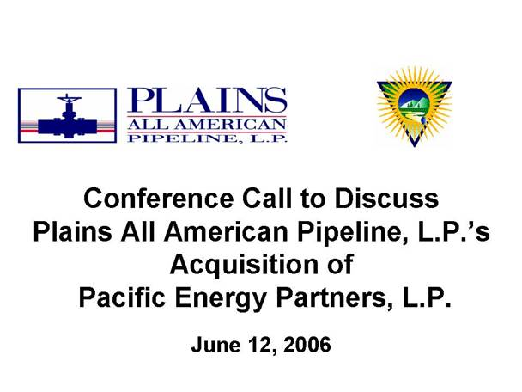
Filed by Plains All American Pipeline, L.P. pursuant to Rule 425 under the Securities Act of 1933 and deemed filed pursuant to Rule 14a-12 under the Securities Exchange Act of 1934 Subject Company: Pacific Energy Partners, L.P. Commission File No.: 1-31345 Conference Call to Discuss Plains All American Pipeline, L.P.s Acquisition of Pacific Energy Partners, L.P. June 12, 2006

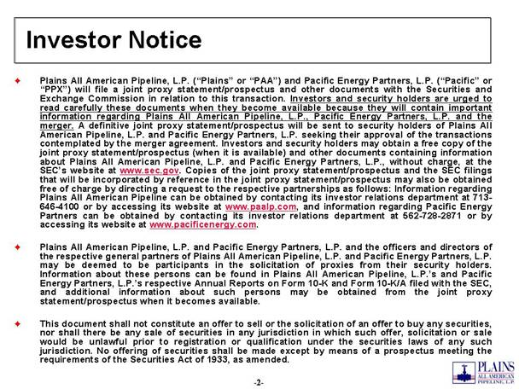
Investor Notice Plains All American Pipeline, L.P. (Plains or PAA) and Pacific Energy Partners, L.P. (Pacific or PPX) will file a joint proxy statement/prospectus and other documents with the Securities and Exchange Commission in relation to this transaction. Investors and security holders are urged to read carefully these documents when they become available because they will contain important information regarding Plains All American Pipeline, L.P., Pacific Energy Partners, L.P. and the merger. A definitive joint proxy statement/prospectus will be sent to security holders of Plains All American Pipeline, L.P. and Pacific Energy Partners, L.P. seeking their approval of the transactions contemplated by the merger agreement. Investors and security holders may obtain a free copy of the joint proxy statement/prospectus (when it is available) and other documents containing information about Plains All American Pipeline, L.P. and Pacific Energy Partners, L.P., without charge, at the SECs website at www.sec.gov. Copies of the joint proxy statement/prospectus and the SEC filings that will be incorporated by reference in the joint proxy statement/prospectus may also be obtained free of charge by directing a request to the respective partnerships as follows: Information regarding Plains All American Pipeline can be obtained by contacting its investor relations department at 713-646-4100 or by accessing its website at www.paalp.com, and information regarding Pacific Energy Partners can be obtained by contacting its investor relations department at 562-728-2871 or by accessing its website at www.pacificenergy.com. Plains All American Pipeline, L.P. and Pacific Energy Partners, L.P. and the officers and directors of the respective general partners of Plains All American Pipeline, L.P. and Pacific Energy Partners, L.P. may be deemed to be participants in the solicitation of proxies from their security holders. Information about these persons can be found in Plains All American Pipeline, L.P.s and Pacific Energy Partners, L.P.s respective Annual Reports on Form 10-K and Form 10-K/A filed with the SEC, and additional information about such persons may be obtained from the joint proxy statement/prospectus when it becomes available. This document shall not constitute an offer to sell or the solicitation of an offer to buy any securities, nor shall there be any sale of securities in any jurisdiction in which such offer, solicitation or sale would be unlawful prior to registration or qualification under the securities laws of any such jurisdiction. No offering of securities shall be made except by means of a prospectus meeting the requirements of the Securities Act of 1933, as amended.

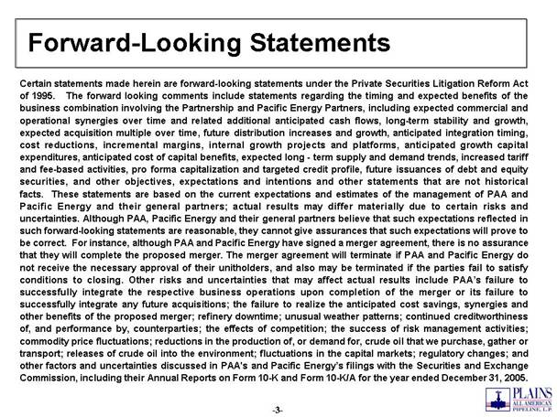
Forward-Looking Statements Certain statements made herein are forward-looking statements under the Private Securities Litigation Reform Act of 1995. The forward looking comments include statements regarding the timing and expected benefits of the business combination involving the Partnership and Pacific Energy Partners, including expected commercial and operational synergies over time and related additional anticipated cash flows, long-term stability and growth, expected acquisition multiple over time, future distribution increases and growth, anticipated integration timing, cost reductions, incremental margins, internal growth projects and platforms, anticipated growth capital expenditures, anticipated cost of capital benefits, expected long - term supply and demand trends, increased tariff and fee-based activities, pro forma capitalization and targeted credit profile, future issuances of debt and equity securities, and other objectives, expectations and intentions and other statements that are not historical facts. These statements are based on the current expectations and estimates of the management of PAA and Pacific Energy and their general partners; actual results may differ materially due to certain risks and uncertainties. Although PAA, Pacific Energy and their general partners believe that such expectations reflected in such forward-looking statements are reasonable, they cannot give assurances that such expectations will prove to be correct. For instance, although PAA and Pacific Energy have signed a merger agreement, there is no assurance that they will complete the proposed merger. The merger agreement will terminate if PAA and Pacific Energy do not receive the necessary approval of their unitholders, and also may be terminated if the parties fail to satisfy conditions to closing. Other risks and uncertainties that may affect actual results include PAAs failure to successfully integrate the respective business operations upon completion of the merger or its failure to successfully integrate any future acquisitions; the failure to realize the anticipated cost savings, synergies and other benefits of the proposed merger; refinery downtime; unusual weather patterns; continued creditworthiness of, and performance by, counterparties; the effects of competition; the success of risk management activities; commodity price fluctuations; reductions in the production of, or demand for, crude oil that we purchase, gather or transport; releases of crude oil into the environment; fluctuations in the capital markets; regulatory changes; and other factors and uncertainties discussed in PAA's and Pacific Energys filings with the Securities and Exchange Commission, including their Annual Reports on Form 10-K and Form 10-K/A for the year ended December 31, 2005.

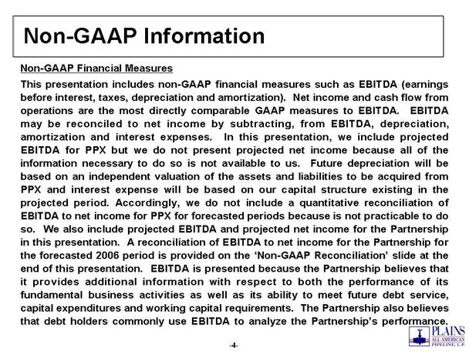
Non-GAAP Information Non-GAAP Financial Measures This presentation includes non-GAAP financial measures such as EBITDA (earnings before interest, taxes, depreciation and amortization). Net income and cash flow from operations are the most directly comparable GAAP measures to EBITDA. EBITDA may be reconciled to net income by subtracting, from EBITDA, depreciation, amortization and interest expenses. In this presentation, we include projected EBITDA for PPX but we do not present projected net income because all of the information necessary to do so is not available to us. Future depreciation will be based on an independent valuation of the assets and liabilities to be acquired from PPX and interest expense will be based on our capital structure existing in the projected period. Accordingly, we do not include a quantitative reconciliation of EBITDA to net income for PPX for forecasted periods because is not practicable to do so. We also include projected EBITDA and projected net income for the Partnership in this presentation. A reconciliation of EBITDA to net income for the Partnership for the forecasted 2006 period is provided on the Non-GAAP Reconciliation slide at the end of this presentation. EBITDA is presented because the Partnership believes that it provides additional information with respect to both the performance of its fundamental business activities as well as its ability to meet future debt service, capital expenditures and working capital requirements. The Partnership also believes that debt holders commonly use EBITDA to analyze the Partnerships performance.

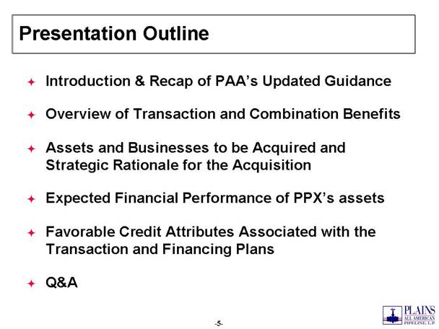
Presentation Outline Introduction & Recap of PAAs Updated Guidance Overview of Transaction and Combination Benefits Assets and Businesses to be Acquired and Strategic Rationale for the Acquisition Expected Financial Performance of PPXs assets Favorable Credit Attributes Associated with the Transaction and Financing Plans Q&A

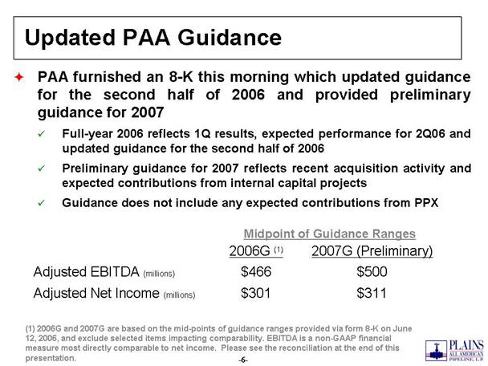
Updated PAA Guidance PAA furnished an 8-K this morning which updated guidance for the second half of 2006 and provided preliminary guidance for 2007 Full-year 2006 reflects 1Q results, expected performance for 2Q06 and updated guidance for the second half of 2006 Preliminary guidance for 2007 reflects recent acquisition activity and expected contributions from internal capital projects Guidance does not include any expected contributions from PPX (1) 2006G and 2007G are based on the mid-points of guidance ranges provided via form 8-K on June 12, 2006, and exclude selected items impacting comparability. EBITDA is a non-GAAP financial measure most directly comparable to net income. Please see the reconciliation at the end of this presentation. $311 $301 Adjusted Net Income (millions) $500 $466 Adjusted EBITDA (millions) 2007G (Preliminary) 2006G (1) Midpoint of Guidance Ranges

Transaction Summary PAA to acquire PPX for $2.4 billion in two simultaneous transactions PAA to acquire general partner interest, incentive distribution rights, 2.6 million PPX common units and 7.8 million PPX subordinated units from LB Pacific, LP for $700 million PAA to acquire remaining public PPX common units by exchanging 0.77 PAA common units for each PPX common unit Based on PAA & PPX closing prices on June 9th, PPX unitholders are receiving market premium of 10.6% Based on 20-day trailing average PAA & PPX closing prices, PPX unitholders are receiving market premium of 14.3% The result of the transactions will be that the general partner and limited partner interests in PPX will be extinguished, PPX will be merged into PAA and the PPX operating subsidiaries will be directly or indirectly owned by PAA

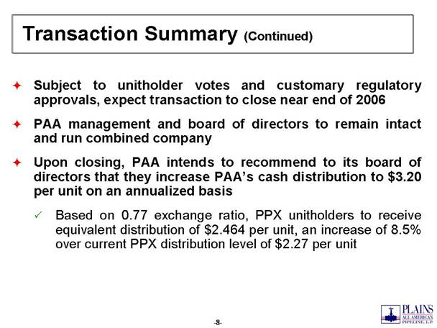
Transaction Summary (Continued) Subject to unitholder votes and customary regulatory approvals, expect transaction to close near end of 2006 PAA management and board of directors to remain intact and run combined company Upon closing, PAA intends to recommend to its board of directors that they increase PAAs cash distribution to $3.20 per unit on an annualized basis Based on 0.77 exchange ratio, PPX unitholders to receive equivalent distribution of $2.464 per unit, an increase of 8.5% over current PPX distribution level of $2.27 per unit

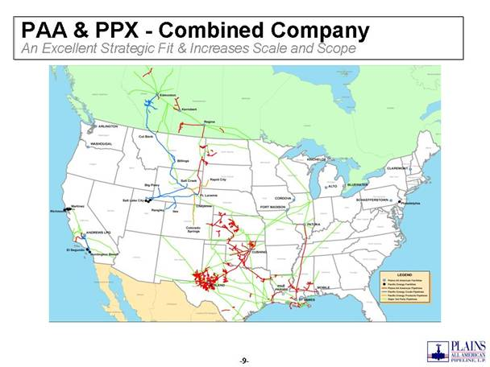
PAA & PPX - Combined Company An Excellent Strategic Fit & Increases Scale and Scope

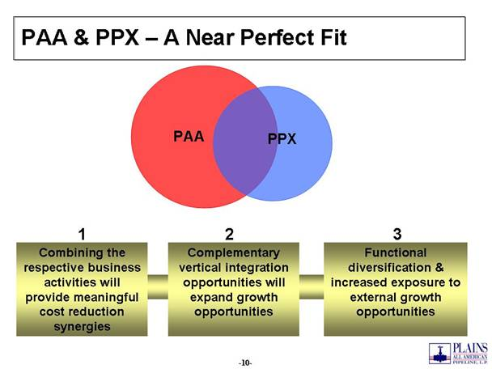
PAA & PPX  A Near Perfect Fit Combining the respective business activities will provide meaningful cost reduction synergies Complementary vertical integration opportunities will expand growth opportunities Functional diversification & increased exposure to external growth opportunities PAA PPX 1 2 3

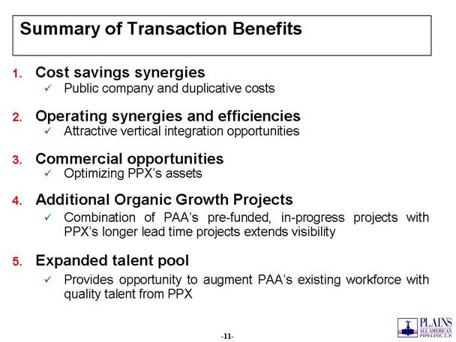
Summary of Transaction Benefits Cost savings synergies Public company and duplicative costs Operating synergies and efficiencies Attractive vertical integration opportunities Commercial opportunities Optimizing PPXs assets Additional Organic Growth Projects Combination of PAAs pre-funded, in-progress projects with PPXs longer lead time projects extends visibility Expanded talent pool Provides opportunity to augment PAAs existing workforce with quality talent from PPX

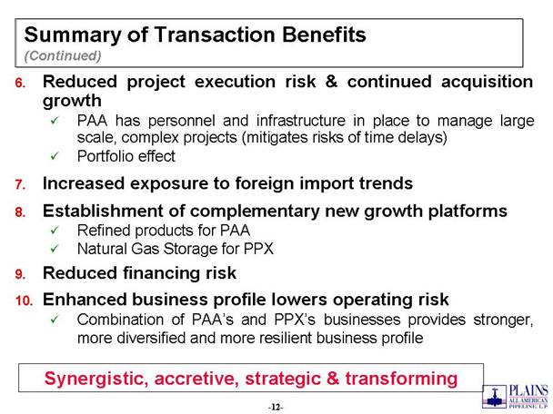
Summary of Transaction Benefits (Continued) Reduced project execution risk & continued acquisition growth PAA has personnel and infrastructure in place to manage large scale, complex projects (mitigates risks of time delays) Portfolio effect Increased exposure to foreign import trends Establishment of complementary new growth platforms Refined products for PAA Natural Gas Storage for PPX Reduced financing risk Enhanced business profile lowers operating risk Combination of PAAs and PPXs businesses provides stronger, more diversified and more resilient business profile Synergistic, accretive, strategic & transforming

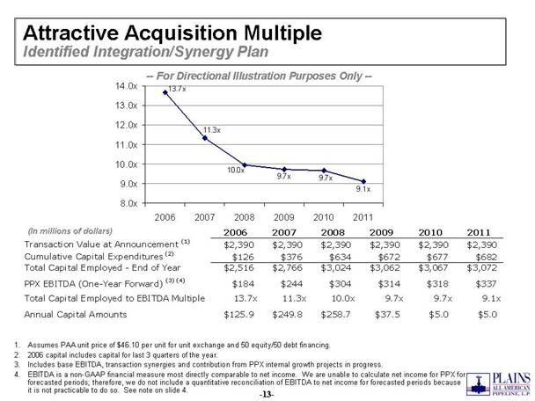
Attractive Acquisition Multiple Identified Integration/Synergy Plan Assumes PAA unit price of $46.10 per unit for unit exchange and 50 equity/50 debt financing. 2006 capital includes capital for last 3 quarters of the year. Includes base EBITDA, transaction synergies and contribution from PPX internal growth projects in progress. EBITDA is a non-GAAP financial measure most directly comparable to net income. We are unable to calculate net income for PPX for forecasted periods; therefore, we do not include a quantitative reconciliation of EBITDA to net income for forecasted periods because it is not practicable to do so. See note on slide 4. -- For Directional Illustration Purposes Only -- 9.1x 9.7x 9.7x 10.0x 11.3x 13.7x 8.0x 9.0x 10.0x 11.0x 12.0x 13.0x 14.0x (In millions of dollars) 2006 2007 2008 2009 2010 2011 2006 2007 2008 2009 2010 2011 Transaction Value at Announcement (1) $2,390 $2,390 $2,390 $2,390 $2,390 $2,390 Cumulative Capital Expenditures (2) $126 $376 $634 $672 $677 $682 Total Capital Employed - End of Year $2,516 $2,766 $3,024 $3,062 $3,067 $3,072 PPX EBITDA (One-Year Forward) (3) (4) $184 $244 $304 $314 $318 $337 Total Capital Employed to EBITDA Multiple 13.7x 11.3x 10.0x 9.7x 9.7x 9.1x Annual Capital Amounts $125.9 $249.8 $258.7 $37.5 $5.0 $5.0

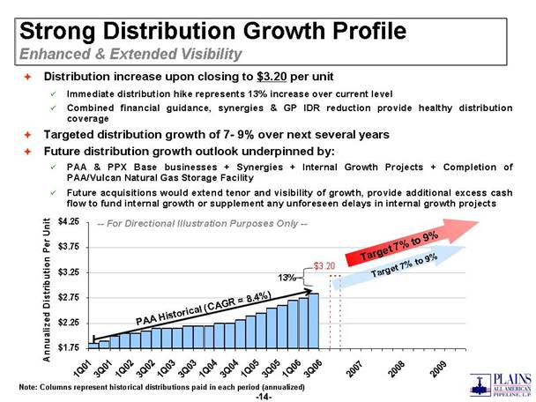
7% to 9% -- For Directional Illustration Purposes Only -- Strong Distribution Growth Profile Enhanced & Extended Visibility Distribution increase upon closing to $3.20 per unit Immediate distribution hike represents 13% increase over current level Combined financial guidance, synergies & GP IDR reduction provide healthy distribution coverage Targeted distribution growth of 7- 9% over next several years Future distribution growth outlook underpinned by: PAA & PPX Base businesses + Synergies + Internal Growth Projects + Completion of PAA/Vulcan Natural Gas Storage Facility Future acquisitions would extend tenor and visibility of growth, provide additional excess cash flow to fund internal growth or supplement any unforeseen delays in internal growth projects Note: Columns represent historical distributions paid in each period (annualized) 7% to 9% 13% PAA Historical (CAGR = 8.4%) $3.20 $1.75 $2.25 $2.75 $3.25 < /font>$3.75 $4.25 1Q01 3Q01 1Q02 3Q02 1Q03 3Q03 1Q04 3Q04 1Q05 3Q05 1Q06 3Q06 2007 2008 2009 Annualized Distribution Per Unit PAA Historical (CAGR = 8.4%) 13% $3.20 Target 7% to 9% Target 7% to 9%

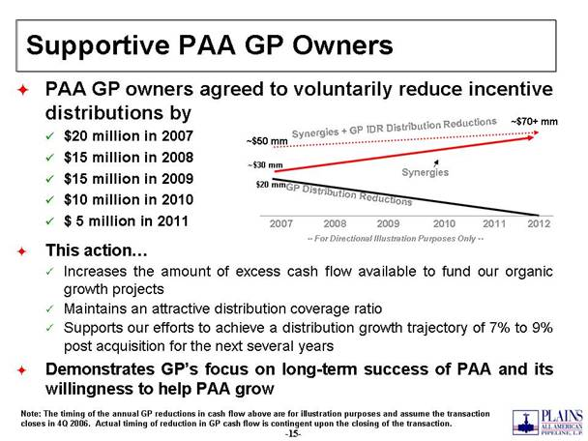
Supportive PAA GP Owners PAA GP owners agreed to voluntarily reduce incentive distributions by $20 million in 2007 $15 million in 2008 $15 million in 2009 $10 million in 2010 $ 5 million in 2011 This action Increases the amount of excess cash flow available to fund our organic growth projects Maintains an attractive distribution coverage ratio Supports our efforts to achieve a distribution growth trajectory of 7% to 9% post acquisition for the next several years Demonstrates GPs focus on long-term success of PAA and its willingness to help PAA grow Synergies -- For Directional Illustration Purposes Only -- Synergies + GP IDR Distribution Reductions 2007 2008 2009 2010 2011 2012 GP Distribution Reductions ~$50 mm ~$70+ mm $20 mm ~$30 mm Note: The timing of the annual GP reductions in cash flow above are for illustration purposes and assume the transaction closes in 4Q 2006. Actual timing of reduction in GP cash flow is contingent upon the closing of the transaction.

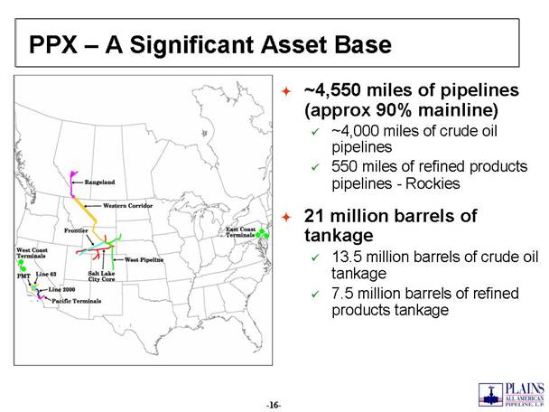
PPX  A Significant Asset Base ~4,550 miles of pipelines (approx 90% mainline) ~4,000 miles of crude oil pipelines 550 miles of refined products pipelines - Rockies 21 million barrels of tankage 13.5 million barrels of crude oil tankage 7.5 million barrels of refined products tankage

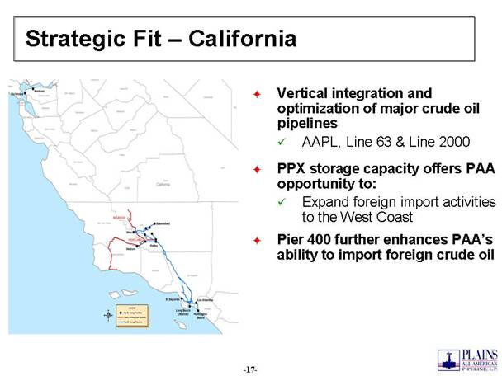
Strategic Fit  California Vertical integration and optimization of major crude oil pipelines AAPL, Line 63 & Line 2000 PPX storage capacity offers PAA opportunity to: Expand foreign import activities to the West Coast Pier 400 further enhances PAAs ability to import foreign crude oil

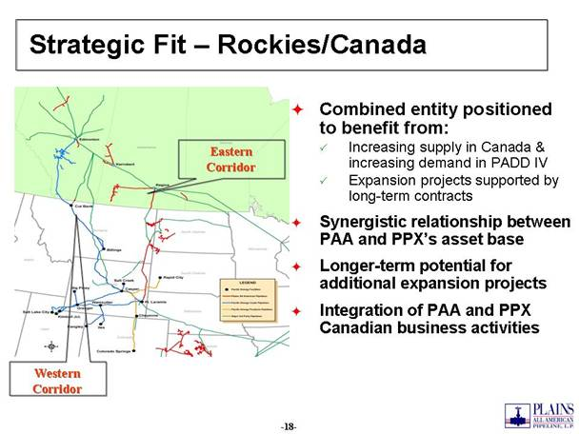
Strategic Fit  Rockies/Canada Combined entity positioned to benefit from: Increasing supply in Canada & increasing demand in PADD IV Expansion projects supported by long-term contracts Synergistic relationship between PAA and PPXs asset base Longer-term potential for additional expansion projects Integration of PAA and PPX Canadian business activities Western Corridor Eastern Corridor

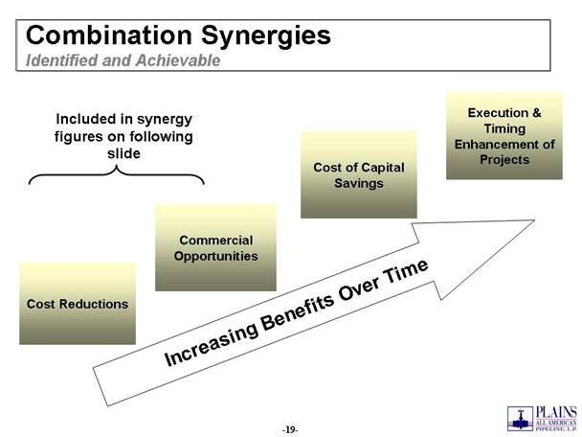
Combination Synergies Identified and Achievable Cost Reductions Commercial Opportunities Cost of Capital Savings Execution & Timing Enhancement of Projects Increasing Benefits Over Time Included in synergy figures on following slide

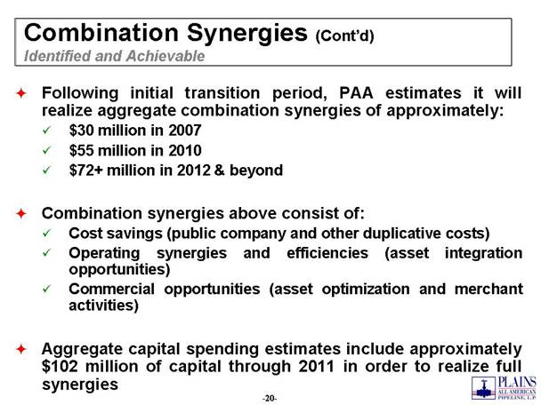
Combination Synergies (Contd) Identified and Achievable Following initial transition period, PAA estimates it will realize aggregate combination synergies of approximately: $30 million in 2007 $55 million in 2010 $72+ million in 2012 & beyond Combination synergies above consist of: Cost savings (public company and other duplicative costs) Operating synergies and efficiencies (asset integration opportunities) Commercial opportunities (asset optimization and merchant activities) Aggregate capital spending estimates include approximately $102 million of capital through 2011 in order to realize full synergies

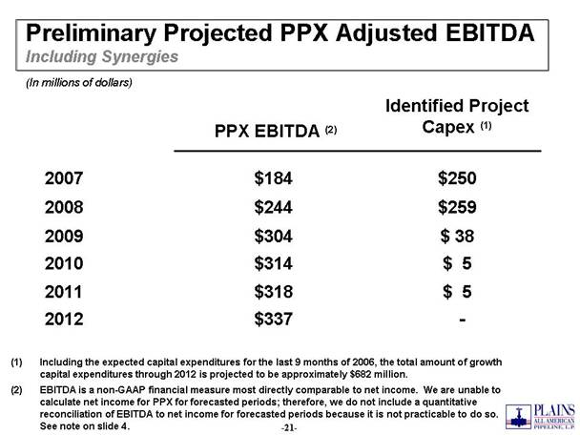
Preliminary Projected PPX Adjusted EBITDA Including Synergies $ 5 $314 2010 $ 5 $318 2011 - $337 2012 $ 38 $304 2009 $259 $244 2008 $250 $184 2007 Identified Project Capex (1) PPX EBITDA (2) (In millions of dollars) Including the expected capital expenditures for the last 9 months of 2006, the total amount of growth capital expenditures through 2012 is projected to be approximately $682 million. EBITDA is a non-GAAP financial measure most directly comparable to net income. We are unable to calculate net income for PPX for forecasted periods; therefore, we do not include a quantitative reconciliation of EBITDA to net income for forecasted periods because it is not practicable to do so. See note on slide 4.

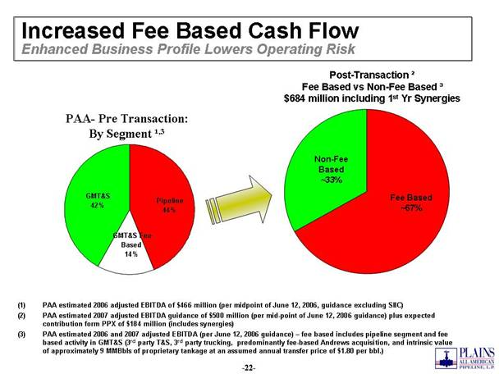
Increased Fee Based Cash Flow Enhanced Business Profile Lowers Operating Risk PAA- Pre Transaction: By Segment ¹,3 PAA estimated 2006 adjusted EBITDA of $466 million (per midpoint of June 12, 2006, guidance excluding SIIC) PAA estimated 2007 adjusted EBITDA guidance of $500 million (per mid-point of June 12, 2006 guidance) plus expected contribution form PPX of $184 million (includes synergies) PAA estimated 2006 and 2007 adjusted EBITDA (per June 12, 2006 guidance)  fee based includes pipeline segment and fee based activity in GMT&S (3rd party T&S, 3rd party trucking, predominantly fee-based Andrews acquisition, and intrinsic value of approximately 9 MMBbls of proprietary tankage at an assumed annual transfer price of $1.80 per bbl.) Post-Transaction ² Fee Based vs Non-Fee Based ³ $684 million including 1st Yr Synergies Pipeline 44% GMT&S 42% GMT&S Fee Based 14% Non-Fee Based ~33% Fee Based ~67%

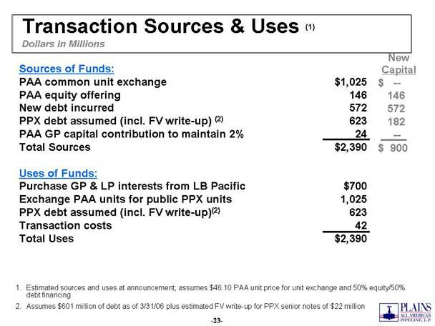
New Capital $ -- 146 572 182 -- $ 900 Transaction Sources & Uses (1) Dollars in Millions Sources of Funds: PAA common unit exchange $1,025 PAA equity offering 146 New debt incurred 572 PPX debt assumed (incl. FV write-up) (2) 623 PAA GP capital contribution to maintain 2% 24 Total Sources $2,390 Uses of Funds: Purchase GP & LP interests from LB Pacific $700 Exchange PAA units for public PPX units 1,025 PPX debt assumed (incl. FV write-up)(2) 623 Transaction costs 42 Total Uses $2,390 Estimated sources and uses at announcement; assumes $46.10 PAA unit price for unit exchange and 50% equity/50% debt financing Assumes $601 million of debt as of 3/31/06 plus estimated FV write-up for PPX senior notes of $22 million

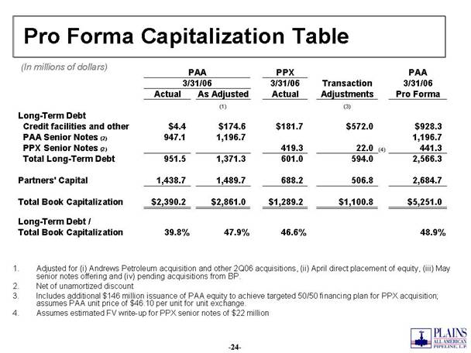
Pro Forma Capitalization Table (In millions of dollars) Adjusted for (i) Andrews Petroleum acquisition and other 2Q06 acquisitions, (ii) April direct placement of equity, (iii) May senior notes offering and (iv) pending acquisitions from BP. Net of unamortized discount Includes additional $146 million issuance of PAA equity to achieve targeted 50/50 financing plan for PPX acquisition; assumes PAA unit price of $46.10 per unit for unit exchange. Assumes estimated FV write-up for PPX senior notes of $22 million PPX PAA 3/31/06 Transaction 3/31/06 Actual As Adjusted Actual Adjustments Pro Forma (1) (3) L ong-Term Debt Credit facilities and other $4.4 $174.6 $181.7 $572.0 $928.3 PAA Senior Notes (2) 947.1 1,196.7 1,196.7 PPX Senior Notes (2) 419.3 22.0 (4) 441.3 Total Long-Term Debt 951.5 1,371.3 601.0 594.0 2,566.23 Partners' Capital 1,438.7 1,489.7 688.2 506.8 2,684.7 Total Book Capitalization $2,390.2 $2,861.0 $1,289.2 $1,100.8 $5,251.0 Long-Term Debt / Total Book Capitalization 39.8% 47.9% 46.6% 48.9% 3/31/06 PAA

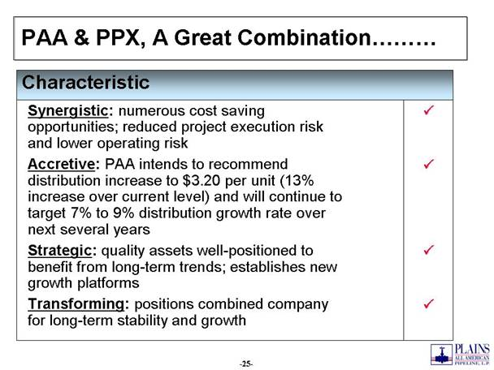
PAA & PPX, A Great Combination P Strategic: quality assets well-positioned to benefit from long-term trends; establishes new growth platforms P Transforming: positions combined company for long-term stability and growth P Accretive: PAA intends to recommend distribution increase to $3.20 per unit (13% increase over current level) and will continue to target 7% to 9% distribution growth rate over next several years P Synergistic: numerous cost saving opportunities; reduced project execution risk and lower operating risk Characteristic

Q&A

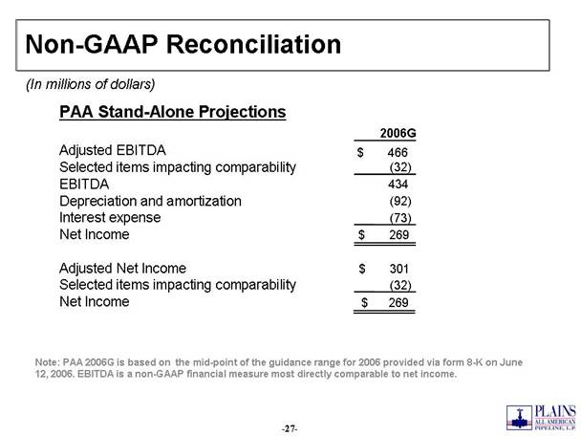
Non-GAAP Reconciliation Note: PAA 2006G is based on the mid-point of the guidance range for 2006 provided via form 8-K on June 12, 2006. EBITDA is a non-GAAP financial measure most directly comparable to net income. (In millions of dollars) PAA Stand-Alone Projections 2006G Adjusted EBITDA $ 466 Selected items impacting comparability (32) EBITDA 434 Depreciation and amortization (92) Interest expense (73) Net Income $ 269 Adjusted Net Income $ 301 Selected items impacting comparability (32) Net Income $ 269

