Filed by Plains All American Pipeline, L.P.
Filed by PAA Natural Gas Storage, L.P.
Pursuant to Rule 425 under the Securities Act of 1933
Subject Company: PAA Natural Gas Storage, L.P.
Commission File No.: 001-34722

Introductory Note: Plains All American Pipeline, L.P. (PAA) and PAA Natural Gas Storage, L.P. are filing these excerpts from the transcript of their earnings call for the quarter ended September 30, 2013 and the related presentation, each of which are posted on the partnerships websites.

This communication does not constitute an offer to sell any securities. Any such offer will be made only by means of a prospectus forming a part of an effective registration statement filed with the Securities and Exchange Commission.

In connection with the proposed merger, a registration statement of PAA, which will include a proxy statement and will constitute a prospectus of PAA, and other materials will be filed with the Securities and Exchange Commission. Investors and security holders are urged to carefully read the documents filed with the Securities and Exchange Commission regarding the proposed transaction when they become available, because they will contain important information about PAA, PNG and the proposed Merger. When available, investors and security holders may obtain a free copy of the proxy statement/prospectus and other documents containing information about PAA and PNG, without charge, at the Securities and Exchange Commissions website at www.sec.gov.

PAA, PNG and certain of their respective directors and executive officers may be deemed to be participants in the solicitation of proxies from the unitholders of PNG in connection with the proposed transaction. Information about the directors and executive officers of the general partner of PAA is set forth in PAAs Annual Report on Form 10-K for the year ended December 31, 2012, which was filed with the Securities and Exchange Commission on February 27, 2013. Information about the directors and executive officers of the general partner of PNG is set forth in PNGs Annual Report on Form 10-K for the year ended December 31, 2012, which was filed with the Securities and Exchange Commission on February 27, 2013. These documents can be obtained without charge at the Securities and Exchange Commissions website indicated above. Additional information regarding the interests of these participants may be obtained by reading the proxy statement/prospectus regarding the proposed transaction when it becomes available.

Plains All American Pipeline, L.P. | 2013 Third-Quarter Earnings Conference Call
PAA Natural Gas Storage, L.P. | Phone: 713-646-4100 or 800/564-3036
 | E-mail: info@paalp.com

Page 1 of 3






2013 Third-Quarter Results Conference Call
November 5, 2013

Investor Relations Introduction:

. . .

Todays presentation will include certain information regarding the proposed merger of PNG with PAA. This presentation does not constitute an offer to sell any securities, and investors should look to the registration statement and proxy statement relating to the proposed merger that will be filed with the Securities and Exchange Commission, and will be available at the Securities and Exchange Commissions website at www.sec.gov.

. . .

Greg Armstrong: Thanks, Roy.

. . .

With respect to PNG, as described on slide 8, last month PAA entered into a definitive agreement to acquire the outstanding publicly traded units of PNG. PAA plans to file a Form S-4 with the SEC in the coming days that will describe, among other things, the proposed transaction, the rationale for this transaction, the background and negotiations leading up to the execution of the definitive merger agreement and the factors considered by the independent committee of the PNG board. Subject to timing considerations associated with the SEC review process and soliciting the required unitholder vote, we are targeting to be in a position to complete this transaction by the end of the year, or shortly thereafter. In any event, we fully anticipate that the transaction will close prior to the early February time period when PNG would

Plains All American Pipeline, L.P. | 2013 Third-Quarter Earnings Conference Call
PAA Natural Gas Storage, L.P. | Phone: 713-646-4100 or 800/564-3036
 | E-mail: info@paalp.com

Page 2 of 3

normally establish a record date for a quarterly distribution with respect to the fourth quarter of 2013. In other words, we expect that PNGs public unitholders will have received PAA common units and will be eligible to receive a distribution on their PAA units held on the normal February record date. I would also note that as previously announced, PNG will be paying a quarterly distribution of $0.3575 per common unit on November 14th to holders of its common units as of the record date of November 1st. Given regulatory limitations and the level of information that is included in PNGs third-quarter earnings release as well as the information that is already available to the public, or will soon be available once the Form S-4 has been filed, we have suspended the issuance of any guidance regarding PNG. Additionally, we do not intend to provide any additional information or take any questions regarding PNGs performance or the proposed transaction on todays call. We appreciate your understanding and cooperation in this regard.

Plains All American Pipeline, L.P. | 2013 Third-Quarter Earnings Conference Call
PAA Natural Gas Storage, L.P. | Phone: 713-646-4100 or 800/564-3036
 | E-mail: info@paalp.com

Page 3 of 3

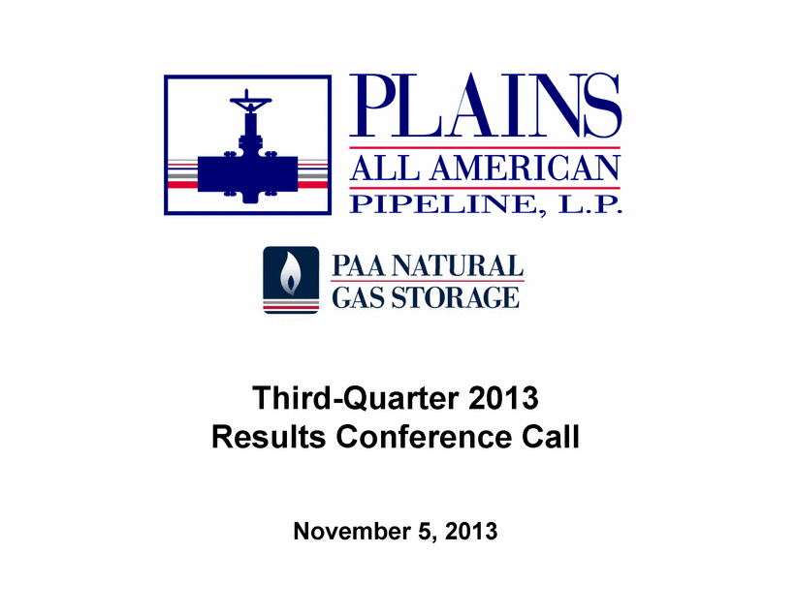 | Third-Quarter 2013 Results Conference Call -1- November 5, 2013

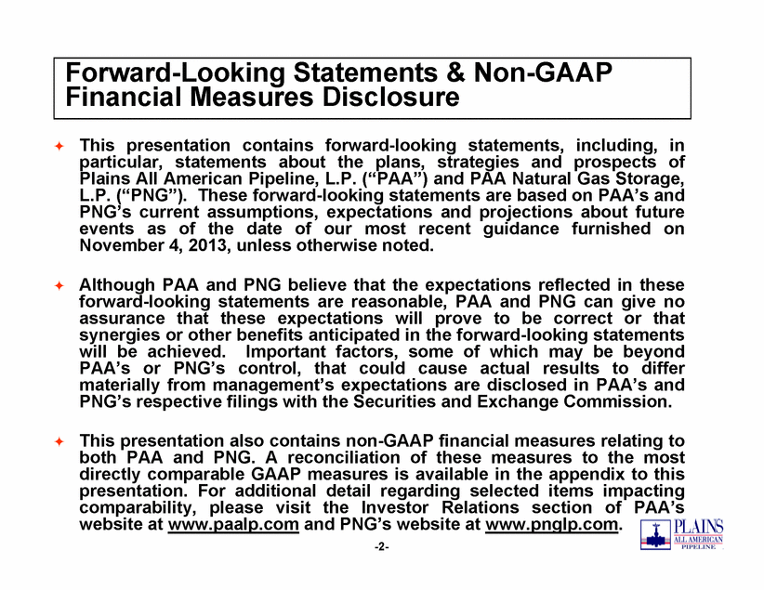 | Forward-Looking Statements & Non-GAAP Financial Measures Disclosure . This presentation contains forward-looking statements, including, in particular, statements about the plans, strategies and prospects of Plains All American Pipeline, L.P. (PAA) and PAA Natural Gas Storage, ( PAA ) L.P. (PNG). These forward-looking statements are based on PAAs and PNGs current assumptions, expectations and projections about future events as of the date of our most recent guidance furnished on November 4, 2013, unless otherwise noted. . Although PAA and PNG believe that the expectations reflected in these forward-looking statements are reasonable, PAA and PNG can give no assurance that these expectations will prove to be correct or that synergies or other benefits anticipated in the forward looking statements forward-will be achieved. Important factors, some of which may be beyond PAAs or PNGs control, that could cause actual results to differ materially from managements expectations are disclosed in PAAs and PNGs respective filings with the Securities and Exchange Commission. PNG s . This presentation also contains non-GAAP financial measures relating to both PAA and PNG. A reconciliation of these measures to the most directly comparable GAAP measures is available in the appendix to this -2- y p pp presentation. For additional detail regarding selected items impacting comparability, please visit the Investor Relations section of PAAs website at www.paalp.com and PNGs website at www.pnglp.com.

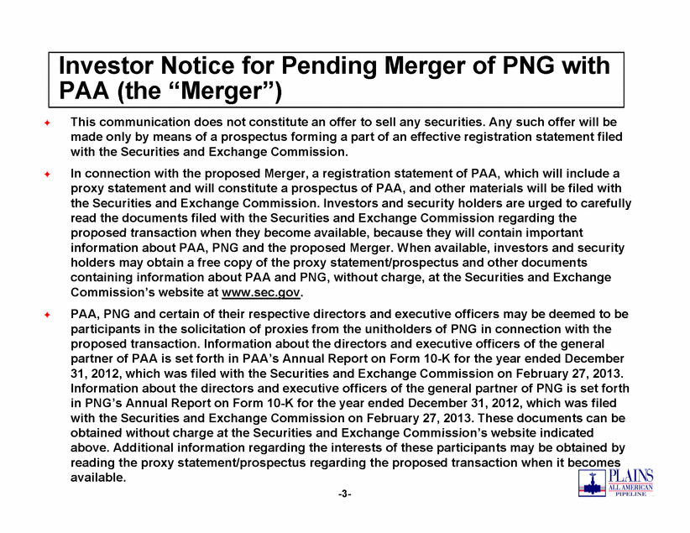 | Investor Notice for Pending Merger of PNG with PAA (Merger) the Merger ) . This communication does not constitute an offer to sell any securities. Any such offer will be made only by means of a prospectus forming a part of an effective registration statement filed with the Securities and Exchange Commission. . In connection with the proposed Merger, a registration statement of PAA, which will include a proxy statement and will constitute a prospectus of PAA, and other materials will be filed with the Securities and Exchange Commission. Investors and security holders are urged to carefully read the documents filed with the Securities and Exchange Commission regarding the proposed transaction when they become available because they will available, contain important information about PAA, PNG and the proposed Merger. When available, investors and security holders may obtain a free copy of the proxy statement/prospectus and other documents containing information about PAA and PNG, without charge, at the Securities and Exchange Commissions website at www.sec.gov. . PAA, PNG and certain of their respective directors and executive officers may be deemed to be participants in the solicitation of proxies from the unitholders of PNG in connection with the proposed transaction. Information about the directors and executive officers of the general partner of PAA is set forth in PAAs Annual Report on Form 10-K for the year ended December 31, 2012, which was filed with the Securities and Exchange Commission on February 27, 2013. Information about the directors and executive officers of the general partner of PNG is set forth in PNGs Annual Report on Form 10-K for the year ended December 31, 2012, which was filed with the Securities and Exchange Commission on February 27, 2013. These documents can be obtained without charge at the Securities Exchange Commissions -3- and Commission s website indicated above. Additional information regarding the interests of these participants may be obtained by reading the proxy statement/prospectus regarding the proposed transaction when it becomes available.

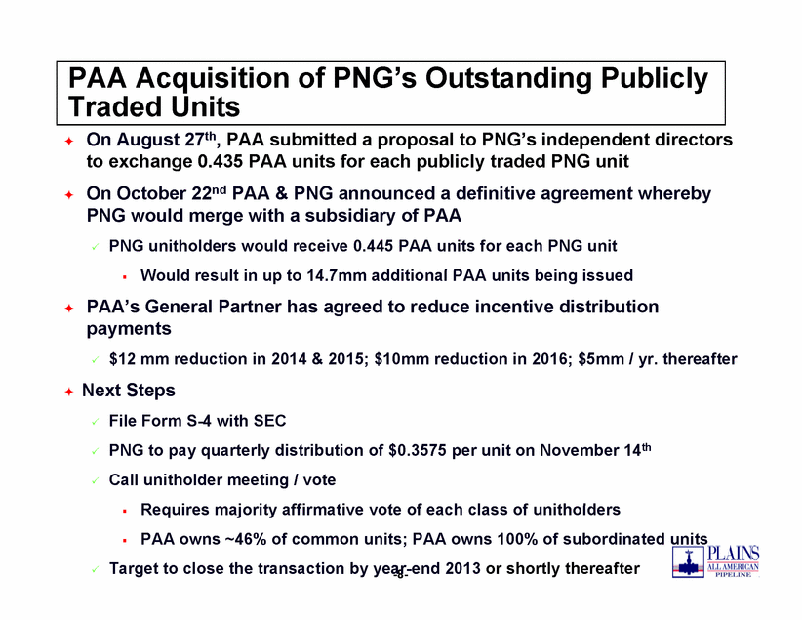 | PAA Acquisition of PNGs Outstanding Publicly Traded Units . On August 27th, PAA submitted a proposal to PNGs independent directors to exchange 0.435 PAA units for each publicly traded PNG unit . On 22nd a definitive agreement whereby October PAA & PNG announced PNG would merge with a subsidiary of PAA . PNG unitholders would receive 0.445 PAA units for each PNG unit W ld lt i t 14 7 dditi l PAA it b i i d . Would result in up to 14.7mm additional units being issued . PAAs General Partner has agreed to reduce incentive distribution payments . $12 mm reduction in 2014 & 2015; $10mm reduction in 2016; $5mm / yr. thereafter . Next Steps . File Form S-4 with SEC . PNG to pay quarterly distribution of $0.3575 per unit on November 14th . Call unitholder meeting / vote R i j it ffi ti t f h l f ith ld -8- . Requires majority affirmative vote of each class of unitholders . PAA owns ~46% of common units; PAA owns 100% of subordinated units . Target to close the transaction by year-end 2013 or shortly thereafter

