Filed by Plains All American Pipeline, L.P. (1-14569)
Pursuant to Rule 425 under the Securities Act of 1933

Subject Company: Pacific Energy Partners, L.P. (1-31345)
Commission File No: 333-135712

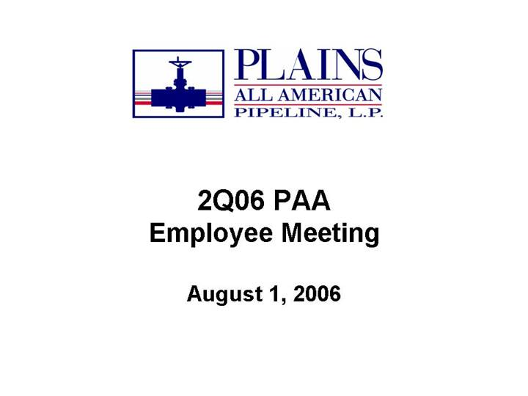
2Q06 PAA Employee Meeting August 1, 2006

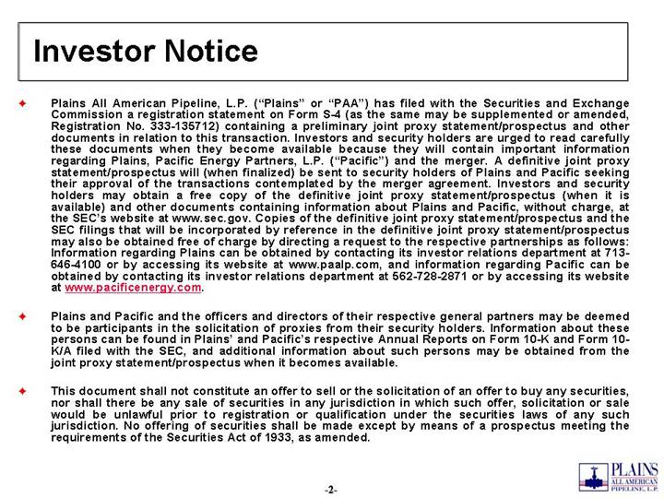
Investor Notice Plains All American Pipeline, L.P. (Plains or PAA) has filed with the Securities and Exchange Commission a registration statement on Form S-4 (as the same may be supplemented or amended, Registration No. 333-135712) containing a preliminary joint proxy statement/prospectus and other documents in relation to this transaction. Investors and security holders are urged to read carefully these documents when they become available because they will contain important information regarding Plains, Pacific Energy Partners, L.P. (Pacific) and the merger. A definitive joint proxy statement/prospectus will (when finalized) be sent to security holders of Plains and Pacific seeking their approval of the transactions contemplated by the merger agreement. Investors and security holders may obtain a free copy of the definitive joint proxy statement/prospectus (when it is available) and other documents containing information about Plains and Pacific, without charge, at the SECs website at www.sec.gov. Copies of the definitive joint proxy statement/prospectus and the SEC filings that will be incorporated by reference in the definitive joint proxy statement/prospectus may also be obtained free of charge by directing a request to the respective partnerships as follows: Information regarding Plains can be obtained by contacting its investor relations department at 713-646-4100 or by accessing its website at www.paalp.com, and information regarding Pacific can be obtained by contacting its investor relations department at 562-728-2871 or by accessing its website at www.pacificenergy.com. Plains and Pacific and the officers and directors of their respective general partners may be deemed to be participants in the solicitation of proxies from their security holders. Information about these persons can be found in Plains and Pacifics respective Annual Reports on Form 10-K and Form 10-K/A filed with the SEC, and additional information about such persons may be obtained from the joint proxy statement/prospectus when it becomes available. This document shall not constitute an offer to sell or the solicitation of an offer to buy any securities, nor shall there be any sale of securities in any jurisdiction in which such offer, solicitation or sale would be unlawful prior to registration or qualification under the securities laws of any such jurisdiction. No offering of securities shall be made except by means of a prospectus meeting the requirements of the Securities Act of 1933, as amended.

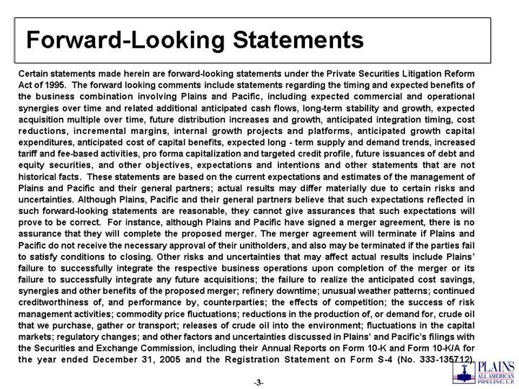
Forward-Looking Statements Certain statements made herein are forward-looking statements under the Private Securities Litigation Reform Act of 1995. The forward looking comments include statements regarding the timing and expected benefits of the business combination involving Plains and Pacific, including expected commercial and operational synergies over time and related additional anticipated cash flows, long-term stability and growth, expected acquisition multiple over time, future distribution increases and growth, anticipated integration timing, cost reductions, incremental margins, internal growth projects and platforms, anticipated growth capital expenditures, anticipated cost of capital benefits, expected long - term supply and demand trends, increased tariff and fee-based activities, pro forma capitalization and targeted credit profile, future issuances of debt and equity securities, and other objectives, expectations and intentions and other statements that are not historical facts. These statements are based on the current expectations and estimates of the management of Plains and Pacific and their general partners; actual results may differ materially due to certain risks and uncertainties. Although Plains, Pacific and their general partners believe that such expectations reflected in such forward-looking statements are reasonable, they cannot give assurances that such expectations will prove to be correct. For instance, although Plains and Pacific have signed a merger agreement, there is no assurance that they will complete the proposed merger. The merger agreement will terminate if Plains and Pacific do not receive the necessary approval of their unitholders, and also may be terminated if the parties fail to satisfy conditions to closing. Other risks and uncertainties that may affect actual results include Plains failure to successfully integrate the respective business operations upon completion of the merger or its failure to successfully integrate any future acquisitions; the failure to realize the anticipated cost savings, synergies and other benefits of the proposed merger; refinery downtime; unusual weather patterns; continued creditworthiness of, and performance by, counterparties; the effects of competition; the success of risk management activities; commodity price fluctuations; reductions in the production of, or demand for, crude oil that we purchase, gather or transport; releases of crude oil into the environment; fluctuations in the capital markets; regulatory changes; and other factors and uncertainties discussed in Plains and Pacifics filings with the Securities and Exchange Commission, including their Annual Reports on Form 10-K and Form 10-K/A for the year ended December 31, 2005 and the Registration Statement on Form S-4 (No. 333-135712).

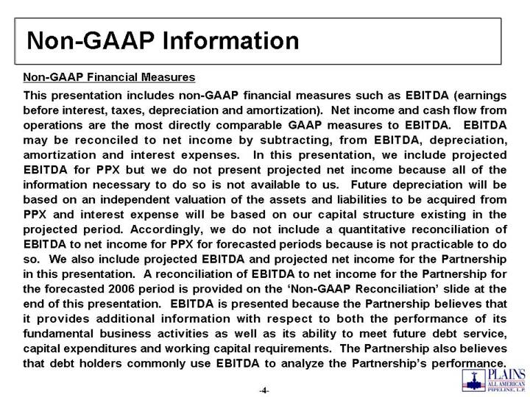
Non-GAAP Information Non-GAAP Financial Measures This presentation includes non-GAAP financial measures such as EBITDA (earnings before interest, taxes, depreciation and amortization). Net income and cash flow from operations are the most directly comparable GAAP measures to EBITDA. EBITDA may be reconciled to net income by subtracting, from EBITDA, depreciation, amortization and interest expenses. In this presentation, we include projected EBITDA for PPX but we do not present projected net income because all of the information necessary to do so is not available to us. Future depreciation will be based on an independent valuation of the assets and liabilities to be acquired from PPX and interest expense will be based on our capital structure existing in the projected period. Accordingly, we do not include a quantitative reconciliation of EBITDA to net income for PPX for forecasted periods because is not practicable to do so. We also include projected EBITDA and projected net income for the Partnership in this presentation. A reconciliation of EBITDA to net income for the Partnership for the forecasted 2006 period is provided on the Non-GAAP Reconciliation slide at the end of this presentation. EBITDA is presented because the Partnership believes that it provides additional information with respect to both the performance of its fundamental business activities as well as its ability to meet future debt service, capital expenditures and working capital requirements. The Partnership also believes that debt holders commonly use EBITDA to analyze the Partnerships performance.

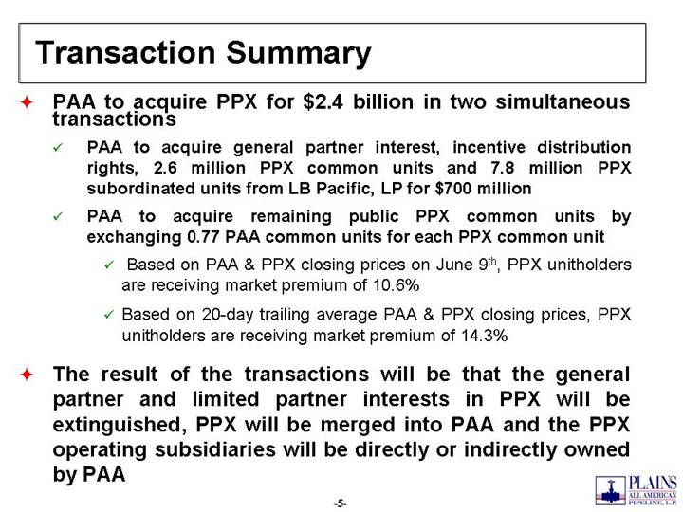
Transaction Summary PAA to acquire PPX for $2.4 billion in two simultaneous transactions PAA to acquire general partner interest, incentive distribution rights, 2.6 million PPX common units and 7.8 million PPX subordinated units from LB Pacific, LP for $700 million PAA to acquire remaining public PPX common units by exchanging 0.77 PAA common units for each PPX common unit Based on PAA & PPX closing prices on June 9th, PPX unitholders are receiving market premium of 10.6% Based on 20-day trailing average PAA & PPX closing prices, PPX unitholders are receiving market premium of 14.3% The result of the transactions will be that the general partner and limited partner interests in PPX will be extinguished, PPX will be merged into PAA and the PPX operating subsidiaries will be directly or indirectly owned by PAA
1

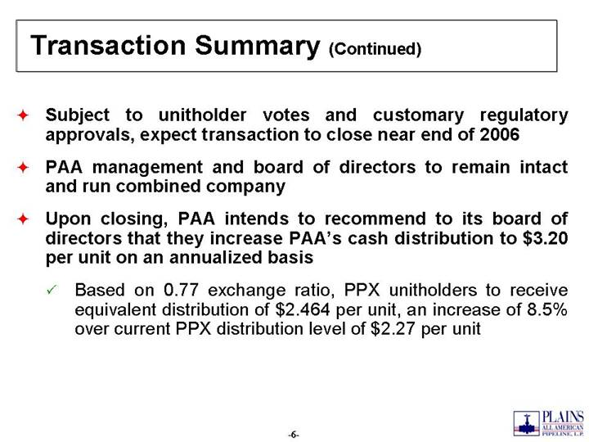
Transaction Summary (Continued) Subject to unitholder votes and customary regulatory approvals, expect transaction to close near end of 2006 PAA management and board of directors to remain intact and run combined company Upon closing, PAA intends to recommend to its board of directors that they increase PAAs cash distribution to $3.20 per unit on an annualized basis Based on 0.77 exchange ratio, PPX unitholders to receive equivalent distribution of $2.464 per unit, an increase of 8.5% over current PPX distribution level of $2.27 per unit

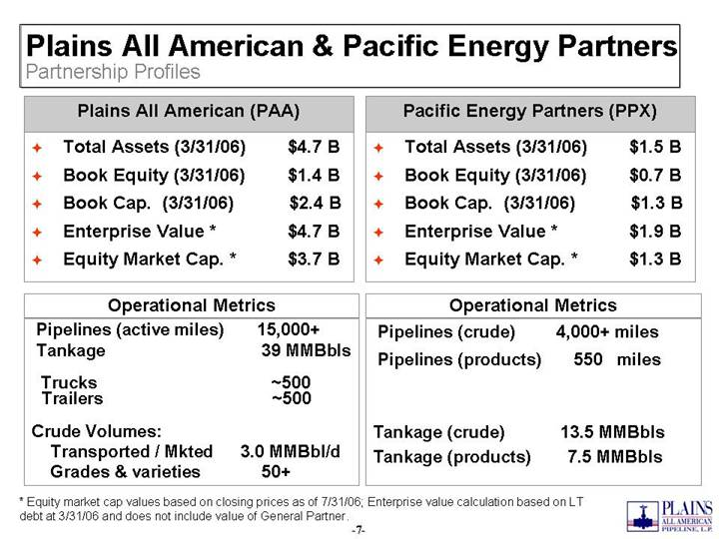
Plains All American & Pacific Energy Partners Partnership Profiles Total Assets (3/31/06) $4.7 B Book Equity (3/31/06) $1.4 B Book Cap. (3/31/06) $2.4 B Enterprise Value * $4.7 B Equity Market Cap. * $3.7 B Plains All American (PAA) Pipelines (active miles) 15,000+ Tankage 39 MMBbls Trucks ~500 Trailers ~500 Crude Volumes: Transported / Mkted 3.0 MMBbl/d Grades & varieties 50+ Operational Metrics Total Assets (3/31/06) $1.5 B Book Equity (3/31/06) $0.7 B Book Cap. (3/31/06) $1.3 B Enterprise Value * $1.9 B Equity Market Cap. * $1.3 B Pacific Energy Partners (PPX) Pipelines (crude) 4,000+ miles Pipelines (products) 550 miles Tankage (crude) 13.5 MMBbls Tankage (products) 7.5 MMBbls Operational Metrics * Equity market cap values based on closing prices as of 7/31/06; Enterprise value calculation based on LT debt at 3/31/06 and does not include value of General Partner.

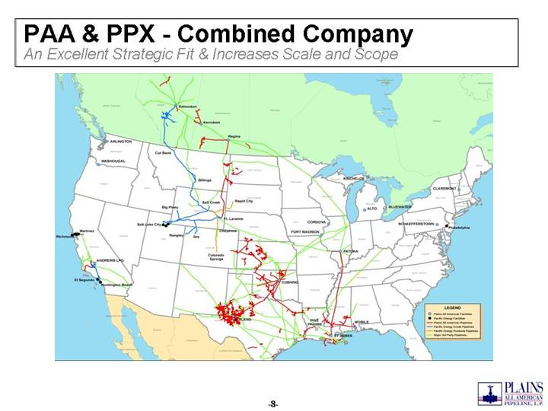
PAA & PPX - Combined Company An Excellent Strategic Fit & Increases Scale and Scope

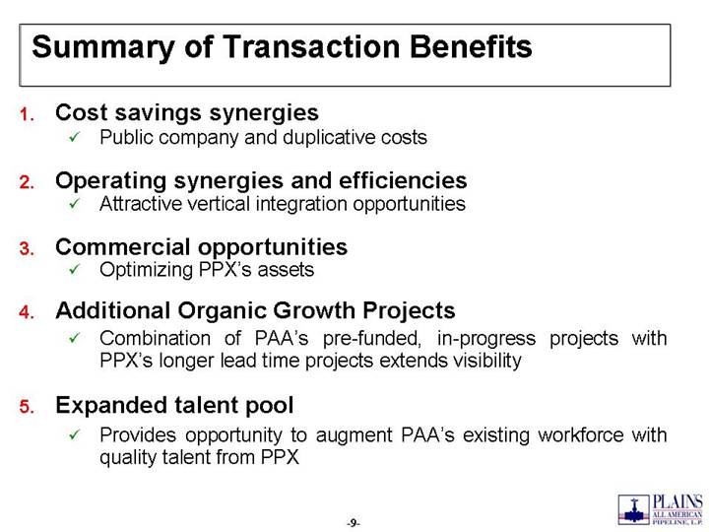
Summary of Transaction Benefits 1. Cost savings synergies Public company and duplicative costs 2. Operating synergies and efficiencies Attractive vertical integration opportunities 3. Commercial opportunities Optimizing PPXs assets 4. Additional Organic Growth Projects Combination of PAAs pre-funded, in-progress projects with PPXs longer lead time projects extends visibility 5. Expanded talent pool Provides opportunity to augment PAAs existing workforce with quality talent from PPX

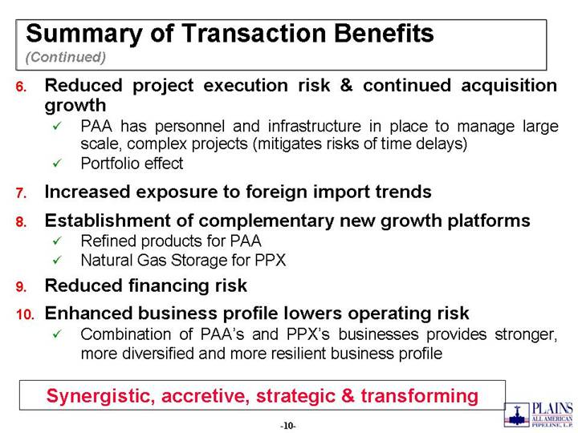
Summary of Transaction Benefits (Continued) 6. Reduced project execution risk & continued acquisition growth PAA has personnel and infrastructure in place to manage large scale, complex projects (mitigates risks of time delays) Portfolio effect 7. Increased exposure to foreign import trends 8. Establishment of complementary new growth platforms Refined products for PAA Natural Gas Storage for PPX 9. Reduced financing risk 10. Enhanced business profile lowers operating risk Combination of PAAs and PPXs businesses provides stronger, more diversified and more resilient business profile Synergistic, accretive, strategic & transforming

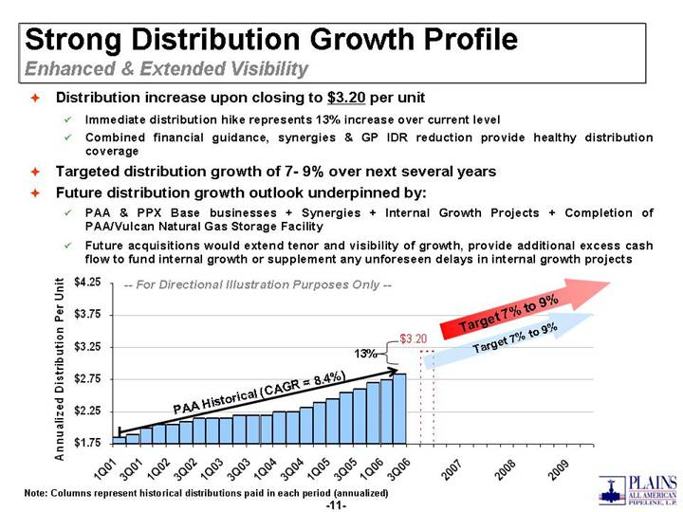
Target 7% to 9% -- For Directional Illustration Purposes Only -- Strong Distribution Growth Profile Enhanced & Extended Visibility Distribution increase upon closing to $3.20 per unit Immediate distribution hike represents 13% increase over current level Combined financial guidance, synergies & GP IDR reduction provide healthy distribution coverage Targeted distribution growth of 7 - 9% over next several years Future distribution growth outlook underpinned by: PAA & PPX Base businesses + Synergies + Internal Growth Projects + Completion of PAA/Vulcan Natural Gas Storage Facility Future acquisitions would extend tenor and visibility of growth, provide additional excess cash flow to fund internal growth or supplement any unforeseen delays in internal growth projects Note: Columns represent historical distributions paid in each period (annualized) Target 7% to 9% 13% PAA Historical (CAGR = 8.4%) -14- $3.20 $1.75 $2.25 $2.75 $3.25 $3.75 $4.25 1Q01 3Q01 1Q02 3Q02 1Q03 3Q03 1Q04 3Q04 1Q05 3Q05 1Q06 3Q06 2007 2008 2009 Annualized Distribution Per Unit

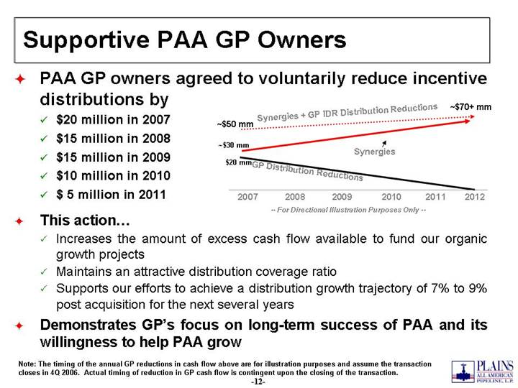
Supportive PAA GP Owners PAA GP owners agreed to voluntarily reduce incentive distributions by $20 million in 2007 $15 million in 2008 $15 million in 2009 $10 million in 2010 $ 5 million in 2011 This action Increases the amount of excess cash flow available to fund our organic growth projects Maintains an attractive distribution coverage ratio Supports our efforts to achieve a distribution growth trajectory of 7% to 9% post acquisition for the next several years Demonstrates GPs focus on long-term success of PAA and its willingness to help PAA grow Synergies -- For Directional Illustration Purposes Only -- Synergies + GP IDR Distribution Reductions 2007 2008 2009 2010 2011 2012 GP Distribution Reductions ~$50 mm ~$70+ mm $20 mm ~$30 mm Note: The timing of the annual GP reductions in cash flow above are for illustration purposes and assume the transaction closes in 4Q 2006. Actual timing of reduction in GP cash flow is contingent upon the closing of the transaction.

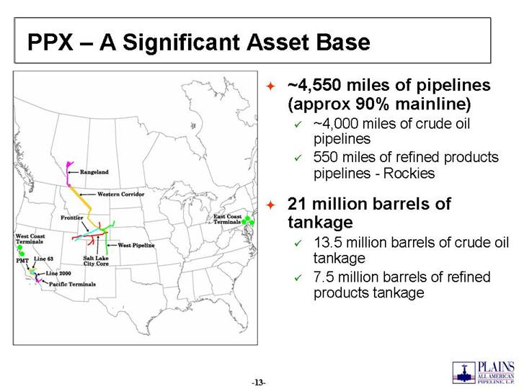
PPX  A Significant Asset Base ~4,550 miles of pipelines (approx 90% mainline) ~4,000 miles of crude oil pipelines 550 miles of refined products pipelines - Rockies 21 million barrels of tankage 13.5 million barrels of crude oil tankage 7.5 million barrels of refined products tankage

Strategic Fit  California Vertical integration and optimization of major crude oil pipelines AAPL, Line 63 & Line 2000 PPX storage capacity offers PAA opportunity to: Expand foreign import activities to the West Coast Pier 400 further enhances PAAs ability to import foreign crude oil

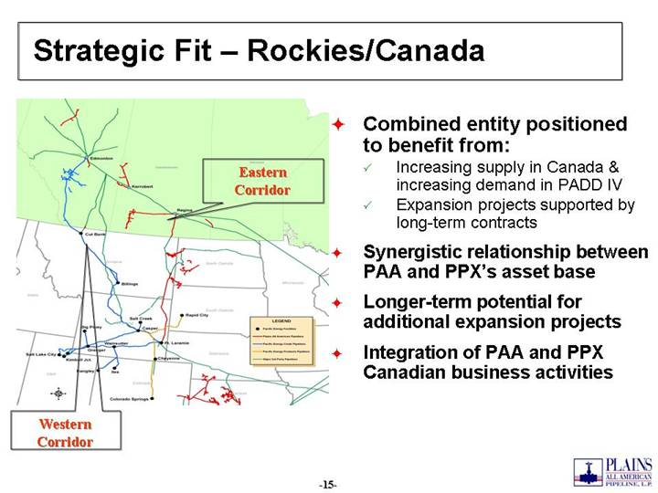
Strategic Fit  Rockies/Canada Combined entity positioned to benefit from: Increasing supply in Canada & increasing demand in PADD IV Expansion projects supported by long-term contracts Synergistic relationship between PAA and PPXs asset base Longer-term potential for additional expansion projects Integration of PAA and PPX Canadian business activities Western Corridor Eastern Corridor

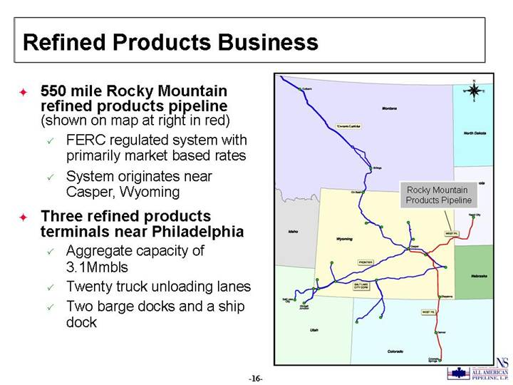
Refined Products Business 550 mile Rocky Mountain refined products pipeline (shown on map at right in red) FERC regulated system with primarily market based rates System originates near Casper, Wyoming Three refined products terminals near Philadelphia Aggregate capacity of 3.1Mmbls Twenty truck unloading lanes Two barge docks and a ship dock Western Corridor Rocky Mountain Products Pipeline

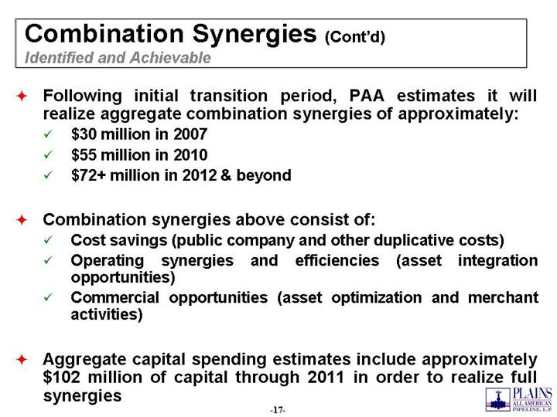
Combination Synergies (Contd) Identified and Achievable Following initial transition period, PAA estimates it will realize aggregate combination synergies of approximately: $30 million in 2007 $55 million in 2010 $72+ million in 2012 & beyond Combination synergies above consist of: Cost savings (public company and other duplicative costs) Operating synergies and efficiencies (asset integration opportunities) Commercial opportunities (asset optimization and merchant activities) Aggregate capital spending estimates include approximately $102 million of capital through 2011 in order to realize full synergies

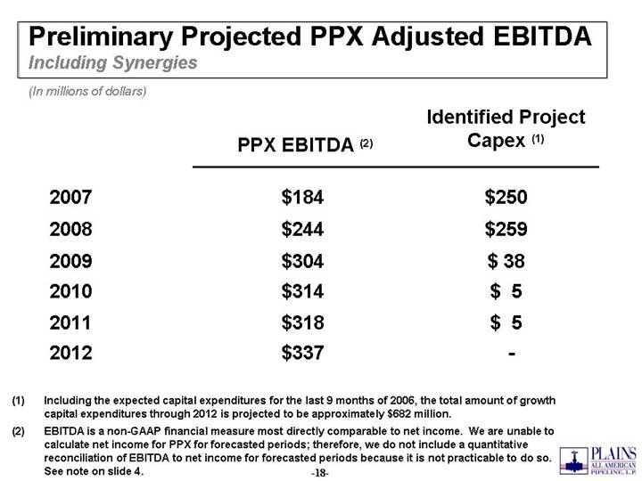
Preliminary Projected PPX Adjusted EBITDA Including Synergies $ 5 $314 2010 $ 5 $318 2011 - $337 2012 $ 38 $304 2009 $259 $244 2008 $250 $184 2007 Identified Project Capex (1) PPX EBITDA (2) (In millions of dollars) (1) Including the expected capital expenditures for the last 9 months of 2006, the total amount of growth capital expenditures through 2012 is projected to be approximately $682 million. (2) EBITDA is a non-GAAP financial measure most directly comparable to net income. We are unable to calculate net income for PPX for forecasted periods; therefore, we do not include a quantitative reconciliation of EBITDA to net income for forecasted periods because it is not practicable to do so. See note on slide 4.

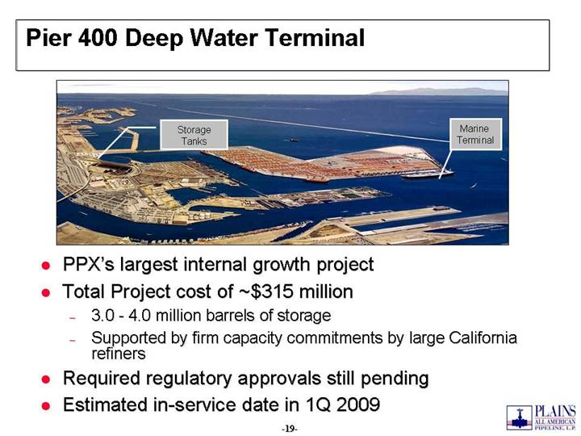
Pier 400 Deep Water Terminal PPXs largest internal growth project Total Project cost of ~$315 million 3.0 - 4.0 million barrels of storage Supported by firm capacity commitments by large California refiners Required regulatory approvals still pending Estimated in-service date in 1Q 2009 Storage Tanks Marine Terminal

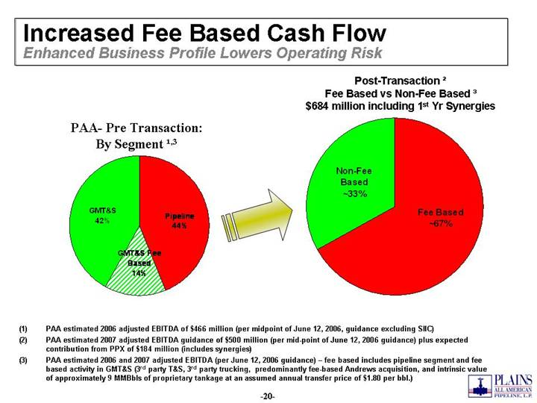
Increased Fee Based Cash Flow Enhanced Business Profile Lowers Operating Risk PAA- Pre Transaction: By Segment 1,3 (1) PAA estimated 2006 adjusted EBITDA of $466 million (per midpoint of June 12, 2006, guidance excluding SIIC) (2) PAA estimated 2007 adjusted EBITDA guidance of $500 million (per mid-point of June 12, 2006 guidance) plus expected contribution from PPX of $184 million (includes synergies) (3) PAA estimated 2006 and 2007 adjusted EBITDA (per June 12, 2006 guidance)  fee based includes pipeline segment and fee based activity in GMT&S (3rd party T&S, 3rd party trucking, predominantly fee-based Andrews acquisition, and intrinsic value of approximately 9 MMBbls of proprietary tankage at an assumed annual transfer price of $1.80 per bbl.) Post-Transaction 2 Fee Based vs Non-Fee Based 3 $684 million including 1st Yr Synergies Pipeline 44% GMT&S 42% GMT&S Fee Based 14% Non-Fee Based ~33% Fee Based ~67%

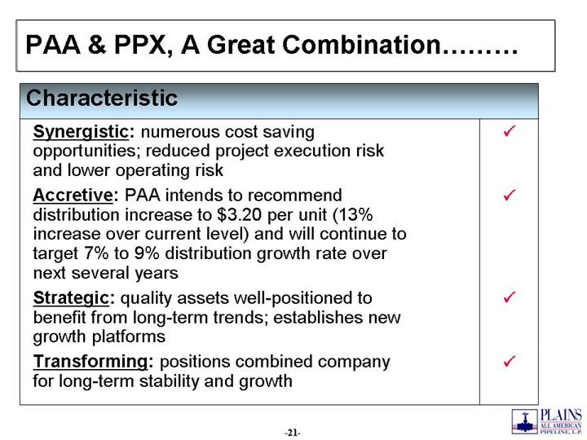
PAA & PPX, A Great Combination Strategic: quality assets well-positioned to benefit from long-term trends; establishes new growth platforms Transforming: positions combined company for long-term stability and growth Accretive: PAA intends to recommend distribution increase to $3.20 per unit (13% increase over current level) and will continue to target 7% to 9% distribution growth rate over next several years Synergistic: numerous cost saving opportunities; reduced project execution risk and lower operating risk Characteristic

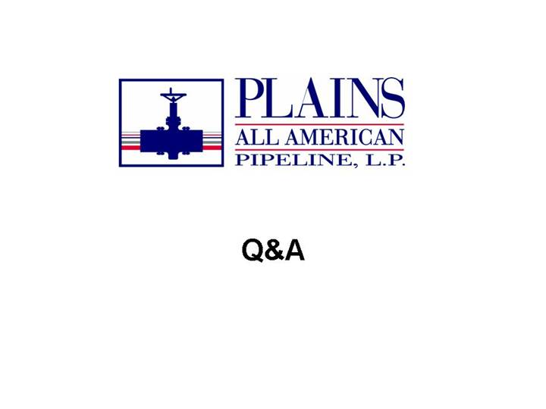
Q&A

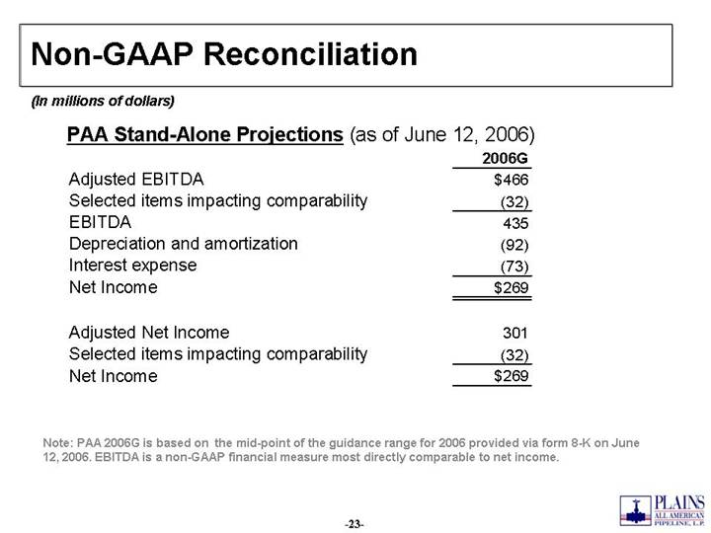
Non-GAAP Reconciliation Note: PAA 2006G is based on the mid-point of the guidance range for 2006 provided via form 8-K on June 12, 2006. EBITDA is a non-GAAP financial measure most directly comparable to net income. PAA Stand-Alone Projections (as of June 12, 2006) (In millions of dollars) 2006G Adjusted EBITDA $466 Selected items impacting comparability (32) EBITDA 435 Depreciation and amortization (92) Interest expense (73) Net Income $269 Adjusted Net Income 301 Selected items impacting comparability (32) Net Income $269

