UNITED STATES

SECURITIES AND EXCHANGE COMMISSION

Washington, D.C. 20549

SCHEDULE 14A

Proxy Statement Pursuant to Section 14(a) of

the Securities Exchange Act of 1934 (Amendment No. )

Filed by the Registrant x

Filed by a Party other than the Registrant o

Check the appropriate box:

- Preliminary Proxy Statement

- Confidential, for Use of the Commission Only (as permitted by Rule 14a-6(e)(2))

- Definitive Proxy Statement

- Definitive Additional Materials

- Soliciting Material under §240.14a-12

PLAINS GP HOLDINGS, L.P.

(Name of Registrant as Specified In Its Charter)

(Name of Person(s) Filing Proxy Statement, if other than the Registrant)

Payment of Filing Fee (Check the appropriate box):

- No fee required.

- Fee computed on table below per Exchange Act Rules 14a-6(i)(1) and 0-11.

  - Title of each class of securities to which transaction applies:

  - Aggregate number of securities to which transaction applies:

  - Per unit price or other underlying value of transaction computed pursuant to Exchange Act Rule 0-11 (set forth the amount on which the filing fee is calculated and state how it was determined):

  - Proposed maximum aggregate value of transaction:

  - Total fee paid:

- Fee paid previously with preliminary materials.

- Check box if any part of the fee is offset as provided by Exchange Act Rule 0-11(a)(2) and identify the filing for which the offsetting fee was paid previously. Identify the previous filing by registration statement number, or the Form or Schedule and the date of its filing.
  - Amount Previously Paid:

  - Form, Schedule or Registration Statement No.:

  - Filing Party:

  - Date Filed:

On July 11, 2016, Plains GP Holdings, L.P. (“PAGP”) and Plains All American Pipeline, L.P. (“PAA”) announced that they had entered into a definitive agreement with PAA GP Holdings LLC, Plains All American GP LLC, Plains AAP, L.P. (“AAP”), and PAA GP LLC (“PAA GP”), pursuant to which, among other things, PAA will issue common units representing limited partner interests in PAA to AAP and will assume the outstanding debt under AAP’s credit facility in exchange for (i) AAP’s direct interest in the incentive distribution rights of PAA; and (ii) AAP’s indirect interest in the economic rights associated with PAA GP’s interest in PAA (the “Simplification Transaction”). On July 12, 2016, PAGP and PAA held a webcast conference call (the “Conference Call”). Set forth below are (a) the written transcript of the Conference Call and (b) slides presented at the Conference Call.

######

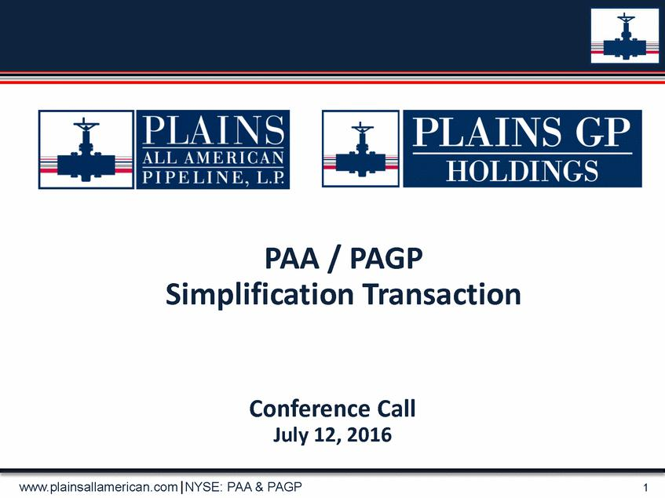

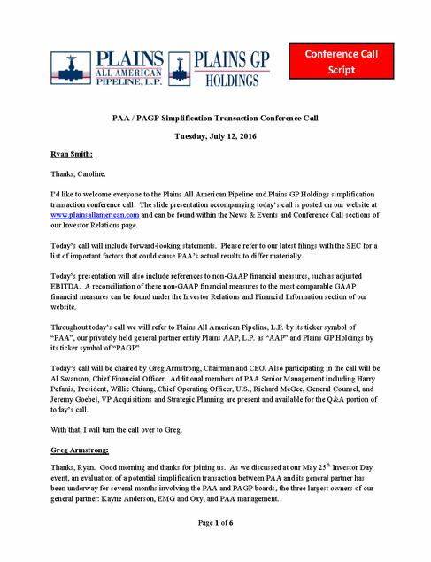

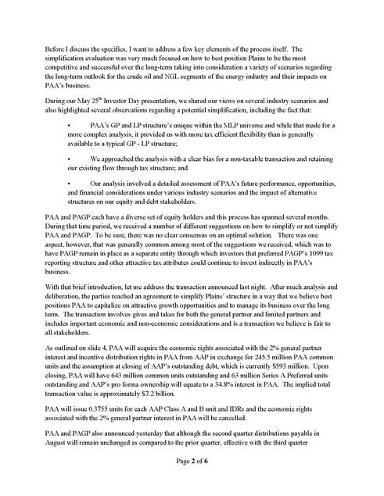

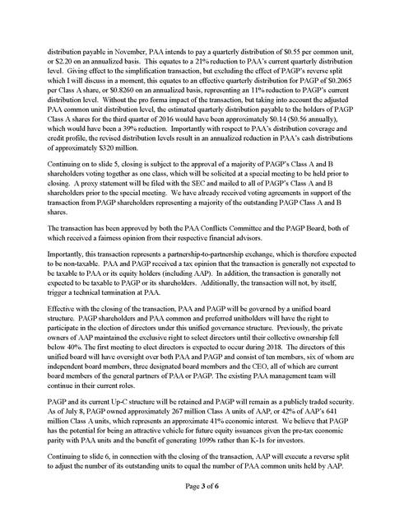

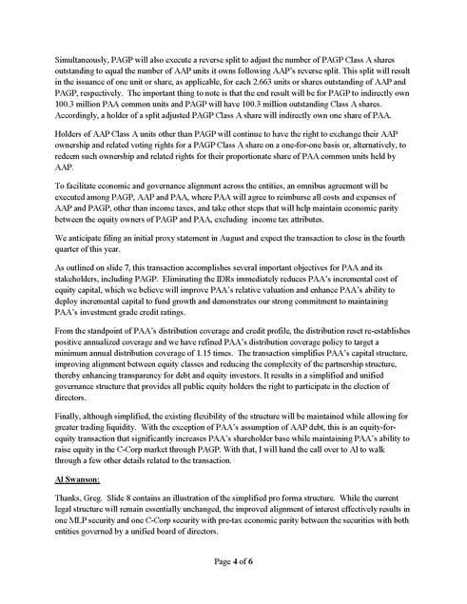

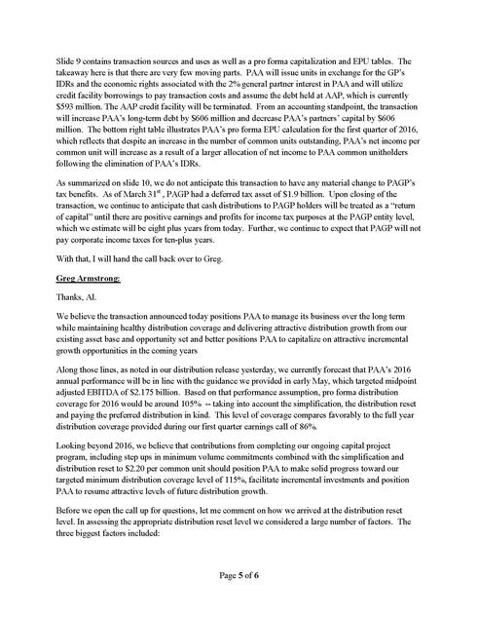

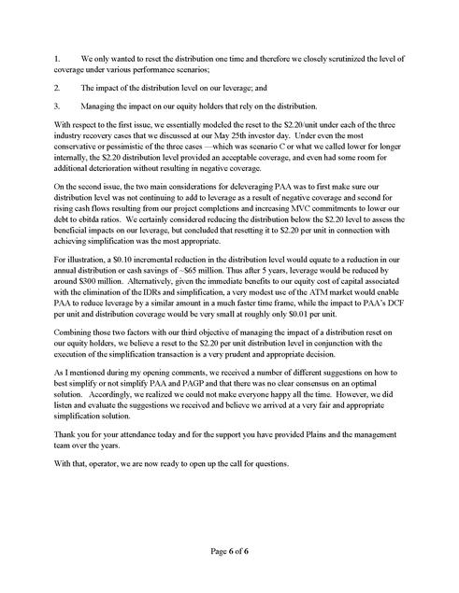

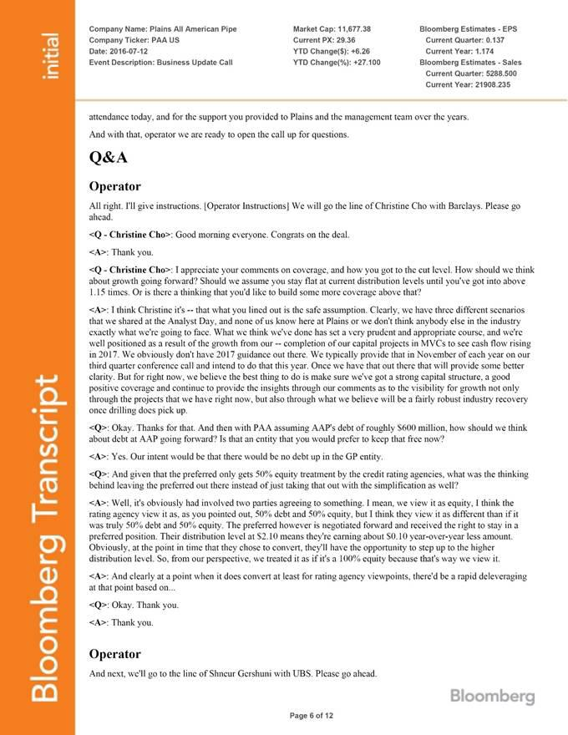

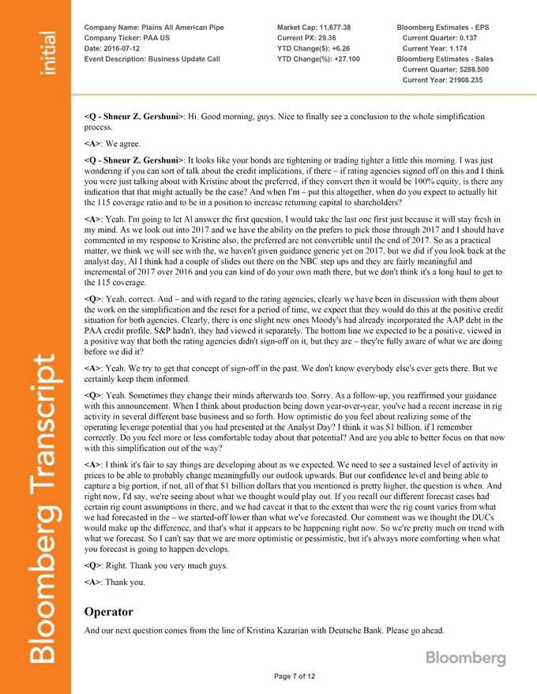

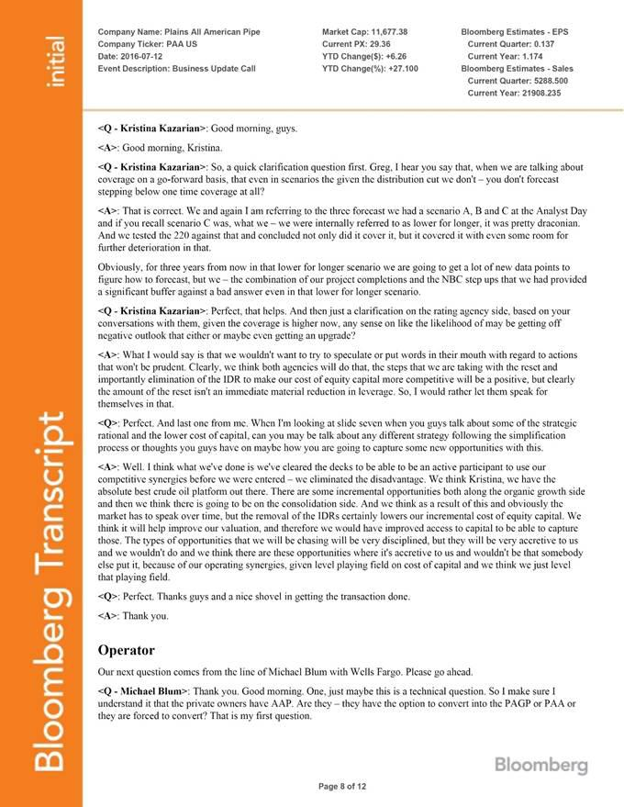

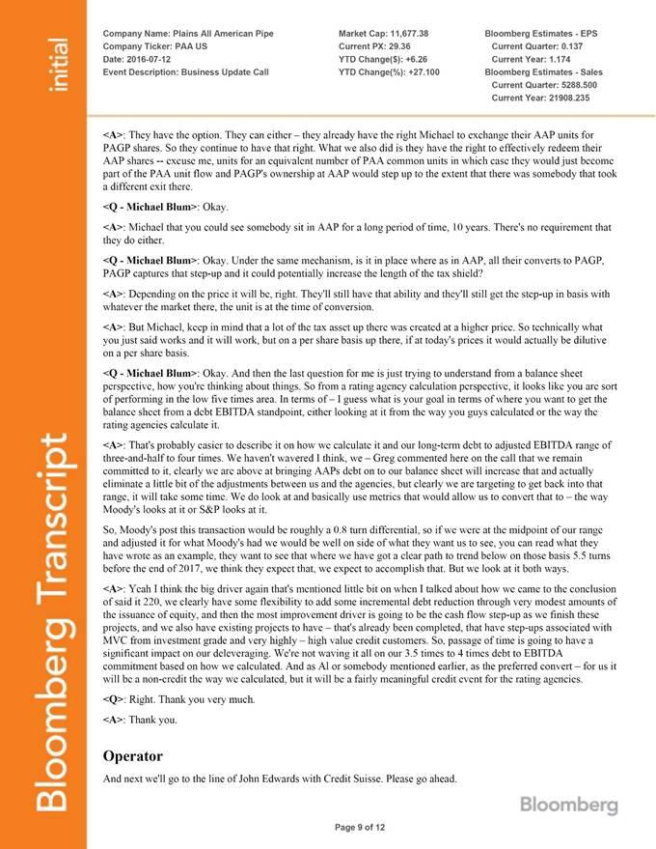

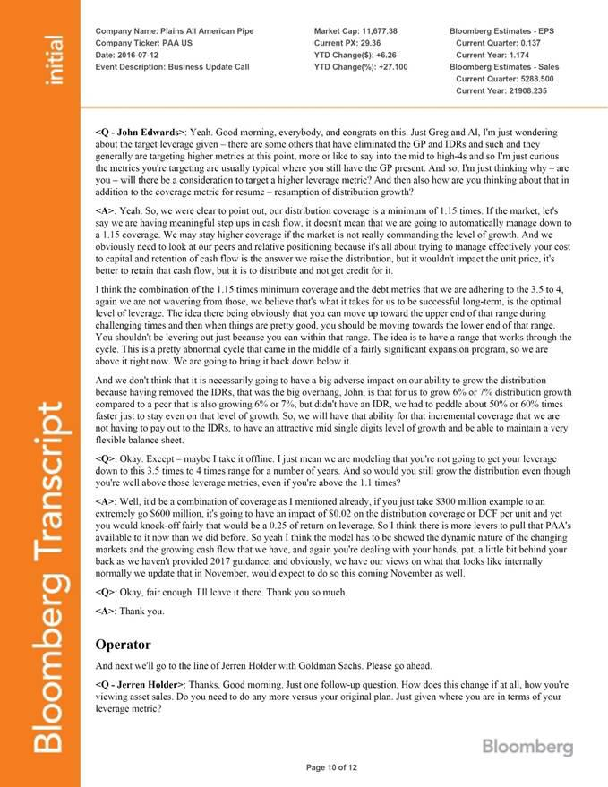

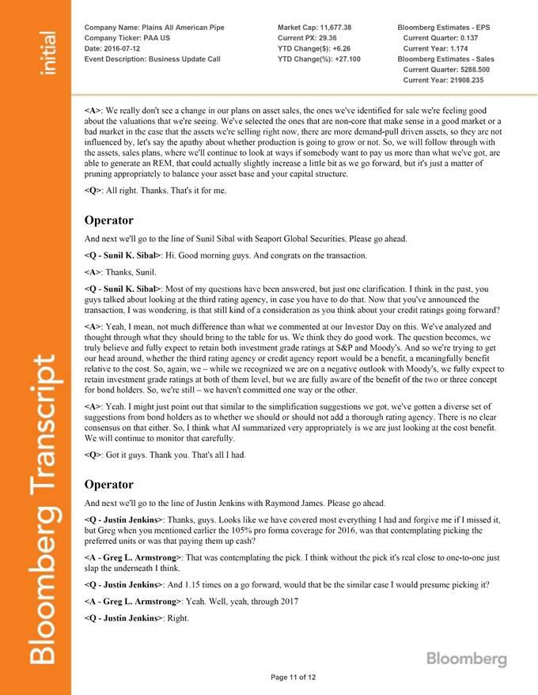

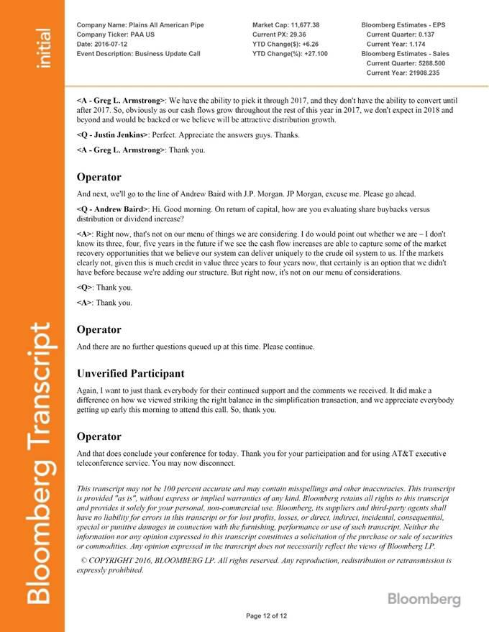

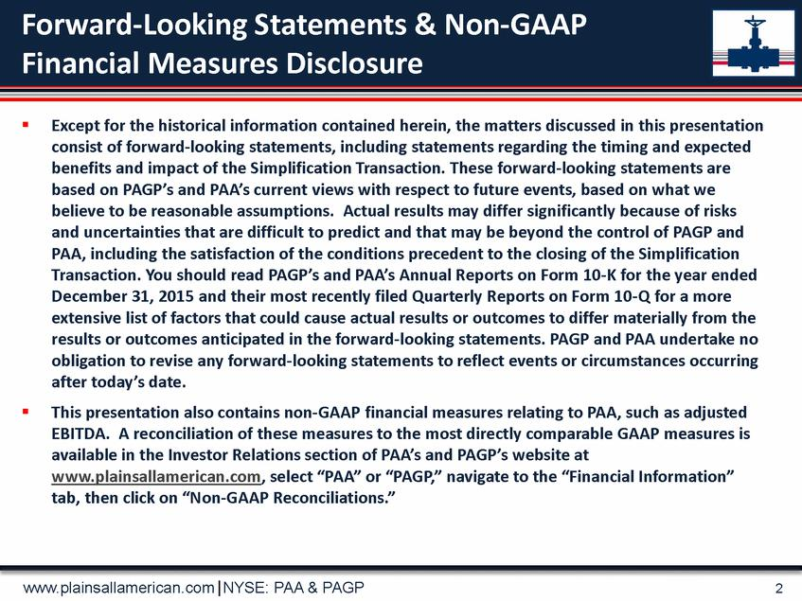

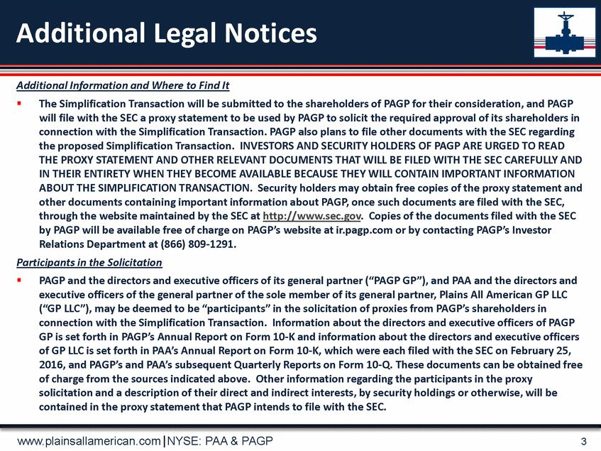

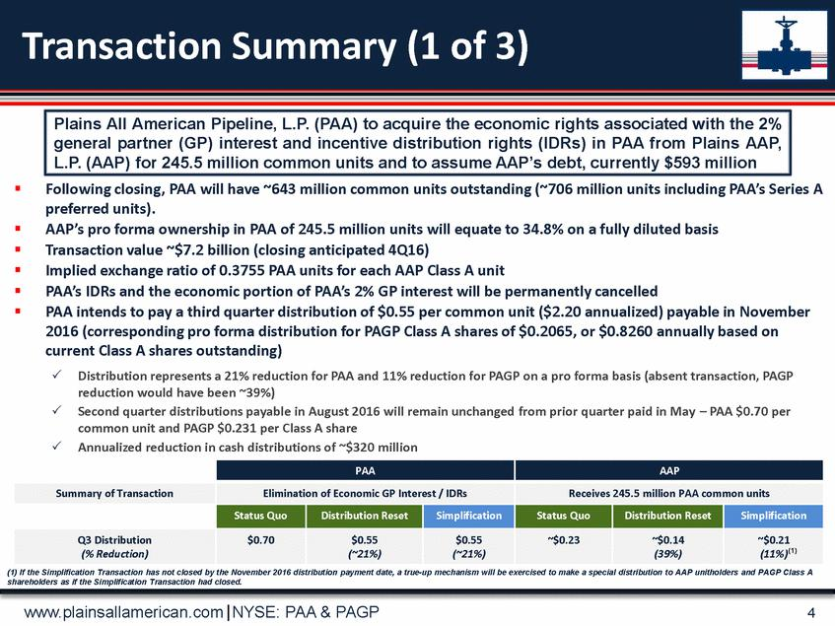

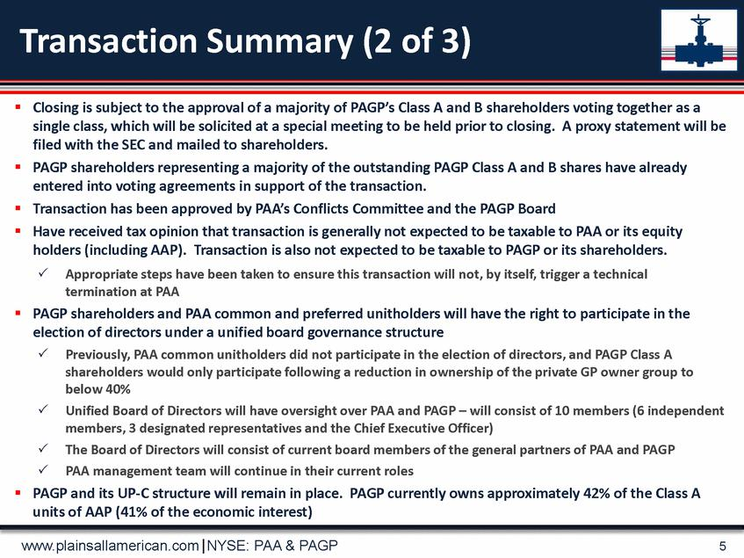

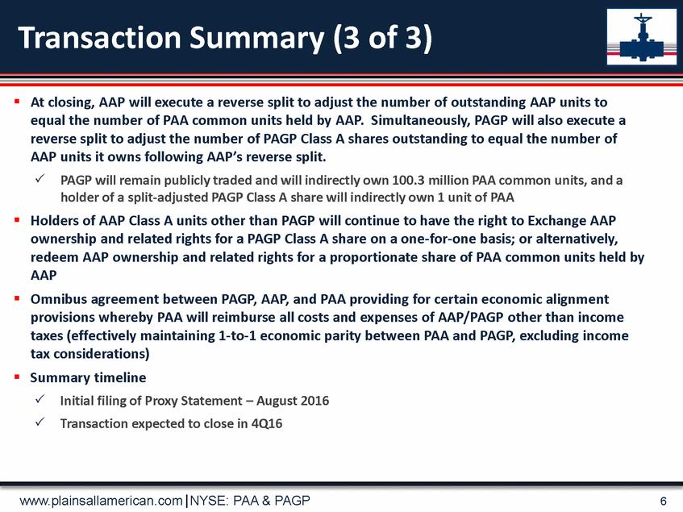

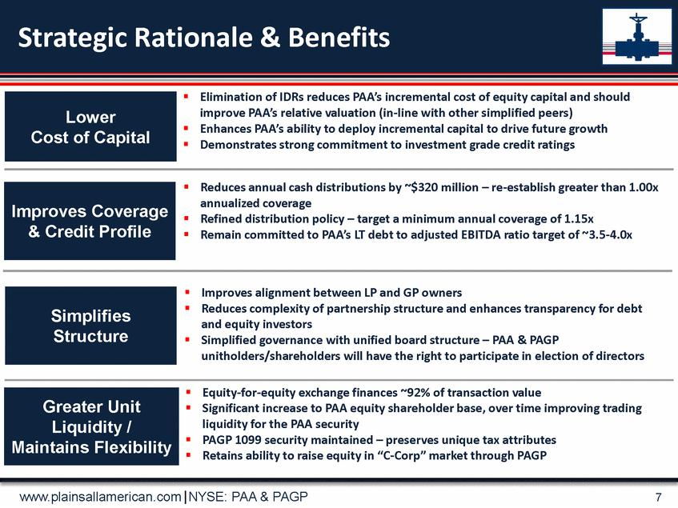

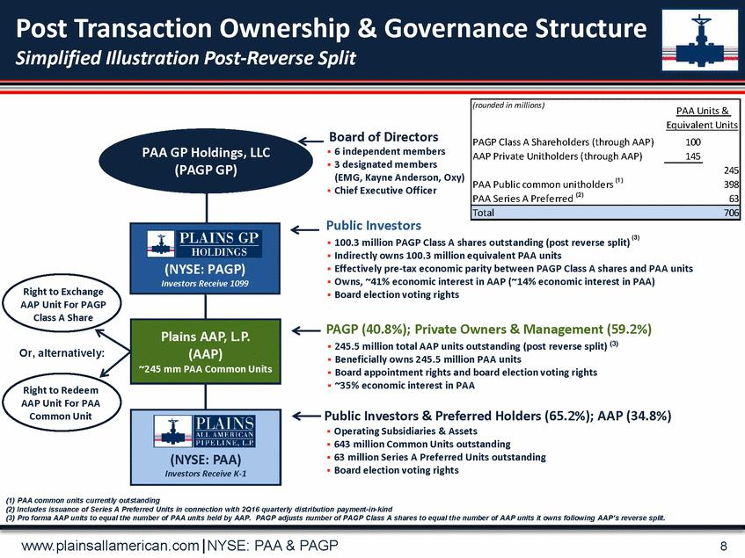

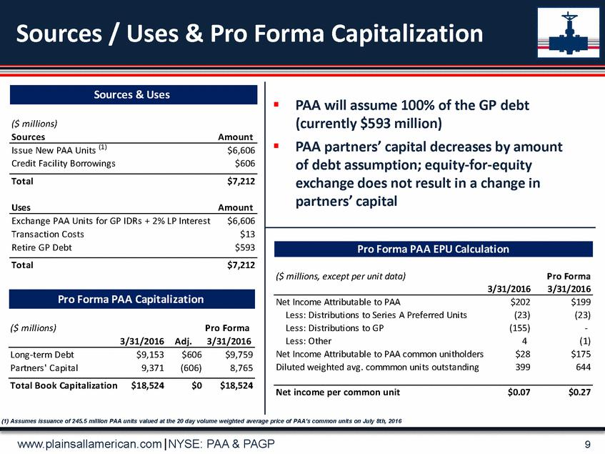

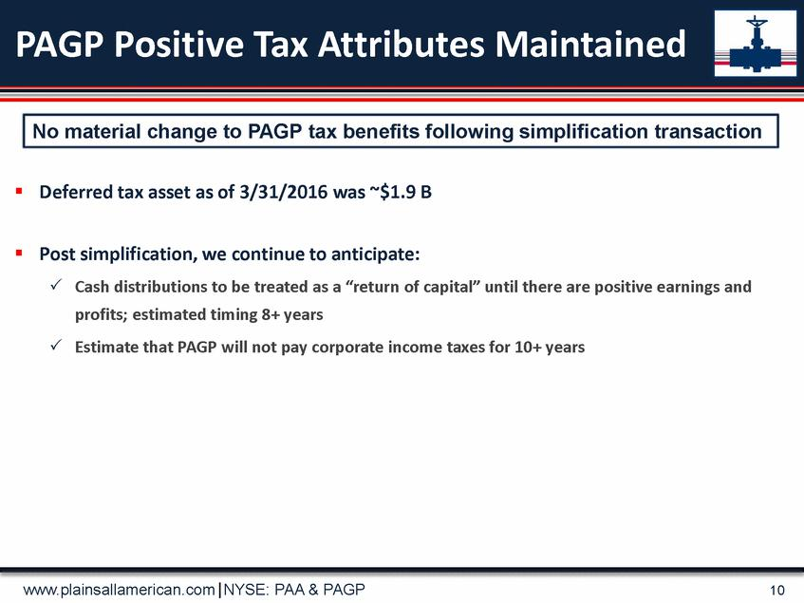

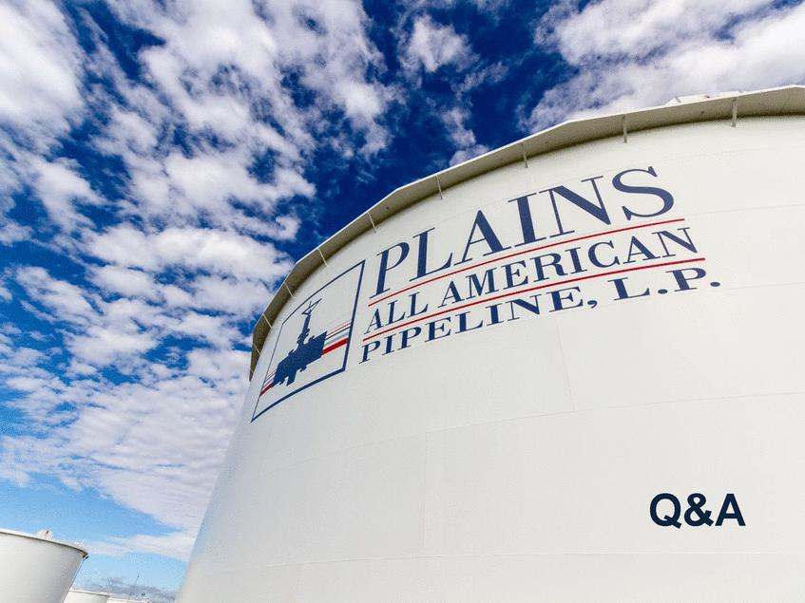

Additional Information and Where to Find It

The Simplification Transaction will be submitted to the shareholders of PAGP for their consideration, and PAGP will file with the SEC a proxy statement to be used by PAGP to solicit the required approval of its shareholders in connection with the Simplification Transaction. PAGP also plans to file other documents with the SEC regarding the proposed Simplification Transaction. INVESTORS AND SECURITY HOLDERS OF PAGP ARE URGED TO READ THE PROXY STATEMENT AND OTHER RELEVANT DOCUMENTS THAT WILL BE FILED WITH THE SEC CAREFULLY AND IN THEIR ENTIRETY WHEN THEY BECOME AVAILABLE BECAUSE THEY WILL CONTAIN IMPORTANT INFORMATION ABOUT THE SIMPLIFICATION TRANSACTION. Security holders may obtain free copies of the proxy statement and other documents containing important information about PAGP, once such documents are filed with the SEC, through the website maintained by the SEC at http://www.sec.gov. Copies of the documents filed with the SEC by PAGP will be available free of charge on PAGP’s website at ir.pagp.com or by contacting PAGP’s Investor Relations Department at (866) 809-1291.

Participants in the Solicitation

PAGP and the directors and executive officers of its general partner (“PAGP GP”), and PAA and the directors and executive officers of the general partner of the sole member of its general partner, GP LLC, may be deemed to be “participants” in the solicitation of proxies from PAGP’s shareholders in connection with the Simplification Transaction. Information about the directors and executive officers of PAGP GP is set forth in PAGP’s Annual Report on Form 10-K and information about the directors and executive officers of GP LLC is set forth in PAA’s Annual Report on Form 10-K, which were each filed with the SEC on February 25, 2016, and PAGP’s and PAA’s subsequent Quarterly Reports on Form 10-Q. These documents can be obtained free of charge from the sources indicated above. Other information regarding the participants in the proxy solicitation and a description of their direct and indirect interests, by security holdings or otherwise, will be contained in the proxy statement that PAGP intends to file with the SEC.

