Filed by Plains All American Pipeline, L.P. (1-14569) Pursuant to Rule 425 under the Securities Act of 1933
Subject Company: Pacific Energy Partners, L.P. (1-31345)
Commission File No: 333-135712

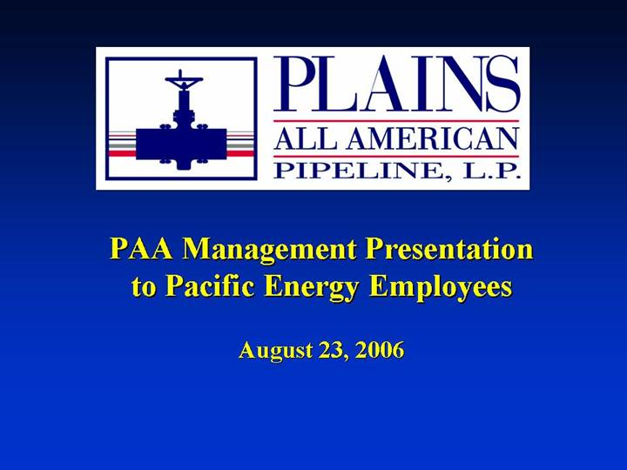
PAA Management Presentation to Pacific Energy Employees August 23, 2006

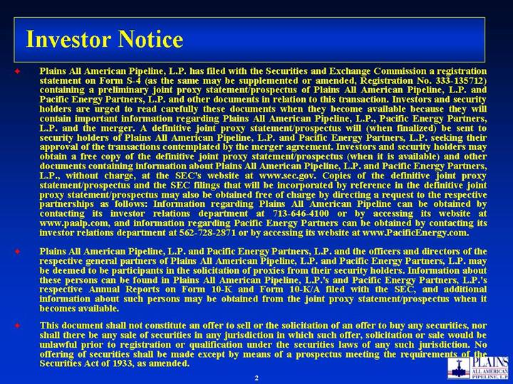
Investor Notice Plains All American Pipeline, L.P. has filed with the Securities and Exchange Commission a registration statement on Form S-4 (as the same may be supplemented or amended, Registration No. 333-135712) containing a preliminary joint proxy statement/prospectus of Plains All American Pipeline, L.P. and Pacific Energy Partners, L.P. and other documents in relation to this transaction. Investors and security holders are urged to read carefully these documents when they become available because they will contain important information regarding Plains All American Pipeline, L.P., Pacific Energy Partners, L.P. and the merger. A definitive joint proxy statement/prospectus will (when finalized) be sent to security holders of Plains All American Pipeline, L.P. and Pacific Energy Partners, L.P. seeking their approval of the transactions contemplated by the merger agreement. Investors and security holders may obtain a free copy of the definitive joint proxy statement/prospectus (when it is available) and other documents containing information about Plains All American Pipeline, L.P. and Pacific Energy Partners, L.P., without charge, at the SECs website at www.sec.gov. Copies of the definitive joint proxy statement/prospectus and the SEC filings that will be incorporated by reference in the definitive joint proxy statement/prospectus may also be obtained free of charge by directing a request to the respective partnerships as follows: Information regarding Plains All American Pipeline can be obtained by contacting its investor relations department at 713-646-4100 or by accessing its website at www.paalp.com, and information regarding Pacific Energy Partners can be obtained by contacting its investor relations department at 562-728-2871 or by accessing its website at www.PacificEnergy.com. Plains All American Pipeline, L.P. and Pacific Energy Partners, L.P. and the officers and directors of the respective general partners of Plains All American Pipeline, L.P. and Pacific Energy Partners, L.P. may be deemed to be participants in the solicitation of proxies from their security holders. Information about these persons can be found in Plains All American Pipeline, L.P.s and Pacific Energy Partners, L.P.s respective Annual Reports on Form 10-K and Form 10-K/A filed with the SEC, and additional information about such persons may be obtained from the joint proxy statement/prospectus when it becomes available. This document shall not constitute an offer to sell or the solicitation of an offer to buy any securities, nor shall there be any sale of securities in any jurisdiction in which such offer, solicitation or sale would be unlawful prior to registration or qualification under the securities laws of any such jurisdiction. No offering of securities shall be made except by means of a prospectus meeting the requirements of the Securities Act of 1933, as amended.

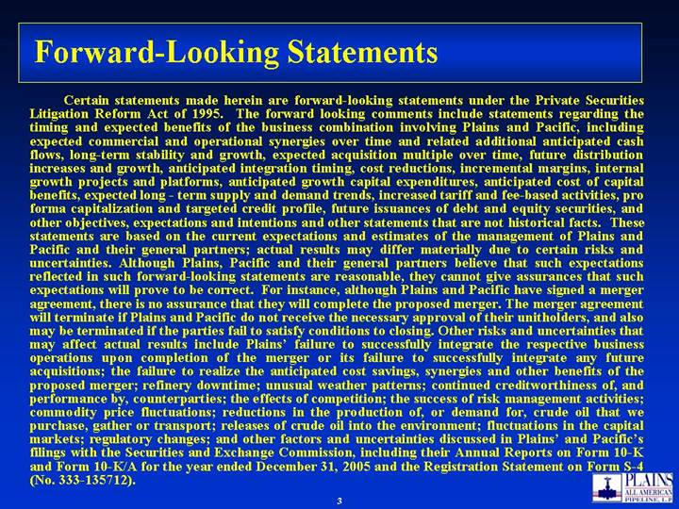
Forward-Looking Statements Certain statements made herein are forward-looking statements under the Private Securities Litigation Reform Act of 1995. The forward looking comments include statements regarding the timing and expected benefits of the business combination involving Plains and Pacific, including expected commercial and operational synergies over time and related additional anticipated cash flows, long-term stability and growth, expected acquisition multiple over time, future distribution increases and growth, anticipated integration timing, cost reductions, incremental margins, internal growth projects and platforms, anticipated growth capital expenditures, anticipated cost of capital benefits, expected long - term supply and demand trends, increased tariff and fee-based activities, pro forma capitalization and targeted credit profile, future issuances of debt and equity securities, and other objectives, expectations and intentions and other statements that are not historical facts. These statements are based on the current expectations and estimates of the management of Plains and Pacific and their general partners; actual results may differ materially due to certain risks and uncertainties. Although Plains, Pacific and their general partners believe that such expectations reflected in such forward-looking statements are reasonable, they cannot give assurances that such expectations will prove to be correct. For instance, although Plains and Pacific have signed a merger agreement, there is no assurance that they will complete the proposed merger. The merger agreement will terminate if Plains and Pacific do not receive the necessary approval of their unitholders, and also may be terminated if the parties fail to satisfy conditions to closing. Other risks and uncertainties that may affect actual results include Plains failure to successfully integrate the respective business operations upon completion of the merger or its failure to successfully integrate any future acquisitions; the failure to realize the anticipated cost savings, synergies and other benefits of the proposed merger; refinery downtime; unusual weather patterns; continued creditworthiness of, and performance by, counterparties; the effects of competition; the success of risk management activities; commodity price fluctuations; reductions in the production of, or demand for, crude oil that we purchase, gather or transport; releases of crude oil into the environment; fluctuations in the capital markets; regulatory changes; and other factors and uncertainties discussed in Plains and Pacifics filings with the Securities and Exchange Commission, including their Annual Reports on Form 10-K and Form 10-K/A for the year ended December 31, 2005 and the Registration Statement on Form S-4 (No. 333-135712).

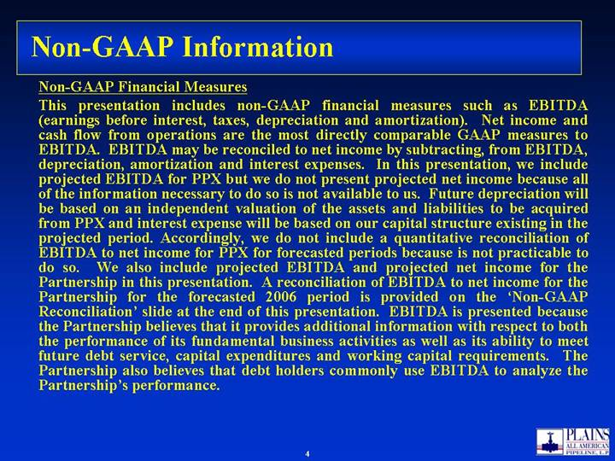
Non-GAAP Information Non-GAAP Financial Measures This presentation includes non-GAAP financial measures such as EBITDA (earnings before interest, taxes, depreciation and amortization). Net income and cash flow from operations are the most directly comparable GAAP measures to EBITDA. EBITDA may be reconciled to net income by subtracting, from EBITDA, depreciation, amortization and interest expenses. In this presentation, we include projected EBITDA for PPX but we do not present projected net income because all of the information necessary to do so is not available to us. Future depreciation will be based on an independent valuation of the assets and liabilities to be acquired from PPX and interest expense will be based on our capital structure existing in the projected period. Accordingly, we do not include a quantitative reconciliation of EBITDA to net income for PPX for forecasted periods because is not practicable to do so. We also include projected EBITDA and projected net income for the Partnership in this presentation. A reconciliation of EBITDA to net income for the Partnership for the forecasted 2006 period is provided on the Non-GAAP Reconciliation slide at the end of this presentation. EBITDA is presented because the Partnership believes that it provides additional information with respect to both the performance of its fundamental business activities as well as its ability to meet future debt service, capital expenditures and working capital requirements. The Partnership also believes that debt holders commonly use EBITDA to analyze the Partnerships performance.

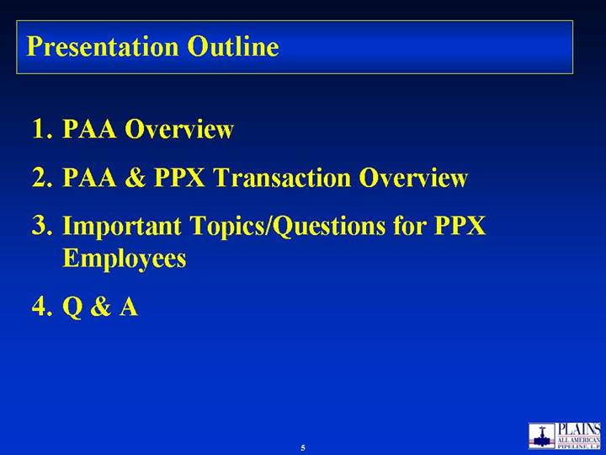
Presentation Outline PAA Overview PAA & PPX Transaction Overview Important Topics/Questions for PPX Employees Q & A

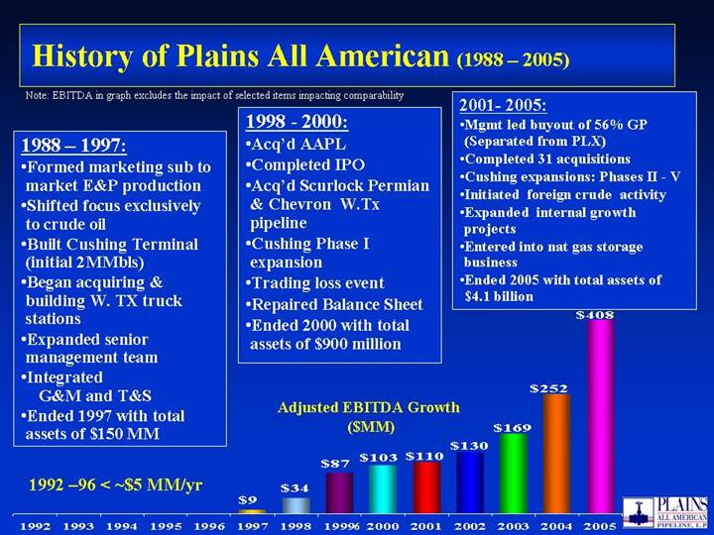
1988  1997: Formed marketing sub to market E&P production Shifted focus exclusively to crude oil Built Cushing Terminal (initial 2MMbls) Began acquiring & building W. TX truck stations Expanded senior management team Integrated G&M and T&S Ended 1997 with total assets of $150 MM 1998 - 2000: Acqd AAPL Completed IPO Acqd Scurlock Permian & Chevron W.Tx pipeline Cushing Phase I expansion Trading loss event Repaired Balance Sheet Ended 2000 with total assets of $900 million 2001- 2005: Mgmt led buyout of 56% GP (Separated from PLX) Completed 31 acquisitions Cushing expansions: Phases II - V Initiated foreign crude activity Expanded internal growth projects Entered into nat gas storage business Ended 2005 with total assets of $4.1 billion History of Plains All American (1988  2005) Adjusted EBITDA Growth ($MM) Note: EBITDA in graph excludes the impact of selected items impacting comparability 1992 96 < ~$5 MM/yr $408 $252 $169 $130 $110 $9 $34 $87 $103 1992 1993 1994 1995 1996 1997 1998 1999 2000 2001 2002 2003 2004 2005

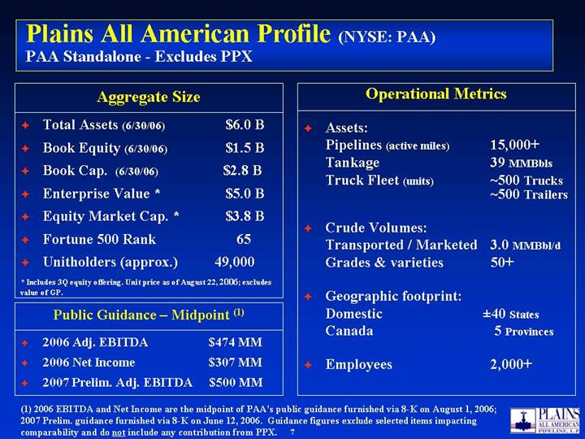
Plains All American Profile (NYSE: PAA) PAA Standalone - Excludes PPX Total Assets (6/30/06) $6.0 B Book Equity (6/30/06) $1.5 B Book Cap. (6/30/06) $2.8 B Enterprise Value * $5.0 B Equity Market Cap. * $3.8 B Fortune 500 Rank 65 Unitholders (approx.) 49,000 Aggregate Size Assets: Pipelines (active miles) 15,000+ Tankage 39 MMBbls Truck Fleet (units) ~500 Trucks ~500 Trailers Crude Volumes: Transported / Marketed 3.0 MMBbl/d Grades & varieties 50+ Geographic footprint: Domestic ±40 States Canada 5 Provinces Employees 2,000+ Operational Metrics * Includes 3Q equity offering. Unit price as of August 22, 2006; excludes value of GP. (1) 2006 EBITDA and Net Income are the midpoint of PAAs public guidance furnished via 8-K on August 1, 2006; 2007 Prelim. guidance furnished via 8-K on June 12, 2006. Guidance figures exclude selected items impacting comparability and do not include any contribution from PPX. 2006 Adj. EBITDA $474 MM 2006 Net Income $307 MM 2007 Prelim. Adj. EBITDA $500 MM Public Guidance  Midpoint (1)

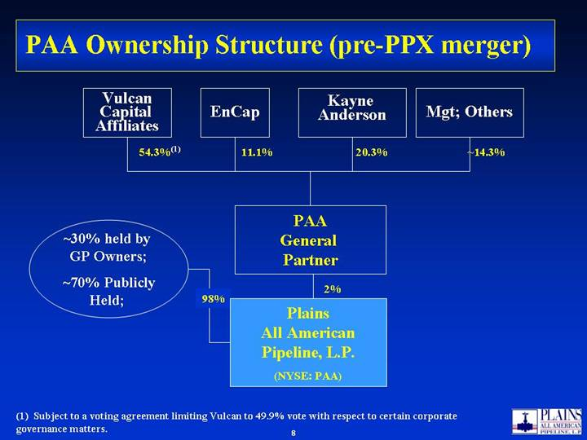
PAA Ownership Structure (pre-PPX merger) (1) Subject to a voting agreement limiting Vulcan to 49.9% vote with respect to certain corporate governance matters. PAA General Partner ~30% held by GP Owners; ~70% Publicly Held; 2% Vulcan Capital Affiliates EnCap 54.3%(1) 20.3% 98% Kayne Anderson Mgt; Others 11.1% ~14.3% Plains All American Pipeline, L.P. (NYSE: PAA)

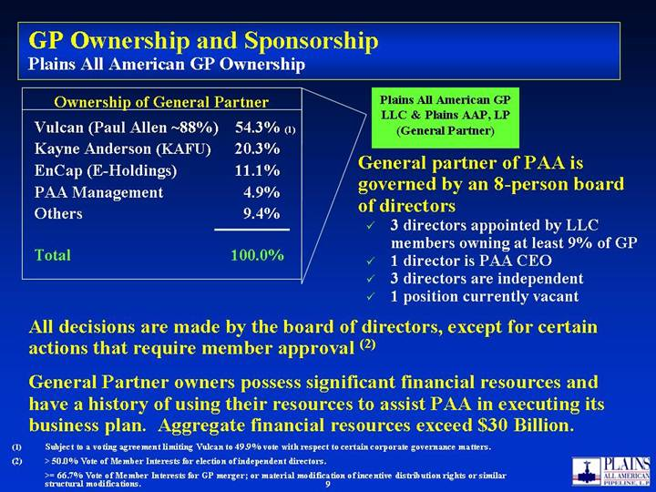
Ownership of General Partner Vulcan (Paul Allen ~88%) 54.3% (1) Kayne Anderson (KAFU) 20.3% EnCap (E-Holdings) 11.1% PAA Management 4.9% Others 9.4% Total 100.0% GP Ownership and Sponsorship Plains All American GP Ownership Plains All American GP LLC & Plains AAP, LP (General Partner) General partner of PAA is governed by an 8-person board of directors 3 directors appointed by LLC members owning at least 9% of GP 1 director is PAA CEO 3 directors are independent 1 position currently vacant All decisions are made by the board of directors, except for certain actions that require member approval (2) General Partner owners possess significant financial resources and have a history of using their resources to assist PAA in executing its business plan. Aggregate financial resources exceed $30 Billion. (1) Subject to a voting agreement limiting Vulcan to 49.9% vote with respect to certain corporate governance matters. (2) > 50.0% Vote of Member Interests for election of independent directors. >= 66.7% Vote of Member Interests for GP merger; or material modification of incentive distribution rights or similar structural modifications.

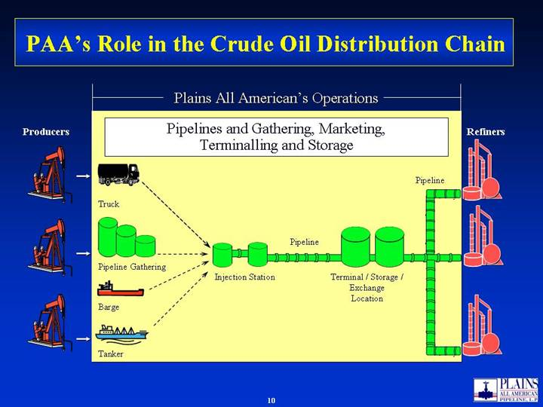
PAAs Role in the Crude Oil Distribution Chain Plains All Americans Operations Pipelines and Gathering, Marketing, Terminalling and Storage Producers Refiners Truck Terminal / Storage / Exchange Location Barge Pipeline Pipeline Gathering Injection Station Pipeline Tanker

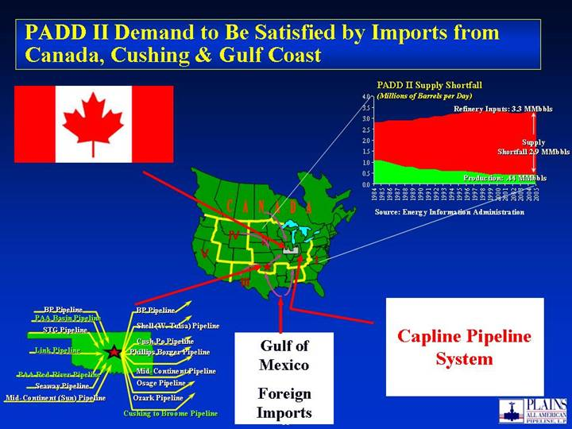
PADD II Demand to Be Satisfied by Imports from Canada, Cushing & Gulf Coast V IV II I III Capline Pipeline System Gulf of Mexico Foreign Imports BP Pipeline PAA Basin Pipeline Link Pipeline Seaway Pipeline BP Pipeline Shell (W. Tulsa) Pipeline Cush-Po Pipeline Mid-Continent Pipeline Osage Pipeline Ozark Pipeline Phillips Borger Pipeline PAA Red River Pipeline Mid-Continent (Sun) Pipeline STG Pipeline Cushing to Broome Pipeline Source: Energy Information Administration

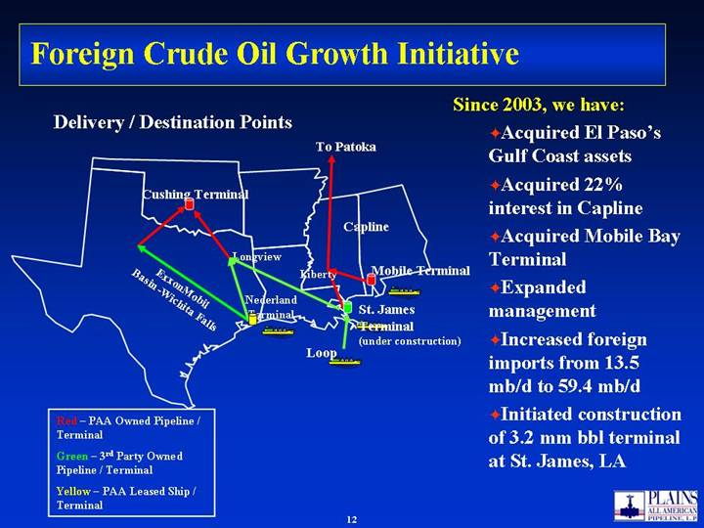
Foreign Crude Oil Growth Initiative Since 2003, we have: Acquired El Pasos Gulf Coast assets Acquired 22% interest in Capline Acquired Mobile Bay Terminal Expanded management Increased foreign imports from 13.5 mb/d to 59.4 mb/d Initiated construction of 3.2 mm bbl terminal at St. James, LA Red  PAA Owned Pipeline / Terminal Green  3rd Party Owned Pipeline / Terminal Yellow  PAA Leased Ship / Terminal Longview Cushing Terminal Loop St. James Terminal (under construction) Nederland Terminal ExxonMobil Basin -Wichita Falls To Patoka Capline Liberty Mobile Terminal Delivery / Destination Points

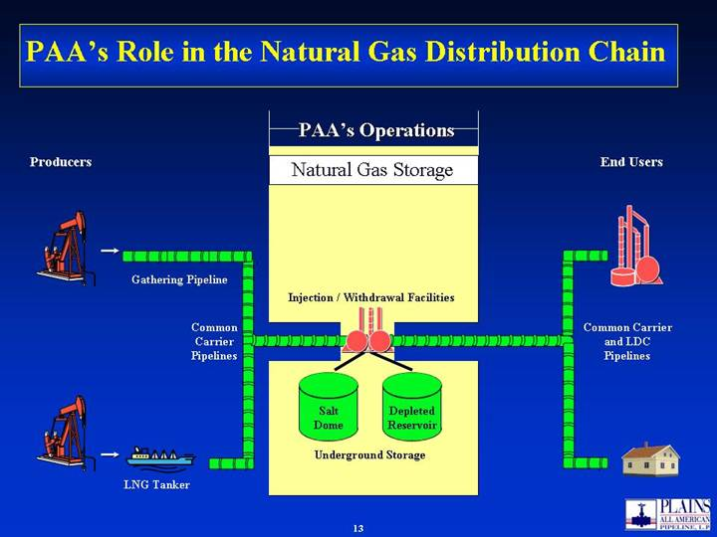
PAAs Role in the Natural Gas Distribution Chain PAAs Operations Natural Gas Storage Producers End Users Underground Storage Gathering Pipeline Injection / Withdrawal Facilities LNG Tanker Salt Dome Depleted Reservoir Common Carrier Pipelines Common Carrier and LDC Pipelines

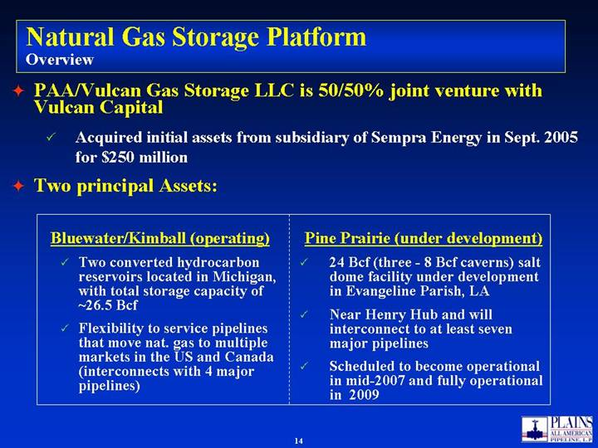
Natural Gas Storage Platform Overview PAA/Vulcan Gas Storage LLC is 50/50% joint venture with Vulcan Capital Acquired initial assets from subsidiary of Sempra Energy in Sept. 2005 for $250 million Two principal Assets: Pine Prairie (under development) 24 Bcf (three - 8 Bcf caverns) salt dome facility under development in Evangeline Parish, LA Near Henry Hub and will interconnect to at least seven major pipelines Scheduled to become operational in mid-2007 and fully operational in 2009 Bluewater/Kimball (operating) Two converted hydrocarbon reservoirs located in Michigan, with total storage capacity of ~26.5 Bcf Flexibility to service pipelines that move nat. gas to multiple markets in the US and Canada (interconnects with 4 major pipelines)

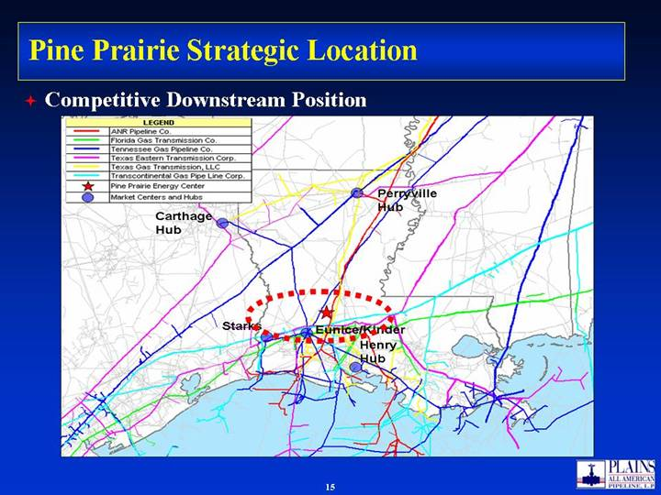
Pine Prairie Strategic Location Competitive Downstream Position

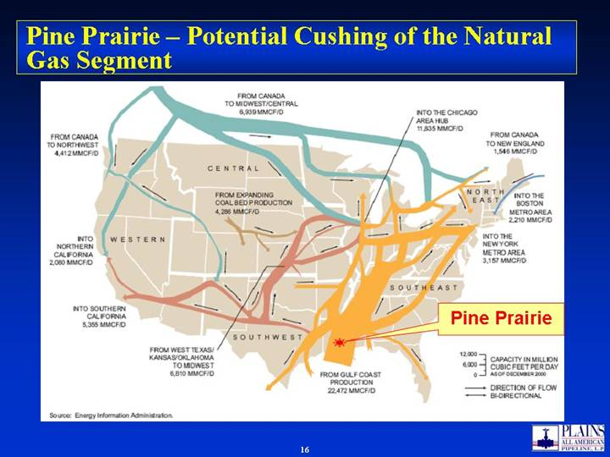
Pine Prairie  Potential Cushing of the Natural Gas Segment Pine Prairie

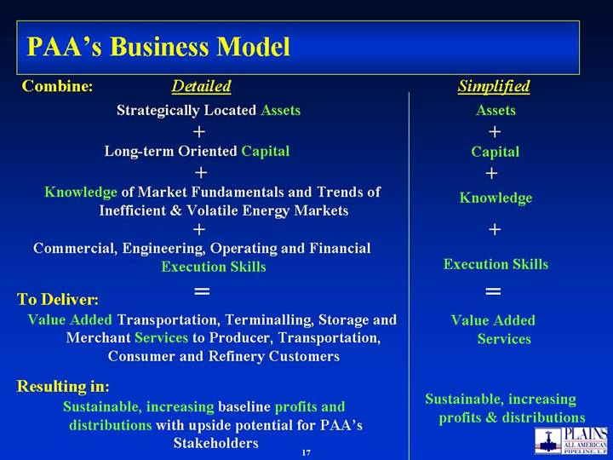
PAAs Business Model Knowledge of Market Fundamentals and Trends of Inefficient & Volatile Energy Markets Commercial, Engineering, Operating and Financial Execution Skills Strategically Located Assets Long-term Oriented Capital Combine: + + + Value Added Transportation, Terminalling, Storage and Merchant Services to Producer, Transportation, Consumer and Refinery Customers = To Deliver: Sustainable, increasing baseline profits and distributions with upside potential for PAAs Stakeholders Resulting in: Detailed + + + = Assets Capital Knowledge Execution Skills Value Added Services Sustainable, increasing profits & distributions Simplified

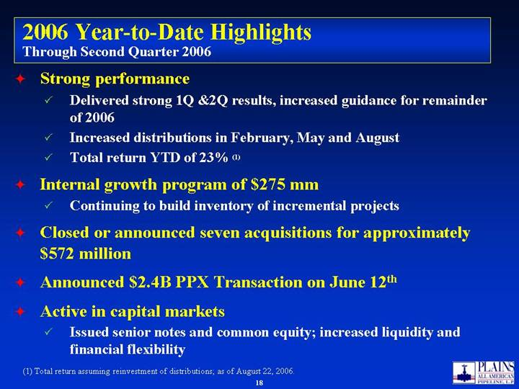
2006 Year-to-Date Highlights Through Second Quarter 2006 Strong performance Delivered strong 1Q &2Q results, increased guidance for remainder of 2006 Increased distributions in February, May and August Total return YTD of 23% (1) Internal growth program of $275 mm Continuing to build inventory of incremental projects Closed or announced seven acquisitions for approximately $572 million Announced $2.4B PPX Transaction on June 12th Active in capital markets Issued senior notes and common equity; increased liquidity and financial flexibility (1) Total return assuming reinvestment of distributions; as of August 22, 2006.

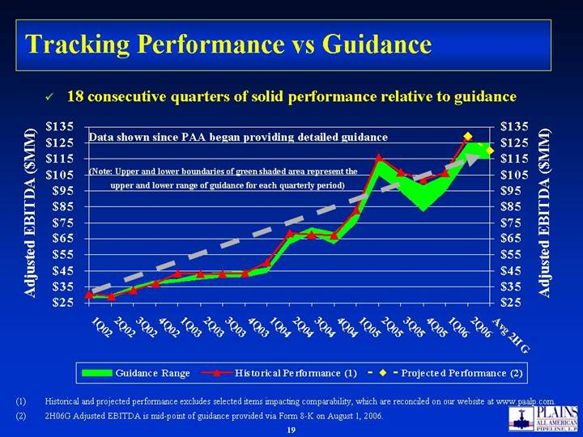
Tracking Performance vs Guidance Historical and projected performance excludes selected items impacting comparability, which are reconciled on our website at www.paalp.com. 2H06G Adjusted EBITDA is mid-point of guidance provided via Form 8-K on August 1, 2006. Data shown since PAA began providing detailed guidance 18 consecutive quarters of solid performance relative to guidance (Note: Upper and lower boundaries of green shaded area represent the upper and lower range of guidance for each quarterly period) $25 $35 $45 $55 $65 $75 $85 $95 $105 $115 $125 $135 1Q02 2Q02 3Q02 4Q02 1Q03 2Q03 3Q03 4Q03 1Q04 2Q04 3Q04 4Q04 1Q05 2Q05 3Q05 4Q05 1Q06 2Q06 Avg 2H G Adjusted EBITDA ($MM) $25 $35 $45 $55 $65 $75 $85 $95 $105 $115 $125 $135 Adjusted EBITDA ($MM) Guidance Range Historical Performance (1) Projected Performance (2)

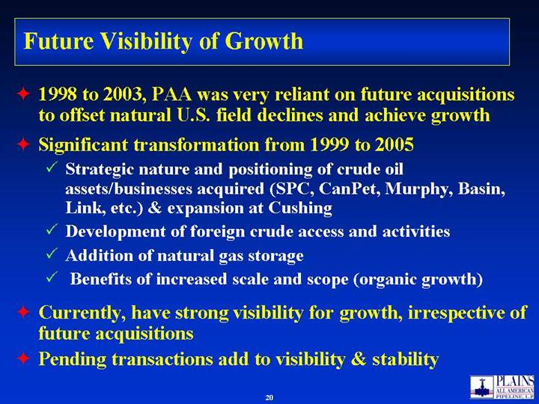
Future Visibility of Growth 1998 to 2003, PAA was very reliant on future acquisitions to offset natural U.S. field declines and achieve growth Significant transformation from 1999 to 2005 Strategic nature and positioning of crude oil assets/businesses acquired (SPC, CanPet, Murphy, Basin, Link, etc.) & expansion at Cushing Development of foreign crude access and activities Addition of natural gas storage Benefits of increased scale and scope (organic growth) Currently, have strong visibility for growth, irrespective of future acquisitions Pending transactions add to visibility & stability

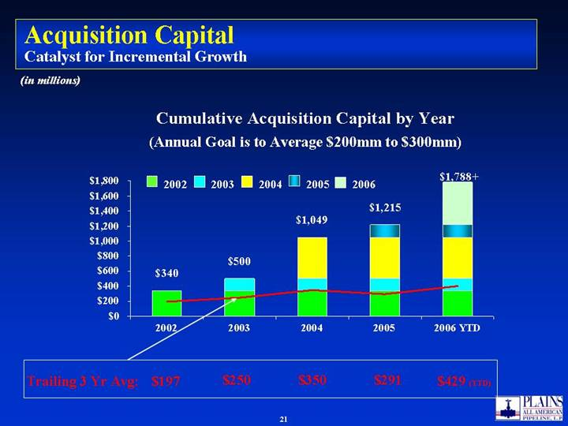
Acquisition Capital Catalyst for Incremental Growth (in millions) Trailing 3 Yr Avg: $197 $250 $350 $291 Cumulative Acquisition Capital by Year (Annual Goal is to Average $200mm to $300mm) 2002 2003 2004 2005 2006 $429 (YTD) $1,215 $1,049 $500 $340 $1,788+ $0 $200 $400 $600 $800 $1,000 $1,200 $1,400 $1,600 $1,800 2002 2003 2004 2005 2006 YTD

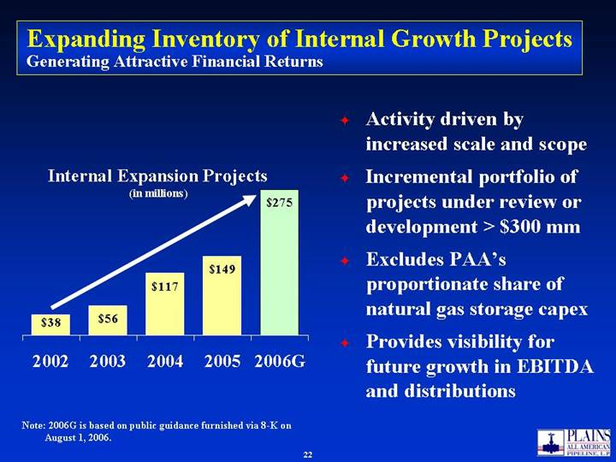
Expanding Inventory of Internal Growth Projects Generating Attractive Financial Returns Activity driven by increased scale and scope Incremental portfolio of projects under review or development > $300 mm Excludes PAAs proportionate share of natural gas storage capex Provides visibility for future growth in EBITDA and distributions Note: 2006G is based on public guidance furnished via 8-K on August 1, 2006. $38 $56 $149 $117 $275 2002 2003 2004 2005 2006G Internal Expansion Projects (in millions)

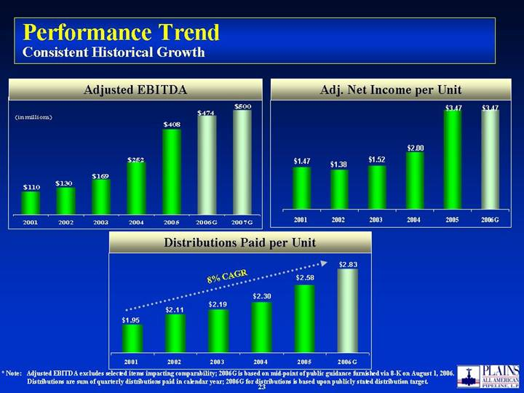
Performance Trend Consistent Historical Growth * Note: Adjusted EBITDA excludes selected items impacting comparability; 2006G is based on mid-point of public guidance furnished via 8-K on August 1, 2006. Distributions are sum of quarterly distributions paid in calendar year; 2006G for distributions is based upon publicly stated distribution target. 8% CAGR Adjusted EBITDA Adj. Net Income per Unit Distributions Paid per Unit (in millions) $110 $130 $169 $252 $408 $474 $500 2001 2002 2003 2004 2005 2006G 2007G $3.47 $2.00 $1.52 $1.38 $1.47 $3.47 2001 2002 2003 2004 2005 2006G $2.58 $2.30 $2.19 $2.11 $1.95 $2.83 2001 2002 2003 2004 2005 2006G

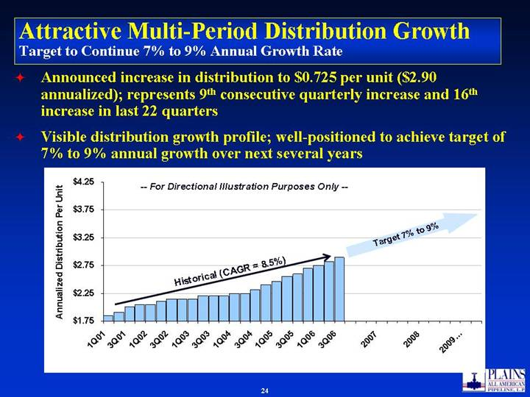
Attractive Multi-Period Distribution Growth Target to Continue 7% to 9% Annual Growth Rate Announced increase in distribution to $0.725 per unit ($2.90 annualized); represents 9th consecutive quarterly increase and 16th increase in last 22 quarters Visible distribution growth profile; well-positioned to achieve target of 7% to 9% annual growth over next several years -- For Directional Illustration Purposes Only -- Target 7% to 9% Historical (CAGR = 8.5%) $1.75 $2.25 $2.75 $3.25 $3.75 $4.25 1Q01 3Q01 1Q02 3Q02 1Q03 3Q03 1Q04 3Q04 1Q05 3Q05 1Q06 3Q06 2007 2008 2009 Annualized Distribution Per Unit

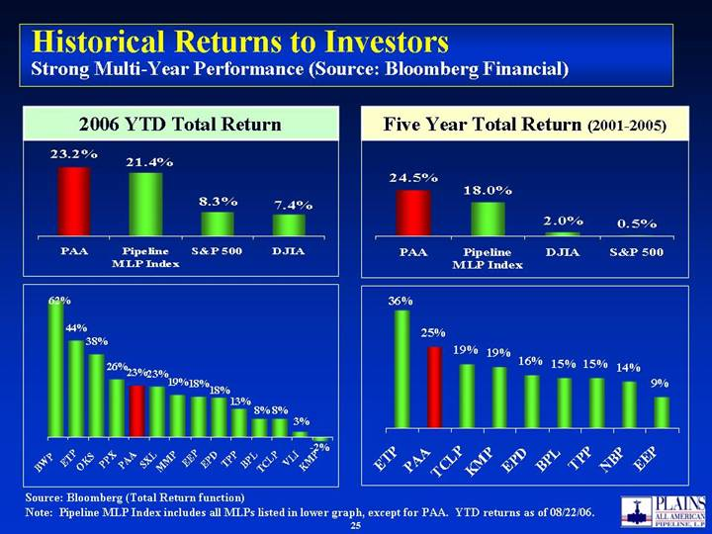
Historical Returns to Investors Strong Multi-Year Performance (Source: Bloomberg Financial) Source: Bloomberg (Total Return function) Note: Pipeline MLP Index includes all MLPs listed in lower graph, except for PAA. YTD returns as of 08/22/06. Five Year Total Return (2001-2005) 2006 YTD Total Return 7.4% 8.3% 21.4% 23.2% PAA Pipeline MLP Index S&P 500 DJIA 26% 23% 23% 19% 18% 62% 44% 38% 3% 8% 8% 13% 18% -2% BWP ETP OKS PPX PAA SXL MMP EEP EPD TPP BPL TCLP VLI KMP 19% 16% 15% 15% 14% 9% 19% 25% 36% ETP PAA TCLP KMP EPD BPL TPP NBP EEP

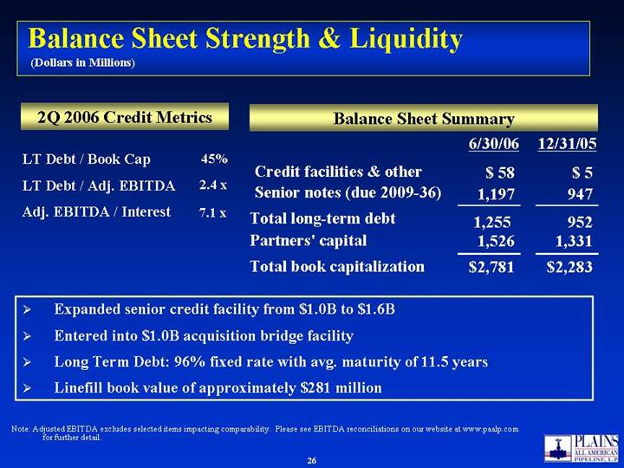
Balance Sheet Strength & Liquidity (Dollars in Millions) Note: Adjusted EBITDA excludes selected items impacting comparability. Please see EBITDA reconciliations on our website at www.paalp.com for further detail. Expanded senior credit facility from $1.0B to $1.6B Entered into $1.0B acquisition bridge facility Long Term Debt: 96% fixed rate with avg. maturity of 11.5 years Linefill book value of approximately $281 million 2Q 2006 Credit Metrics Balance Sheet Summary LT Debt / Book Cap LT Debt / Adj. EBITDA Adj. EBITDA / Interest Credit facilities & other Total long-term debt Partners capital Total book capitalization Senior notes (due 2009-36) $ 58 1,197 1,255 1,526 $2,781 6/30/06 $ 5 947 952 1,331 $2,283 12/31/05 45% 2.4 x 7.1 x


Obey the law Be loyal to the Company Deal fairly with others Treat others with respect Be honest and act with integrity PAAs Basic Ethical Principles

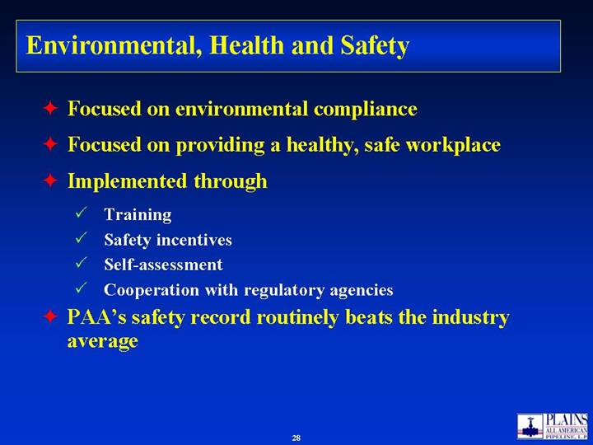
Environmental, Health and Safety Focused on environmental compliance Focused on providing a healthy, safe workplace Implemented through Training Safety incentives Self-assessment Cooperation with regulatory agencies PAAs safety record routinely beats the industry average

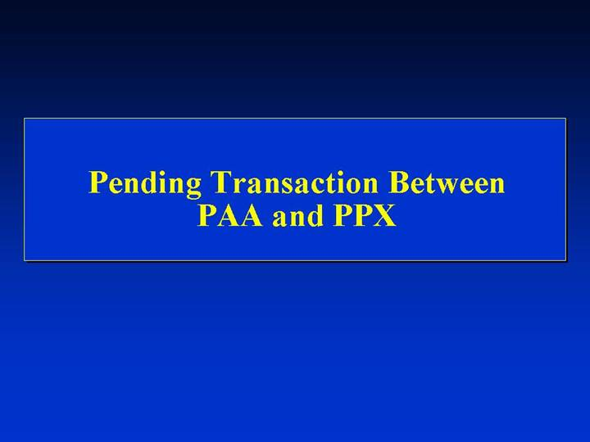
Pending Transaction Between PAA and PPX

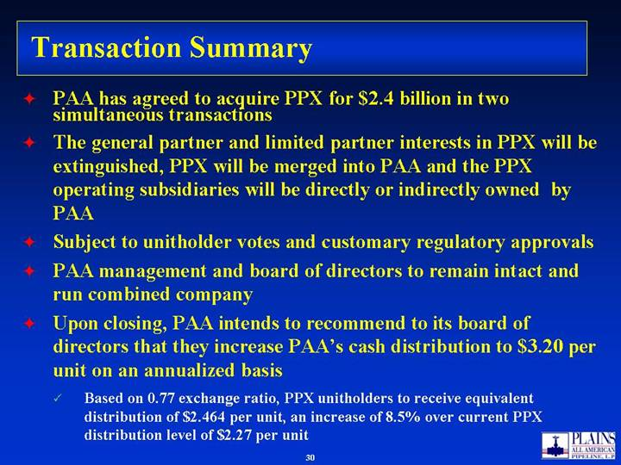
Transaction Summary PAA has agreed to acquire PPX for $2.4 billion in two simultaneous transactions The general partner and limited partner interests in PPX will be extinguished, PPX will be merged into PAA and the PPX operating subsidiaries will be directly or indirectly owned by PAA Subject to unitholder votes and customary regulatory approvals PAA management and board of directors to remain intact and run combined company Upon closing, PAA intends to recommend to its board of directors that they increase PAAs cash distribution to $3.20 per unit on an annualized basis Based on 0.77 exchange ratio, PPX unitholders to receive equivalent distribution of $2.464 per unit, an increase of 8.5% over current PPX distribution level of $2.27 per unit

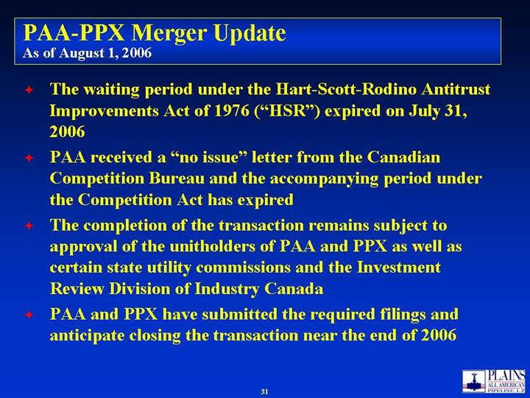
PAA-PPX Merger Update As of August 1, 2006 The waiting period under the Hart-Scott-Rodino Antitrust Improvements Act of 1976 (HSR) expired on July 31, 2006 PAA received a no issue letter from the Canadian Competition Bureau and the accompanying period under the Competition Act has expired The completion of the transaction remains subject to approval of the unitholders of PAA and PPX as well as certain state utility commissions and the Investment Review Division of Industry Canada PAA and PPX have submitted the required filings and anticipate closing the transaction near the end of 2006

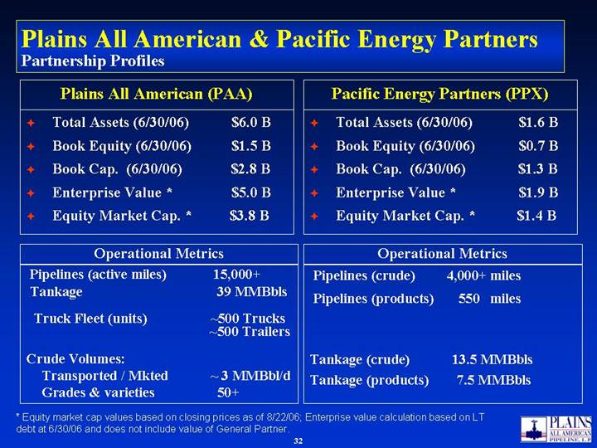
Plains All American & Pacific Energy Partners Partnership Profiles Total Assets (6/30/06) $6.0 B Book Equity (6/30/06) $1.5 B Book Cap. (6/30/06) $2.8 B Enterprise Value * $5.0 B Equity Market Cap. * $3.8 B Plains All American (PAA) Pipelines (active miles) 15,000+ Tankage 39 MMBbls Truck Fleet (units) ~500 Trucks ~500 Trailers Crude Volumes: Transported / Mkted ~ 3 MMBbl/d Grades & varieties 50+ Operational Metrics Total Assets (6/30/06) $1.6 B Book Equity (6/30/06) $0.7 B Book Cap. (6/30/06) $1.3 B Enterprise Value * $1.9 B Equity Market Cap. * $1.4 B Pacific Energy Partners (PPX) Pipelines (crude) 4,000+ miles Pipelines (products) 550 miles Tankage (crude) 13.5 MMBbls Tankage (products) 7.5 MMBbls Operational Metrics * Equity market cap values based on closing prices as of 8/22/06; Enterprise value calculation based on LT debt at 6/30/06 and does not include value of General Partner.

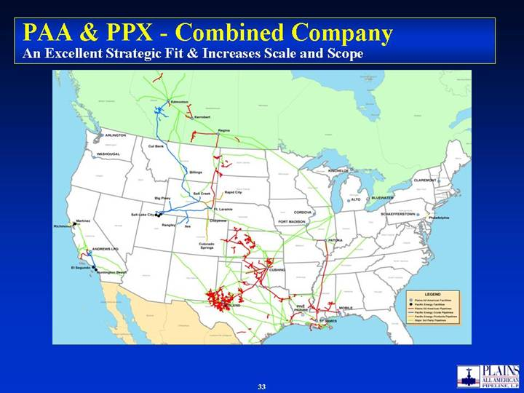
PAA & PPX - Combined Company An Excellent Strategic Fit & Increases Scale and Scope

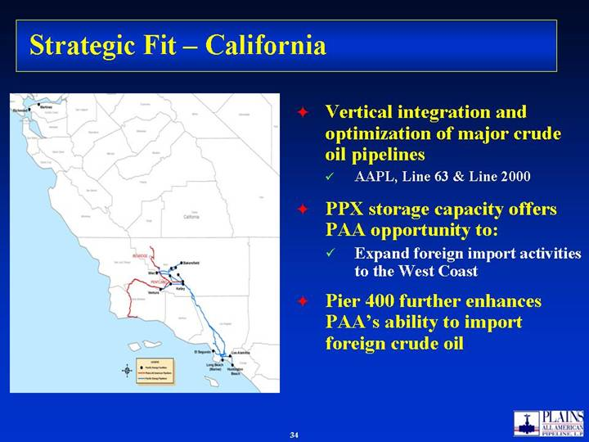
Strategic Fit  California Vertical integration and optimization of major crude oil pipelines AAPL, Line 63 & Line 2000 PPX storage capacity offers PAA opportunity to: Expand foreign import activities to the West Coast Pier 400 further enhances PAAs ability to import foreign crude oil

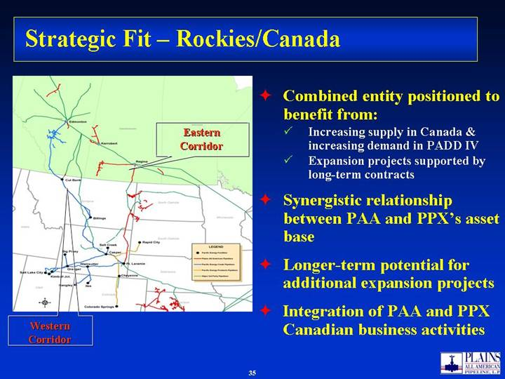
Strategic Fit  Rockies/Canada Combined entity positioned to benefit from: Increasing supply in Canada & increasing demand in PADD IV Expansion projects supported by long-term contracts Synergistic relationship between PAA and PPXs asset base Longer-term potential for additional expansion projects Integration of PAA and PPX Canadian business activities Western Corridor Eastern Corridor

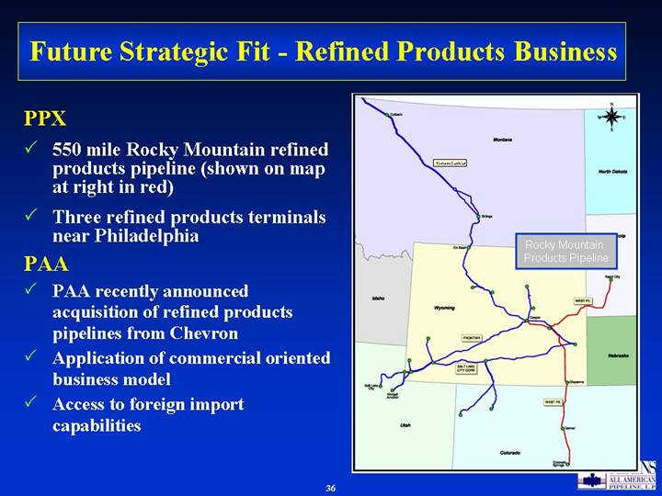
Future Strategic Fit - Refined Products Business PPX 550 mile Rocky Mountain refined products pipeline (shown on map at right in red) Three refined products terminals near Philadelphia PAA PAA recently announced acquisition of refined products pipelines from Chevron Application of commercial oriented business model Access to foreign import capabilities Western Corridor Rocky Mountain Products Pipeline

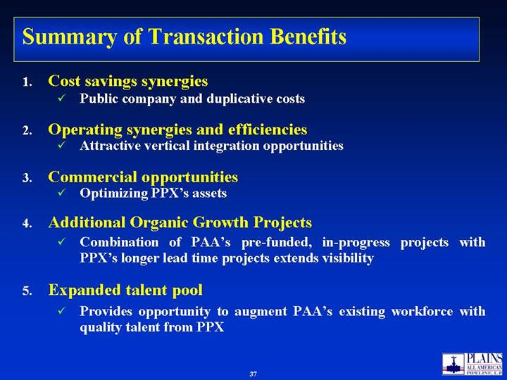
Summary of Transaction Benefits Cost savings synergies Public company and duplicative costs Operating synergies and efficiencies Attractive vertical integration opportunities Commercial opportunities Optimizing PPXs assets Additional Organic Growth Projects Combination of PAAs pre-funded, in-progress projects with PPXs longer lead time projects extends visibility Expanded talent pool Provides opportunity to augment PAAs existing workforce with quality talent from PPX

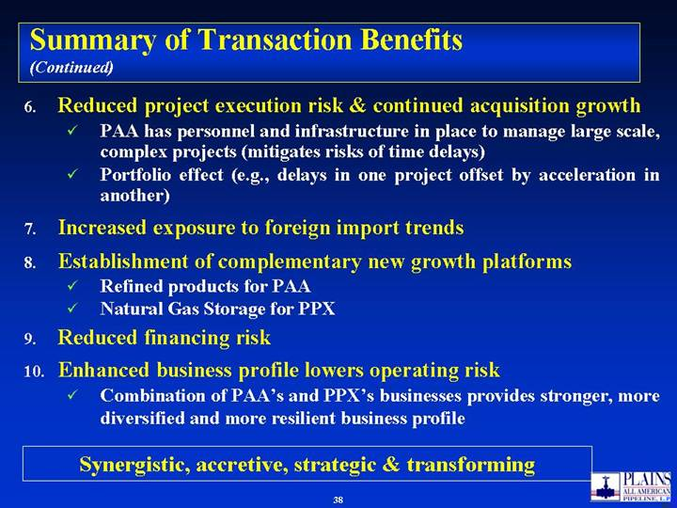
Summary of Transaction Benefits (Continued) Reduced project execution risk & continued acquisition growth PAA has personnel and infrastructure in place to manage large scale, complex projects (mitigates risks of time delays) Portfolio effect (e.g., delays in one project offset by acceleration in another) Increased exposure to foreign import trends Establishment of complementary new growth platforms Refined products for PAA Natural Gas Storage for PPX Reduced financing risk Enhanced business profile lowers operating risk Combination of PAAs and PPXs businesses provides stronger, more diversified and more resilient business profile Synergistic, accretive, strategic & transforming

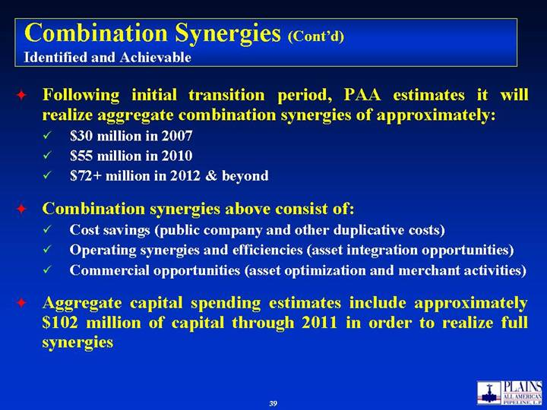
Combination Synergies (Contd) Identified and Achievable Following initial transition period, PAA estimates it will realize aggregate combination synergies of approximately: $30 million in 2007 $55 million in 2010 $72+ million in 2012 & beyond Combination synergies above consist of: Cost savings (public company and other duplicative costs) Operating synergies and efficiencies (asset integration opportunities) Commercial opportunities (asset optimization and merchant activities) Aggregate capital spending estimates include approximately $102 million of capital through 2011 in order to realize full synergies

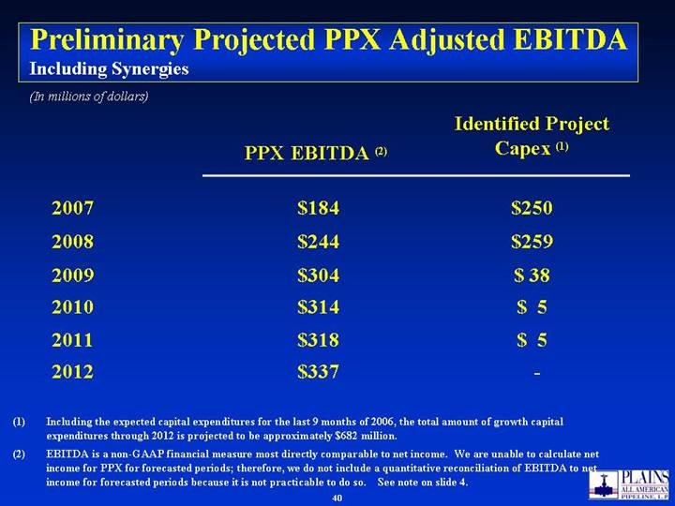
Preliminary Projected PPX Adjusted EBITDA Including Synergies $ 5 $314 2010 $ 5 $318 2011 - $337 2012 $ 38 $304 2009 $259 $244 2008 $250 $184 2007 Identified Project Capex (1) PPX EBITDA (2) (In millions of dollars) Including the expected capital expenditures for the last 9 months of 2006, the total amount of growth capital expenditures through 2012 is projected to be approximately $682 million. EBITDA is a non-GAAP financial measure most directly comparable to net income. We are unable to calculate net income for PPX for forecasted periods; therefore, we do not include a quantitative reconciliation of EBITDA to net income for forecasted periods because it is not practicable to do so. See note on slide 4.

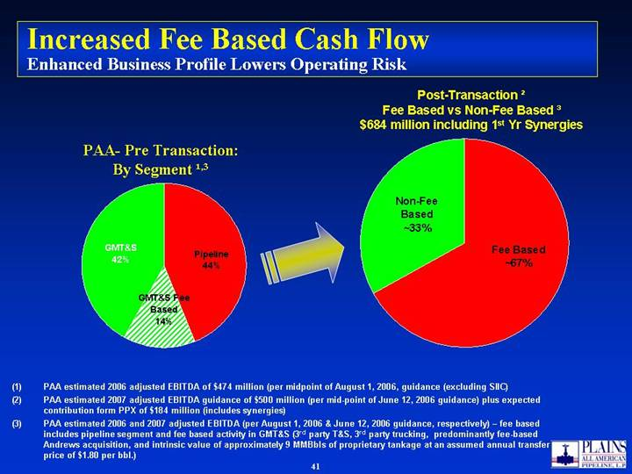
Increased Fee Based Cash Flow Enhanced Business Profile Lowers Operating Risk PAA- Pre Transaction: By Segment ¹,3 PAA estimated 2006 adjusted EBITDA of $474 million (per midpoint of August 1, 2006, guidance (excluding SIIC) PAA estimated 2007 adjusted EBITDA guidance of $500 million (per mid-point of June 12, 2006 guidance) plus expected contribution form PPX of $184 million (includes synergies) PAA estimated 2006 and 2007 adjusted EBITDA (per August 1, 2006 & June 12, 2006 guidance, respectively)  fee based includes pipeline segment and fee based activity in GMT&S (3rd party T&S, 3rd party trucking, predominantly fee-based Andrews acquisition, and intrinsic value of approximately 9 MMBbls of proprietary tankage at an assumed annual transfer price of $1.80 per bbl.) Post-Transaction ² Fee Based vs Non-Fee Based ³ $684 million including 1st Yr Synergies Pipeline 44% GMT&S 42% GMT&S Fee Based 14% Non-Fee Based ~33% Fee Based ~67%

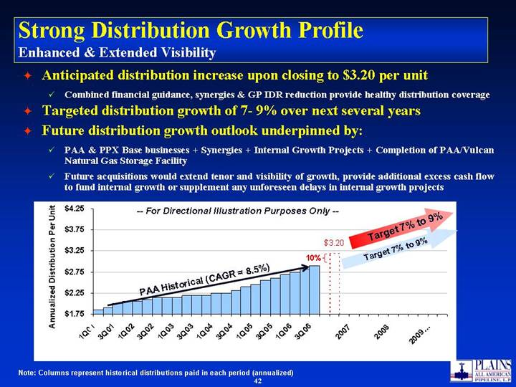
Target 7% to 9% -- For Directional Illustration Purposes Only -- Strong Distribution Growth Profile Enhanced & Extended Visibility Anticipated distribution increase upon closing to $3.20 per unit Combined financial guidance, synergies & GP IDR reduction provide healthy distribution coverage Targeted distribution growth of 7- 9% over next several years Future distribution growth outlook underpinned by: PAA & PPX Base businesses + Synergies + Internal Growth Projects + Completion of PAA/Vulcan Natural Gas Storage Facility Future acquisitions would extend tenor and visibility of growth, provide additional excess cash flow to fund internal growth or supplement any unforeseen delays in internal growth projects Note: Columns represent historical distributions paid in each period (annualized) Target 7% to 9% 10% PAA Historical (CAGR = 8.5%) $3.20 $1.75 $2.25 $2.75 $3.25 $3.75 $4.25 1Q01 3Q01 1Q02 3Q02 1Q03 3Q03 1Q04 3Q04 1Q05 3Q05 1Q06 3Q06 2007 2008 2009 Annualized Distribution Per Unit

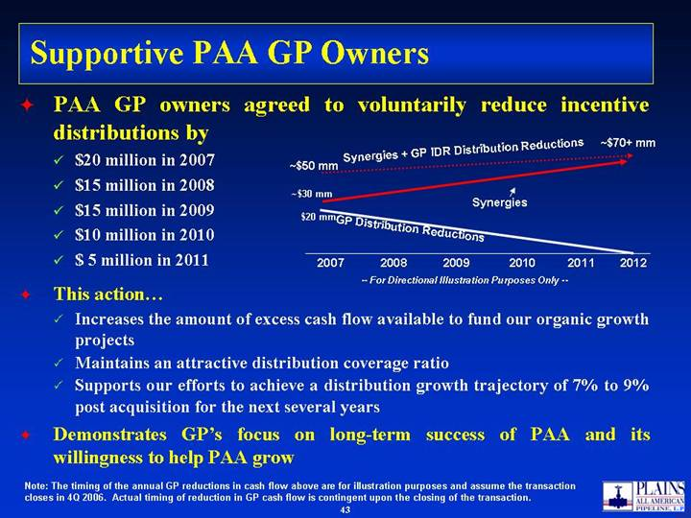
Supportive PAA GP Owners PAA GP owners agreed to voluntarily reduce incentive distributions by $20 million in 2007 $15 million in 2008 $15 million in 2009 $10 million in 2010 $ 5 million in 2011 This action Increases the amount of excess cash flow available to fund our organic growth projects Maintains an attractive distribution coverage ratio Supports our efforts to achieve a distribution growth trajectory of 7% to 9% post acquisition for the next several years Demonstrates GPs focus on long-term success of PAA and its willingness to help PAA grow Synergies -- For Directional Illustration Purposes Only -- Synergies + GP IDR Distribution Reductions 2007 2008 2009 2010 2011 2012 GP Distribution Reductions ~$50 mm ~$70+ mm $20 mm ~$30 mm Note: The timing of the annual GP reductions in cash flow above are for illustration purposes and assume the transaction closes in 4Q 2006. Actual timing of reduction in GP cash flow is contingent upon the closing of the transaction.

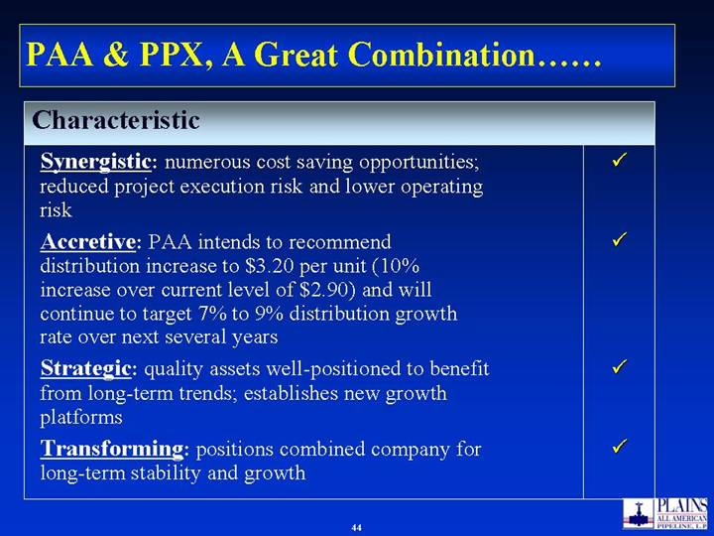
PAA & PPX, A Great Combination Strategic: quality assets well-positioned to benefit from long-term trends; establishes new growth platforms Transforming: positions combined company for long-term stability and growth Accretive: PAA intends to recommend distribution increase to $3.20 per unit (10% increase over current level of $2.90) and will continue to target 7% to 9% distribution growth rate over next several years Synergistic: numerous cost saving opportunities; reduced project execution risk and lower operating risk Characteristic

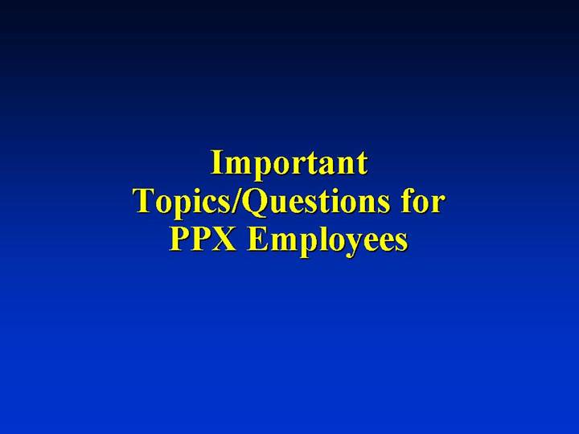
Important Topics/Questions for PPX Employees


Q&A

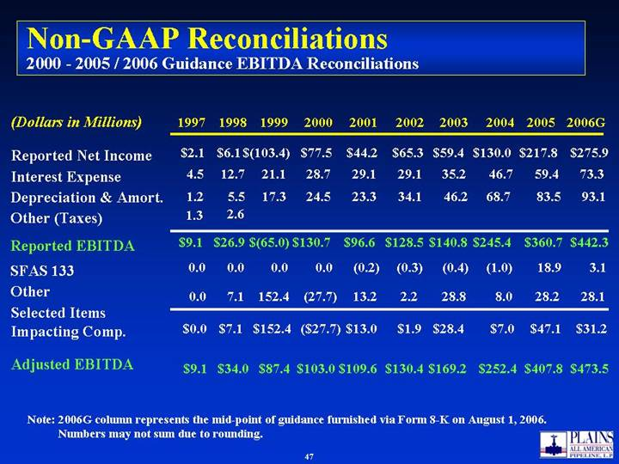
Non-GAAP Reconciliations 2000 - 2005 / 2006 Guidance EBITDA Reconciliations Note: 2006G column represents the mid-point of guidance furnished via Form 8-K on August 1, 2006. Numbers may not sum due to rounding. 2000 2001 2002 2003 2004 2005 Reported Net Income $77.5 $44.2 $65.3 $59.4 $130.0 $217.8 Interest Expense 28.7 29.1 29.1 35.2 46.7 59.4 Depreciation & Amort. 24.5 23.3 34.1 46.2 68.7 83.5 Reported EBITDA $130.7 $96.6 $128.5 $140.8 $245.4 $360.7 SFAS 133 0.0 (0.2) (0.3) (0.4) (1.0) 18.9 Other (27.7) 13.2 2.2 28.8 8.0 28.2 Selected Items Impacting Comp. ($27.7) $13.0 $1.9 $28.4 $7.0 $47.1 Adjusted EBITDA $103.0 $109.6 $130.4 $169.2 $252.4 $407.8 (Dollars in Millions) 2006G $275.9 73.3 93.1 $442.3 3.1 28.1 $31.2 $473.5 1999 $(103.4) 21.1 17.3 $(65.0) 0.0 152.4 $152.4 $87.4 1998 $6.1 12.7 5.5 $26.9 0.0 7.1 $7.1 $34.0 1997 $2.1 4.5 1.2 $9.1 0.0 0.0 $0.0 $9.1 Other (Taxes) 2.6 1.3

