UNITED STATES

SECURITIES AND EXCHANGE COMMISSION

Washington, D.C. 20549

FORM 8-K

CURRENT REPORT

Pursuant to Section 13 or 15(d) of the Securities Exchange Act of 1934

Date of Report (Date of earliest event reported) – August 30, 2025

Plains GP Holdings, L.P.

(Exact name of registrant as specified in its charter)

DELAWARE

(State or other jurisdiction of

1-36132

(Commission File Number)

90-1005472

(IRS Employer Identification No.)

incorporation)

333 Clay Street, Suite 1600, Houston, Texas 77002

(Address of principal executive offices) (Zip Code)

713-646-4100

(Registrant’s telephone number, including area code)

(Former name or former address, if changed since last report.)

Check the appropriate box below if the Form 8-K filing is intended to simultaneously satisfy the filing obligation of the registrant under any of the following provisions:

- Written communications pursuant to Rule 425 under the Securities Act (17 CFR 230.425)

- Soliciting material pursuant to Rule 14a-12 under the Exchange Act (17 CFR 240.14a-12)

- Pre-commencement communications pursuant to Rule 14d-2(b) under the Exchange Act (17 CFR 240.14d-2(b))

- Pre-commencement communications pursuant to Rule 13e-4(c) under the Exchange Act (17 CFR 240.13e-4(c)) Securities registered pursuant to Section 12(b) of the Act:

Title of each class |  | Trading Symbol(s) |  | Name of each exchange on which registered
Common Units |  | PAGP |  | Nasdaq

Indicate by check mark whether the registrant is an emerging growth company as defined in Rule 405 of the Securities Act of 1933 or Rule 12b-2 of the Securities Exchange Act of 1934.

Emerging growth company ☐

If an emerging growth company, indicate by check mark if the registrant has elected not to use the extended transition period for complying with any new or revised financial accounting standards provided pursuant to Section 13(a) of the Exchange Act. o

Item 1.01 Entry into a Material Definitive Agreement.

On August 30, 2025, a wholly-owned subsidiary (the “Buyer”) of Plains All American Pipeline, L.P. (“PAA”), a wholly-owned subsidiary of Plains GP Holdings, L.P. (“PAGP” or the “Registrant”), entered into a definitive Purchase and Sale Agreement (the “PSA”) with subsidiaries of Diamondback Energy, Inc. and Kinetik Holdings Inc. (collectively, the “Sellers”), pursuant to which Buyer will purchase from Sellers an aggregate 55% non-operated interest in EPIC Crude Holdings, LP (“EPIC Crude Holdings”), the entity that owns and operates the EPIC Crude Oil Pipeline (the “Pipeline”). The base purchase price of approximately $1.57 billion is subject to adjustments and includes approximately $600 million of debt. Buyer has also agreed to a potential earnout payment of approximately $193 million should an expansion of the Pipeline to a capacity of at least 900,000 barrels per day be formally sanctioned before the end of 2027. PAA will guaranty certain of the Buyer’s obligations under the PSA.

The EPIC Pipeline provides long-haul crude oil takeaway from the Permian and Eagle Ford basins to the Gulf Coast market at Corpus Christi. EPIC Crude Holdings’ assets include approximately 800 miles of long-haul pipelines (including the EPIC Pipeline), operating capacity of over 600,000 barrels per day with low-cost expansion capabilities, approximately 7 million barrels of operational storage, and over 200,000 barrels per day of export capacity. The remaining 45% interest in EPIC Crude Holdings is owned by a portfolio company of Ares Management Corporation, which also serves as operator.

The transaction is expected to close in the first quarter of 2026, subject to satisfaction or waiver of customary closing conditions, including applicable regulatory approvals. The PSA contains customary representations, warranties, covenants and termination provisions, as well as mutual indemnification provisions for breaches of certain of the representations, warranties and covenants in the PSA, subject to certain limitations.

The foregoing description of the PSA does not purport to be complete and is qualified in its entirety by reference to the full text of the PSA, which the Registrant intends to file as an exhibit to its Quarterly Report on Form 10-Q for the quarter ended September 30, 2025.

Item 7.01 Regulation FD Disclosure.

In accordance with General Instruction B.2 of Form 8-K, the information presented herein under Item 7.01 shall not be deemed “filed” for the purpose of Section 18 of the Securities Exchange Act of 1934, as amended (the “Exchange Act”), or otherwise subject to the liabilities of that section, nor shall such information be deemed incorporated by reference into any filing under the Securities Act of 1933, as amended, or the Exchange Act.

On September 2, 2025, PAA and PAGP issued a press release announcing the execution of the Purchase and Sale Agreement described in Item 1.01 above. A copy of the press release is furnished as Exhibit 99.1 hereto.

Item 9.01 Financial Statements and Exhibits.

(d) Exhibits

 | Exhibit |  |  |  | Description
 | Number
99.1 |  |  |  |  | Press Release Dated September 2, 2025.

- Cover Page Interactive Data File (embedded within the Inline XBRL document). 2

SIGNATURES

Pursuant to the requirements of the Securities Exchange Act of 1934, the registrant has duly caused this report to be signed on its behalf by the undersigned hereunto duly authorized.

Date: September 2, 2025 PLAINS GP HOLDINGS, L.P.

By: PAA GP LLC, its general partner

By: PAA GP Holdings LLC, its general partner

By: /s/ Richard McGee

Name: Richard McGee

Title: Executive Vice President, General Counsel & Secretary

3

Exhibit 99.1


Plains to Acquire 55% Interest in EPIC Crude Holdings, LP

Enhancing Wellhead to Water Strategy

HOUSTON – September 2, 2025 – Plains All American Pipeline, L.P. (Nasdaq: PAA) and Plains GP Holdings (Nasdaq: PAGP) (collectively, “Plains”) announced today that a wholly owned subsidiary has entered into a definitive agreement to acquire from subsidiaries of Diamondback Energy, Inc. and Kinetik Holdings Inc., a 55% non-operated interest in EPIC Crude Holdings, LP (“EPIC Crude Holdings”), the entity that owns and operates the EPIC Crude Oil Pipeline (“EPIC Pipeline”), in a transaction valued at approximately $1.57 billion, inclusive of approximately $600 million of debt. Additionally, Plains has agreed to a potential $193 million earnout payment should an expansion of the pipeline to a capacity of at least 900,000 barrels per day be formally sanctioned before year-end 2027. The transaction is expected to be immediately accretive to distributable cash flow with synergistic opportunities expected to result in mid-teens unlevered returns. The remaining 45% interest in EPIC Crude Holdings is owned by a portfolio company of Ares Management Corporation (“EPIC Management”), which also serves as operator.

The EPIC Pipeline provides long-haul crude oil takeaway from the Permian and Eagle Ford basins to the Gulf Coast market at Corpus Christi. EPIC Crude Holdings’ assets include:

- Approximately 800 miles of long-haul pipelines, including the EPIC Pipeline

- Operating capacity of over 600,000 barrels per day with low-cost expansion capabilities

- Approximately 7 million barrels of operational storage

- Over 200,000 barrels per day of export capacity
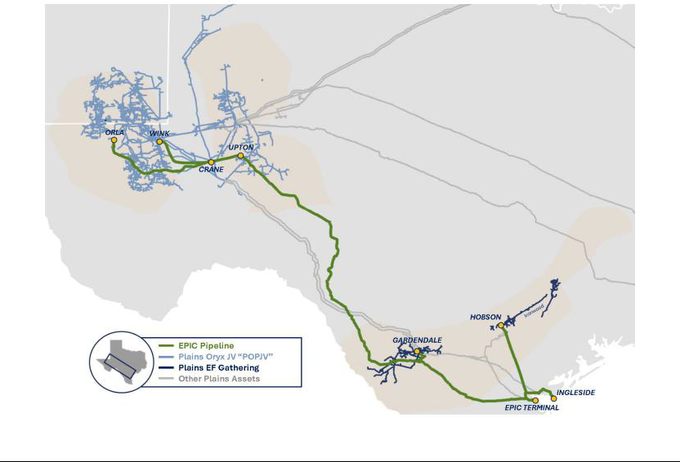

Transaction Highlights:

- Ability to provide customers with additional upstream connectivity and enhanced downstream market connectivity and optionality

- Enhances and expands Plains’ existing Permian well-head to water strategy

- Synergy potential and Permian growth improves acquisition multiple over the next few years

- System underpinned by long-term minimum volume commitments from high-quality customers

- Expect pro forma leverage ratio to remain within target range (excluding NGL divestiture proceeds); strong balance sheet utilized to finance transaction with cash and debt
- Expected to be immediately accretive to distributable cash flow, supporting additional return of capital opportunities

“We are excited to work with the EPIC Management team. This transaction strengthens our position as the premier crude oil midstream provider, complements our asset footprint and enhances our customer offering. The combination of our stake in EPIC Crude Holdings coupled with our existing integrated Permian and Eagle Ford assets enhances our commitment to offering a high level of connectivity and flexibility for our customers. By further linking our Permian and Eagle Ford gathering systems to Corpus Christi, we are enhancing market access and ensuring our customers have reliable, cost-effective routes to multiple demand centers,” said Willie Chiang, Chairman, CEO and President.

“The combined assets will allow us to capture synergies through additional service offerings, and drive value via expanded scale and integration. Our financial flexibility enables us to finance the acquisition utilizing our balance sheet, while maintaining a pro-forma leverage ratio within our established leverage target range. Ultimately, our interest in EPIC Crude Holdings will not only benefit Plains and our partners but also our unit holders by creating further return of capital opportunities.”

The transaction is expected to be completed by early 2026, subject to customary closing conditions, including clearance under the Hart-Scott-Rodino Antitrust Improvements Act of 1976.

Forward-Looking Statements

Except for the historical information contained herein, the matters discussed in this release consist of forward-looking statements including, but not limited to, statements regarding the proposed acquisition of an interest in EPIC Crude Holdings and the terms, timing and anticipated operational, financial and strategic benefits thereof. There are a number of risks and uncertainties that could cause actual results or outcomes to differ materially from results or outcomes anticipated in the forward-looking statements. These risks and uncertainties include, among other things: changes in or disruptions to economic, market or business conditions; substantial declines in commodity prices or demand for crude oil; third-party constraints; legal constraints (including the impact of governmental regulations, orders or policies); unforeseen delays with respect to the receipt of regulatory approvals and completion of other closing conditions; and other factors and uncertainties inherent in transactions of the type discussed herein or in our business as discussed in PAA’s and PAGP’s filings with the Securities and Exchange Commission.

About Plains

PAA is a publicly traded master limited partnership that owns and operates midstream energy infrastructure and provides logistics services for crude oil and natural gas liquids (NGL). PAA owns an extensive network of pipeline gathering and transportation systems, in addition to terminalling, storage, processing, fractionation and other infrastructure assets serving key producing basins, transportation corridors and major market hubs and export outlets in the United States and Canada. On average, PAA handles approximately eight million barrels per day of crude oil and NGL.

PAGP is a publicly traded entity that owns an indirect, non-economic controlling general partner interest in PAA and an indirect limited partner interest in PAA, one of the largest energy infrastructure and logistics companies in North America.

PAA and PAGP are headquartered in Houston, Texas. More information is available at www.plains.com.

Investor Relations Contacts:

Blake Fernandez

Michael Gladstein

PlainsIR@plains.com

(866) 809-1291

