UNITED STATES

SECURITIES AND EXCHANGE COMMISSION

Washington, D.C. 20549

FORM 8-K/A

(Amendment No. 1)

CURRENT REPORT

Pursuant to Section 13 or 15(d) of The Securities Exchange Act of 1934

Date of Report (Date of earliest event reported) — October 31, 2025

Plains All American Pipeline, L.P.

(Exact name of registrant as specified in its charter)

Delaware

(State or other jurisdiction of

1-14569

(Commission File Number)

76-0582150

(IRS Employer Identification No.)

incorporation)

333 Clay Street, Suite 1600, Houston, Texas 77002

(Address of principal executive offices) (Zip Code)

713-646-4100

(Registrant’s telephone number, including area code)

(Former name or former address, if changed since last report)

Check the appropriate box below if the Form 8-K filing is intended to simultaneously satisfy the filing obligation of the registrant under any of the following provisions:

- Written communications pursuant to Rule 425 under the Securities Act (17 CFR 230.425)

- Soliciting material pursuant to Rule 14a-12 under the Exchange Act (17 CFR 240.14a-12)

- Pre-commencement communications pursuant to Rule 14d-2(b) under the Exchange Act (17 CFR 240.14d-2(b))

- Pre-commencement communications pursuant to Rule 13e-4(c) under the Exchange Act (17 CFR 240.13e-4(c)) Securities registered pursuant to Section 12(b) of the Act:
Title of each class |  | Trading Symbol(s) |  | Name of each exchange on which registered
Common Units |  | PAA |  | Nasdaq

Indicate by check mark whether the registrant is an emerging growth company as defined in Rule 405 of the Securities Act of 1933 (§230.405 of this chapter) or Rule 12b-2 of the Securities Exchange Act of 1934 (§240.12b-2 of this chapter).

Emerging growth company ☐

If an emerging growth company, indicate by check mark if the registrant has elected not to use the extended transition period for complying with any new or revised financial accounting standards provided pursuant to Section 13(a) of the Exchange Act. ☐

EXPLANATORY NOTE

On November 6, 2025, Plains All American Pipeline, L.P. (“PAA” or the “Registrant”) filed a Current Report on Form 8-K (the “Original Filing”) to report that on October 31, 2025, pursuant to that certain definitive Purchase and Sale Agreement (the “PSA”) entered into on August 30, 2025 by and among a wholly-owned subsidiary (the “Buyer”) of PAA, and subsidiaries of Diamondback Energy, Inc. and Kinetik Holdings Inc. (collectively, the “Sellers”), Buyer completed the purchase from Sellers of an aggregate 55% non-operated equity interest in EPIC Crude Holdings, LP (“EPIC Crude Holdings”), the entity that owns and operates the EPIC Crude Oil Pipeline (the “EPIC Pipeline”), and an aggregate 55% of the membership interests in EPIC Crude Holdings GP, LLC (“EPIC GP”), the general partner of EPIC Crude Holdings (the “EPIC 55% Transaction”).

Effective November 1, 2025, in a separate transaction from the EPIC 55% Transaction, Buyer also completed the purchase of the remaining 45% equity interest in EPIC Crude Holdings and the remaining 45% of the membership interests in EPIC GP from a subsidiary of Ares Management LLC (the “Ares Seller”) pursuant to that certain definitive Equity Purchase Agreement among Buyer and the Ares Seller (the “EPIC 45% Transaction,” and, together with the EPIC 55% Transaction, the “Transactions”).

As a result of the Transactions, PAA now indirectly owns 100% of the equity interests in EPIC Crude Holdings and 100% of the membership interests in EPIC GP and will serve as operator of record of the EPIC Pipeline.

This Current Report on Form 8-K/A (this “Amendment”) amends and supplements the Original Filing to provide the financial statements of EPIC Crude Holdings, LP and the pro forma financial information of PAA required by Items 9.01(a) and 9.01(b) of Form 8-K. No other modifications to the Original Filing are being made by this Amendment.

Item 9.01. Financial Statements and Exhibits.

- Financial Statements of Business or Funds Acquired.

The audited consolidated financial statements of EPIC Crude Holdings, LP and Subsidiaries as of and for the years ended December 31, 2024 and 2023, including notes thereto, are filed as Exhibit 99.1 to this Current Report on Form 8-K/A and are incorporated herein by reference.

The unaudited consolidated financial statements of EPIC Crude Holdings, LP and Subsidiaries as of and for the nine months ended September 30, 2025 are filed as Exhibit 99.2 to this Current Report on Form 8-K/A and are incorporated herein by reference.

- Pro Forma Financial Information.

The unaudited pro forma condensed combined balance sheet of PAA as of September 30, 2025 and the unaudited pro forma condensed statement of combined continuing operations for the nine months ended September 30, 2025 and for the year ended December 31, 2024, and the notes thereto, are filed as Exhibit 99.3 to this Current Report on Form 8-K/A and are incorporated herein by reference.

(d) Exhibits.

Exhibit Number |  |  |  |  |  | Description
23.1 |  |  | Consent of KPMG LLP.
99.1 |  |  | Audited consolidated financial statements of EPIC Crude Holdings, LP and Subsidiaries as of and for the years ended December
 |  |  | 31, 2024 and 2023, including notes thereto.
99.2 |  |  | Unaudited consolidated financial statements of EPIC Crude Holdings, LP and Subsidiaries as of and for the nine months ended
 |  |  | September 30, 2025.
99.3 |  |  | Unaudited pro forma condensed combined balance sheet of Plains All American Pipeline, L.P. as of September 30, 2025 and
 |  |  | unaudited pro forma condensed statement of combined continuing operations for the nine months ended September 30, 2025 |  |  |  |  | and
 |  |  | for the year ended December 31, 2024, including notes thereto.

- Cover Page Interactive Data File (embedded within the Inline XBRL document)

2

SIGNATURES

Pursuant to the requirements of the Securities Exchange Act of 1934, the Registrant has duly caused this report to be signed on its behalf by the undersigned hereunto duly authorized.

PLAINS ALL AMERICAN PIPELINE, L.P.

 | By: | PAA GP LLC, its general partner
 | By: | Plains AAP, L.P., its sole member
 | By: | Plains All American GP LLC, its general partner
Date: January 15, 2026 | By: | /s/ Chris Herbold
 |  | Name: | Chris Herbold
 |  | Title: | Senior Vice President, Finance and Chief Accounting Officer

3

Exhibit 23.1

Consent of Independent Auditors

We consent to the incorporation by reference in the registration statements (Nos. 333-138888, 333-155673, 333-162477, 333-214778, 333-221845, 333-267725, 333-281967 and 333-281968) on Form S-3 and (Nos. 333-91141, 333-74920, 333-122806, 333-141185, 333-193139, 333-193140 and 333-256507) on Form S-8 of Plains All American Pipeline, L.P. of our report dated April 24, 2025, with respect to the consolidated financial statements of EPIC Crude Holdings, LP, which report appears in this Current Report on Form 8-K of Plains All American Pipeline, L.P. dated January 15, 2026.

/s/ KPMG LLP

San Antonio, Texas

January 15, 2026

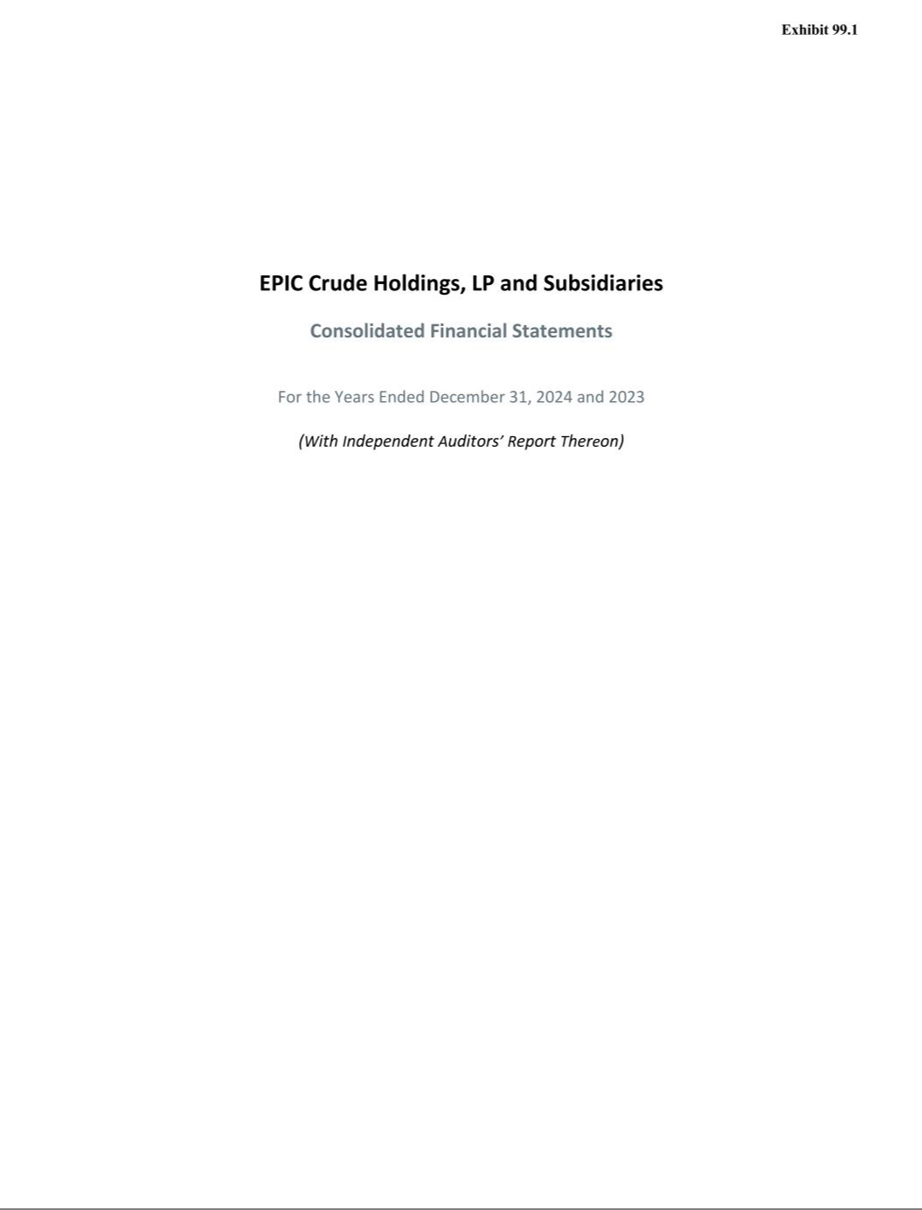

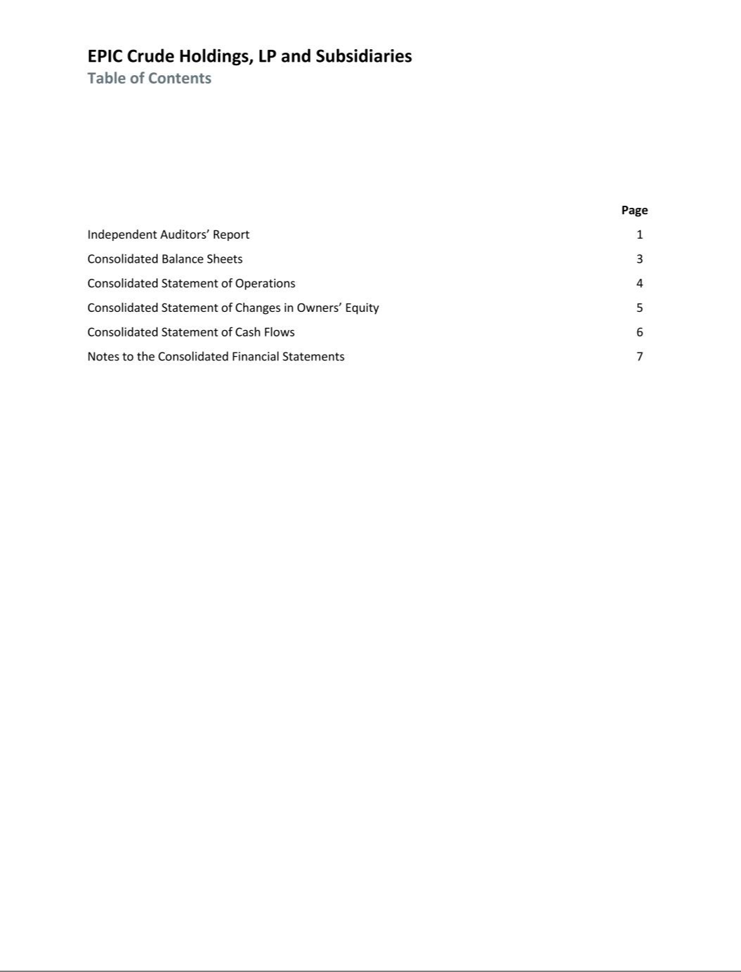

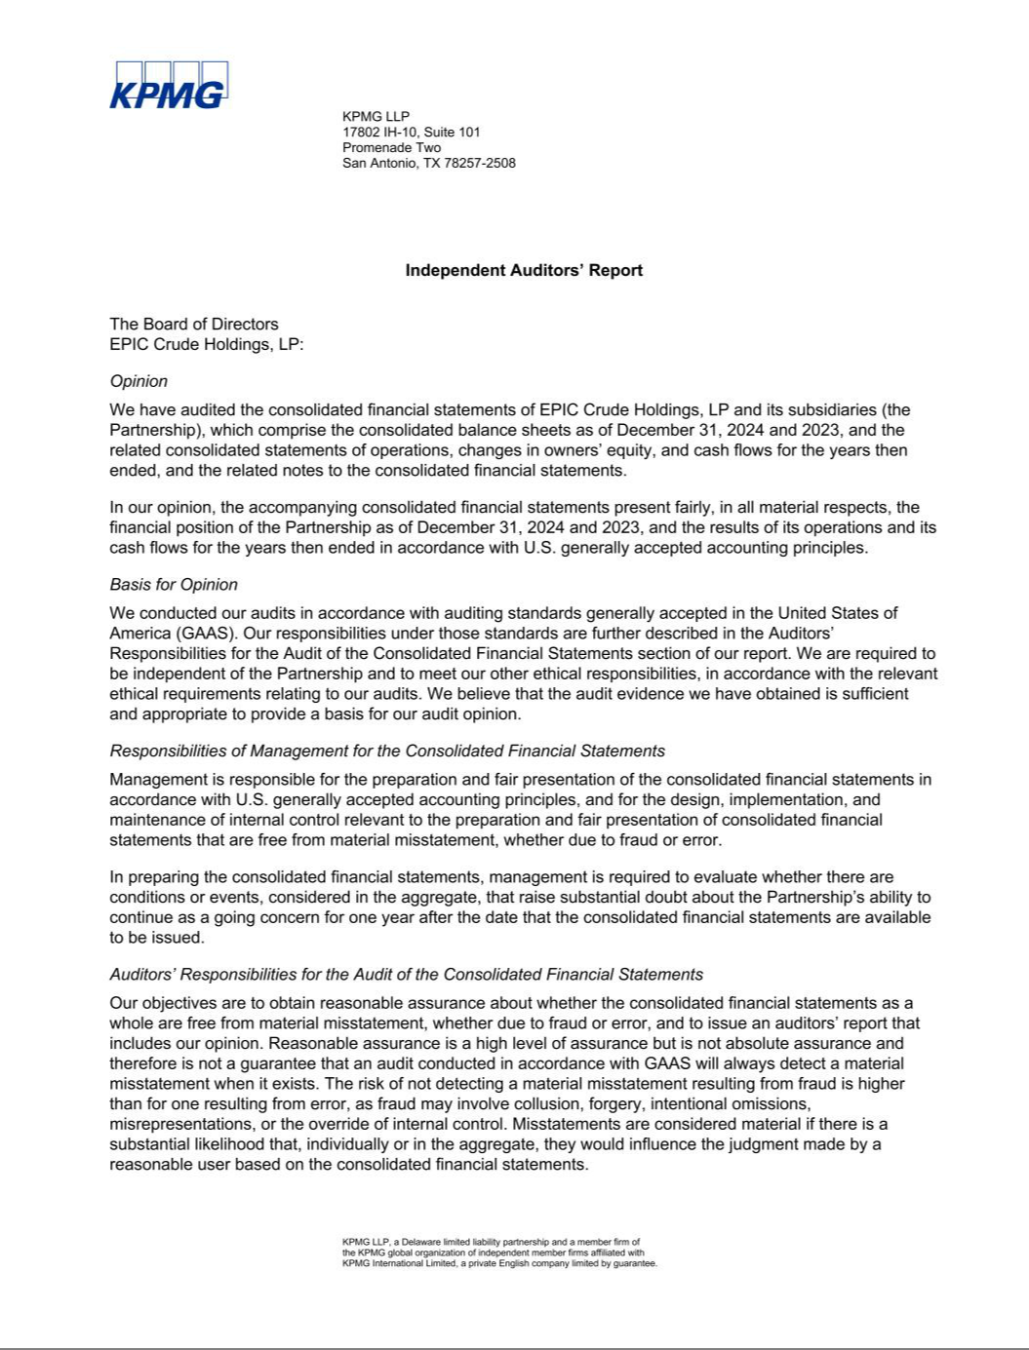

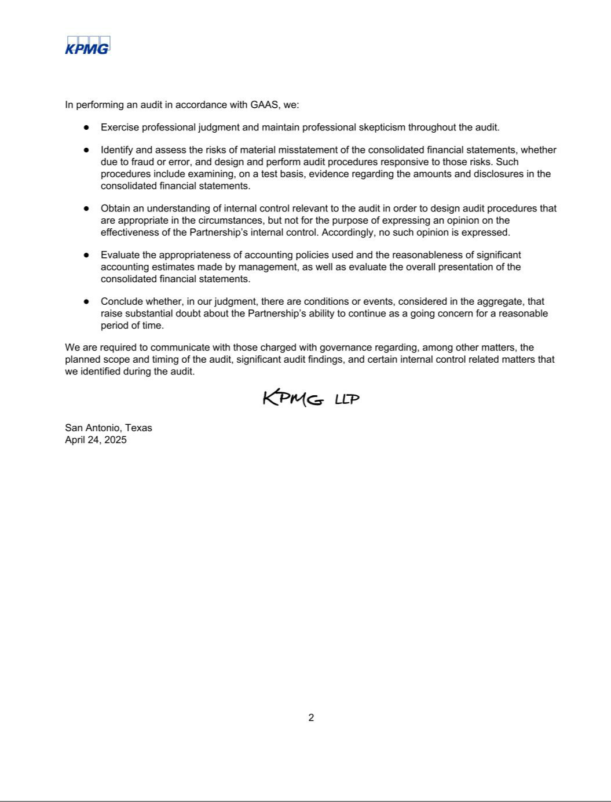

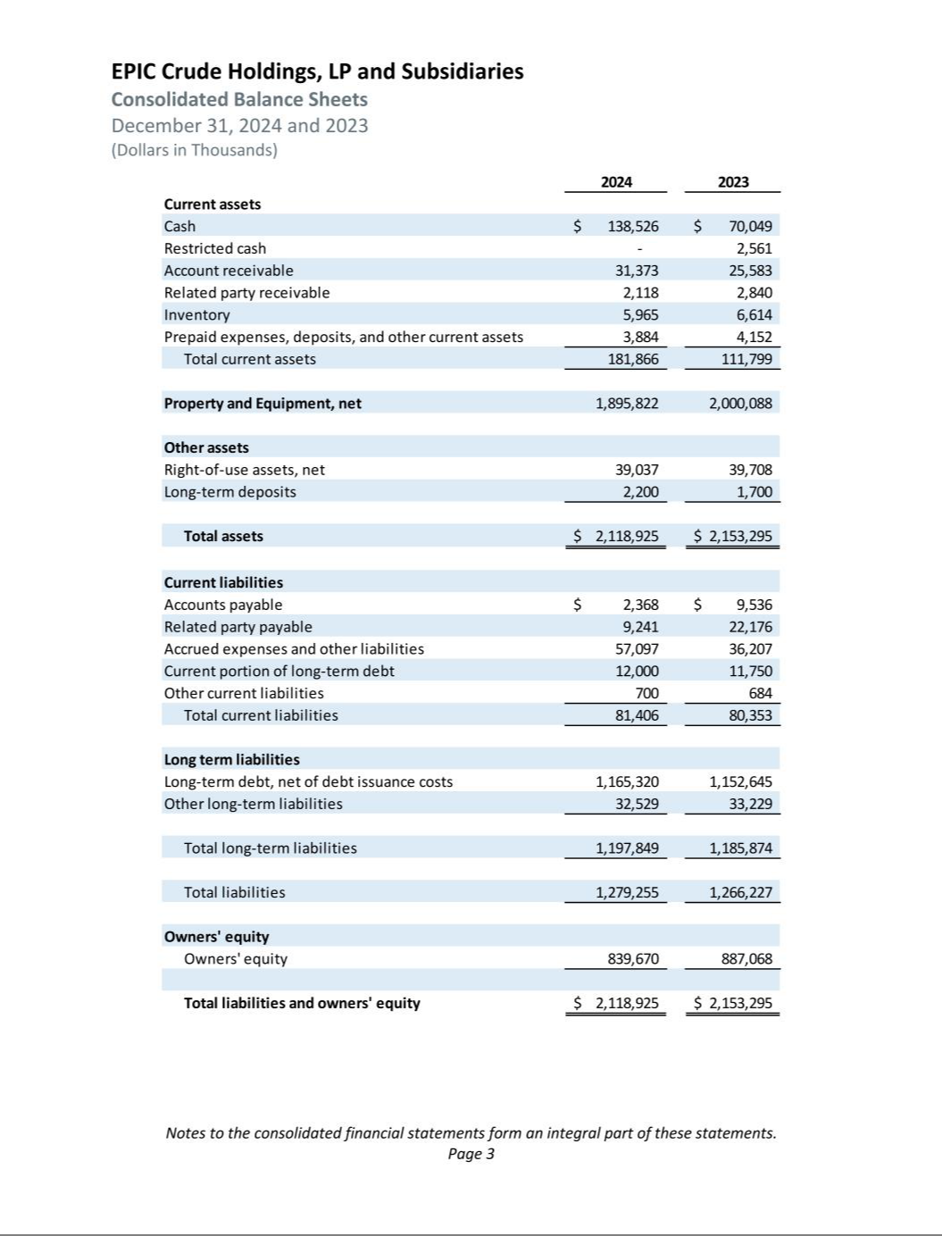

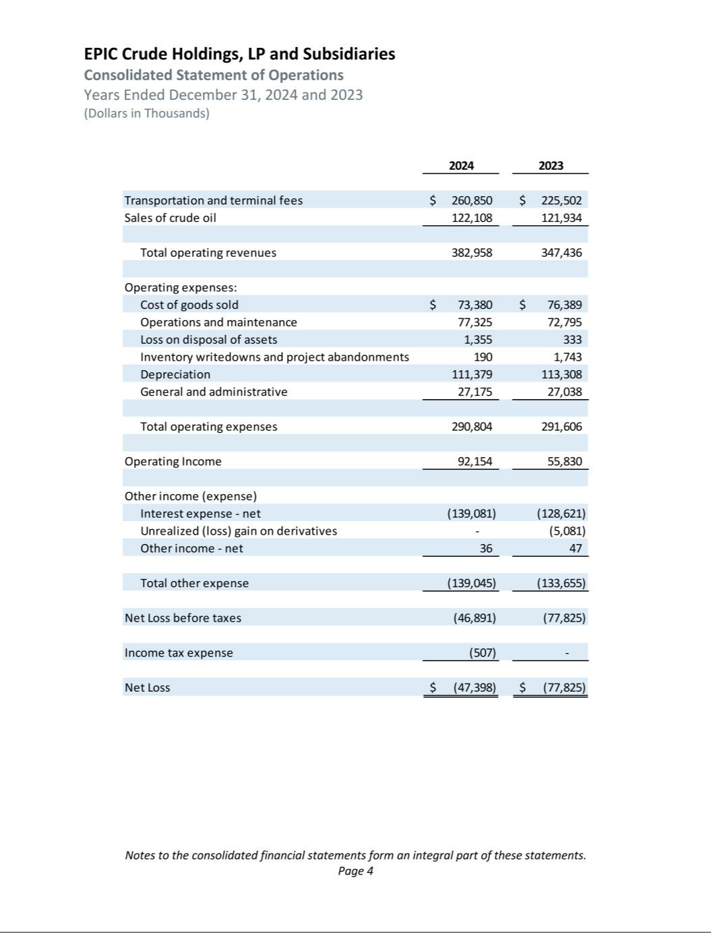

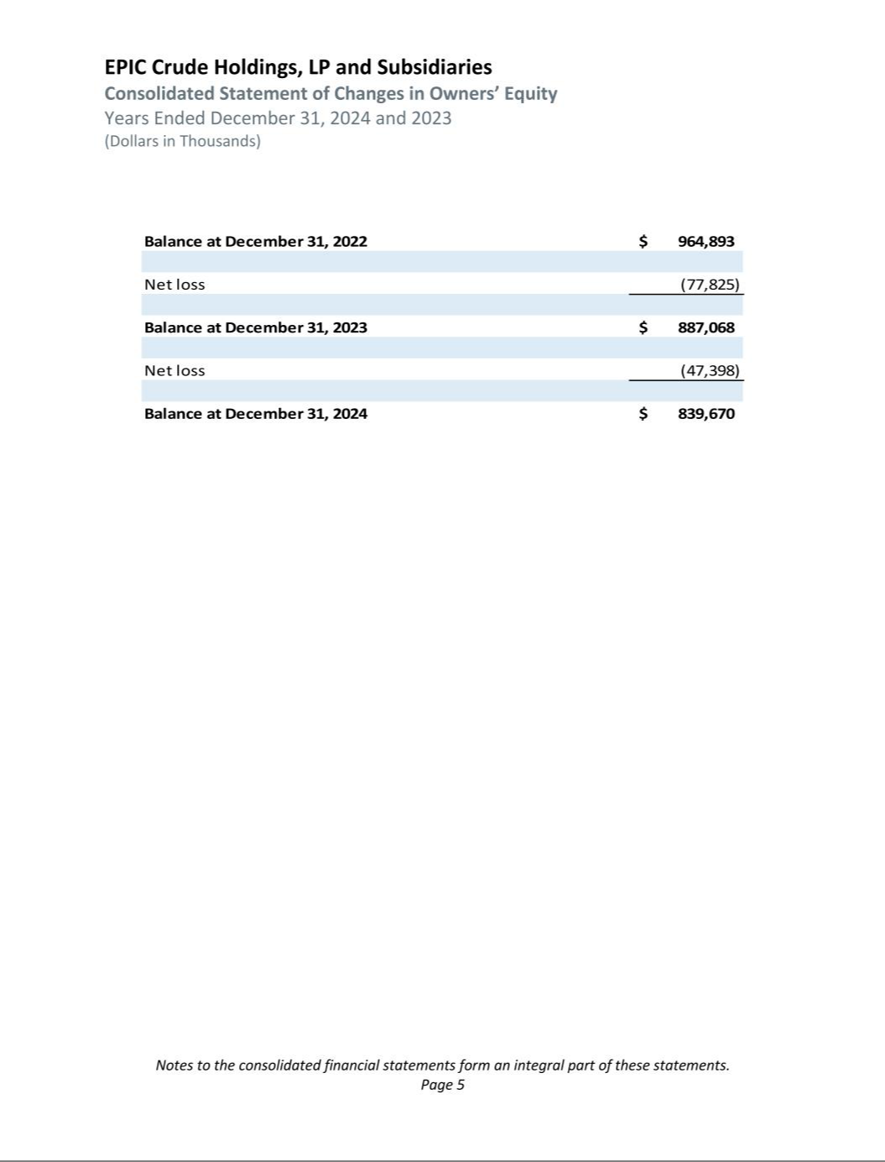

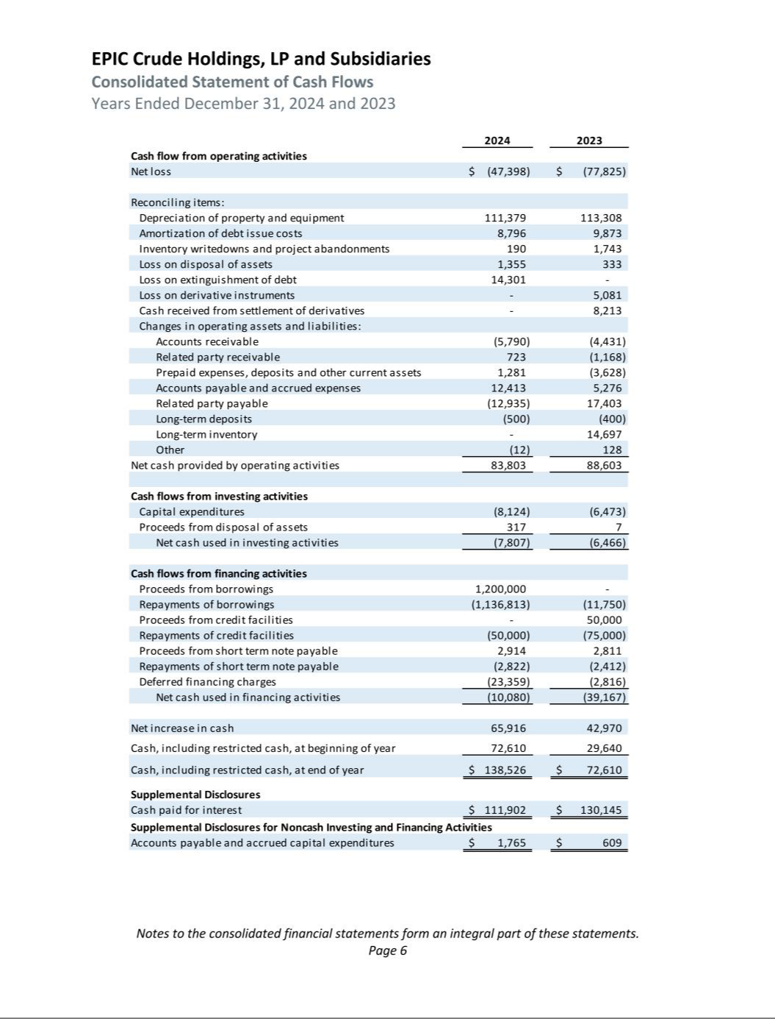

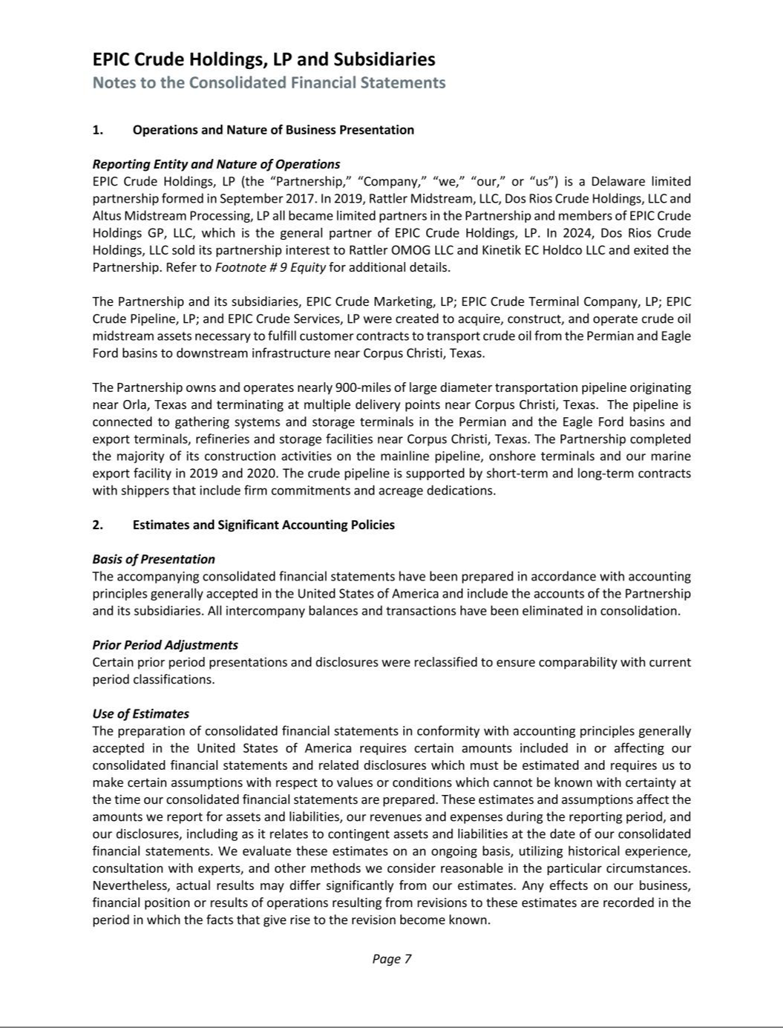

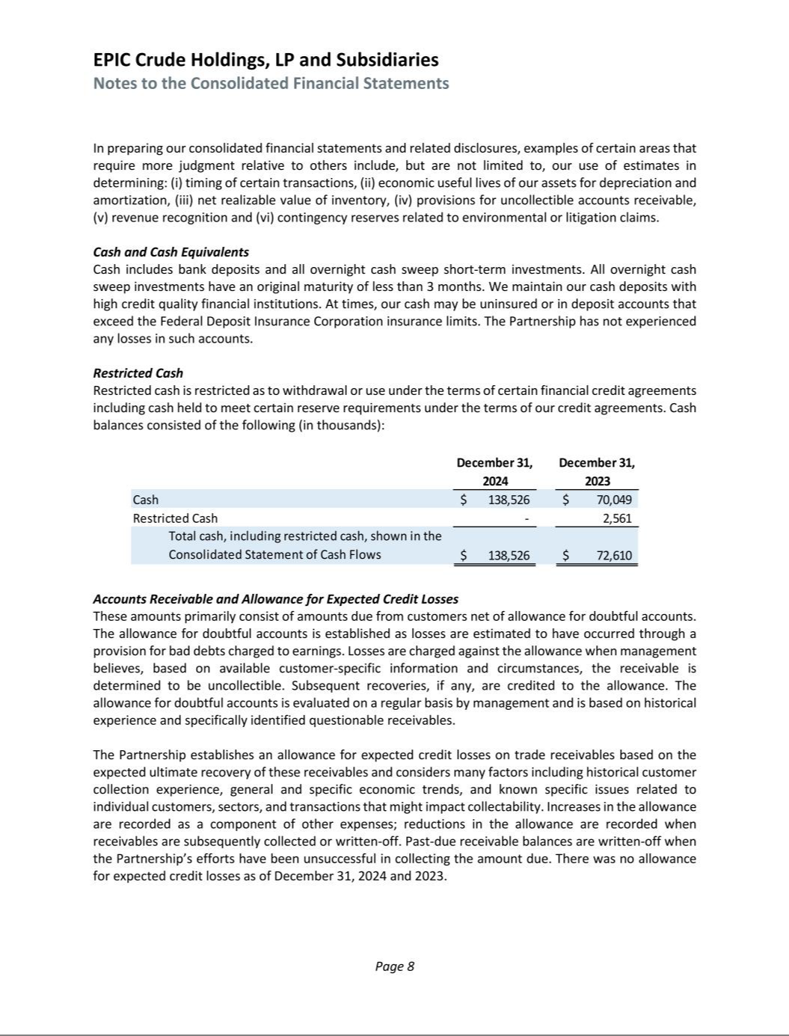

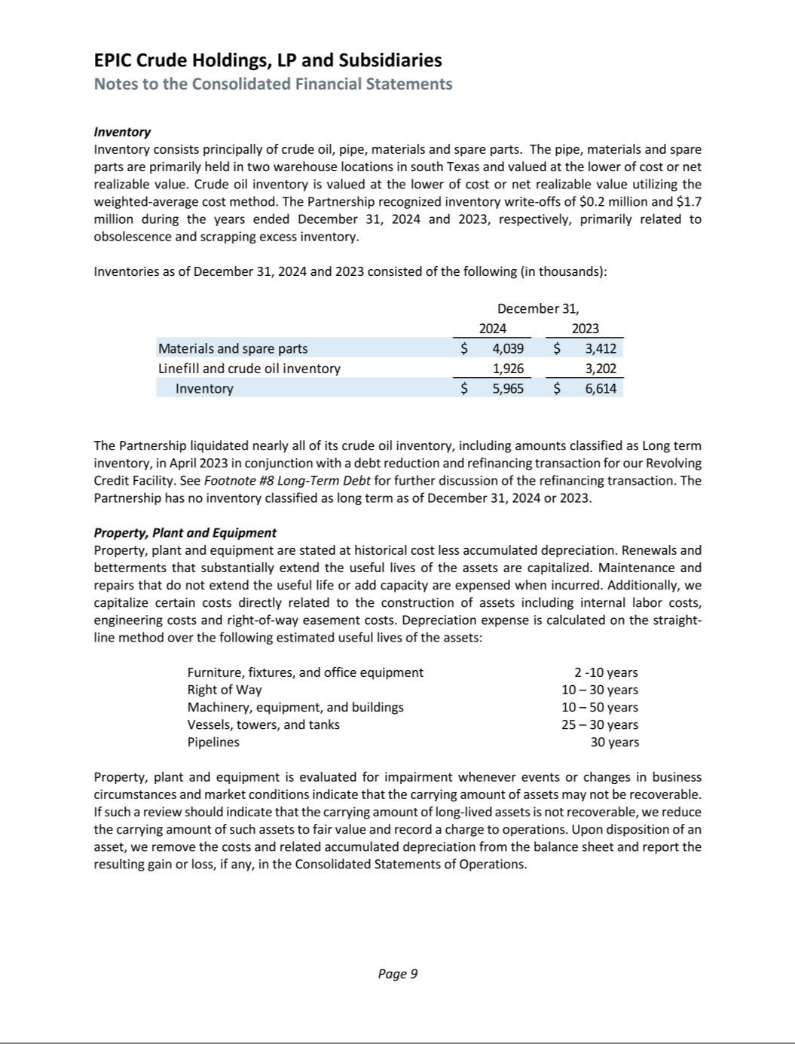

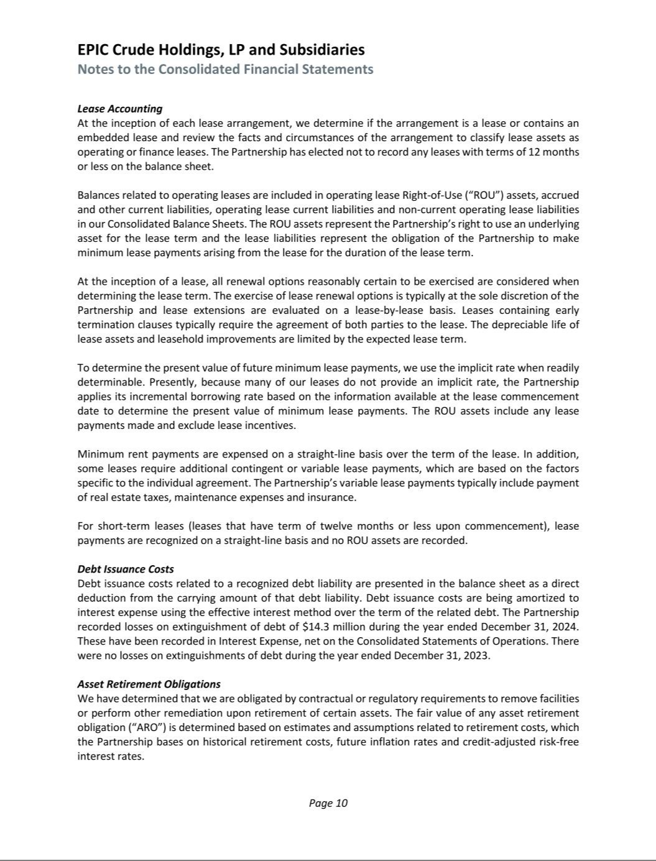

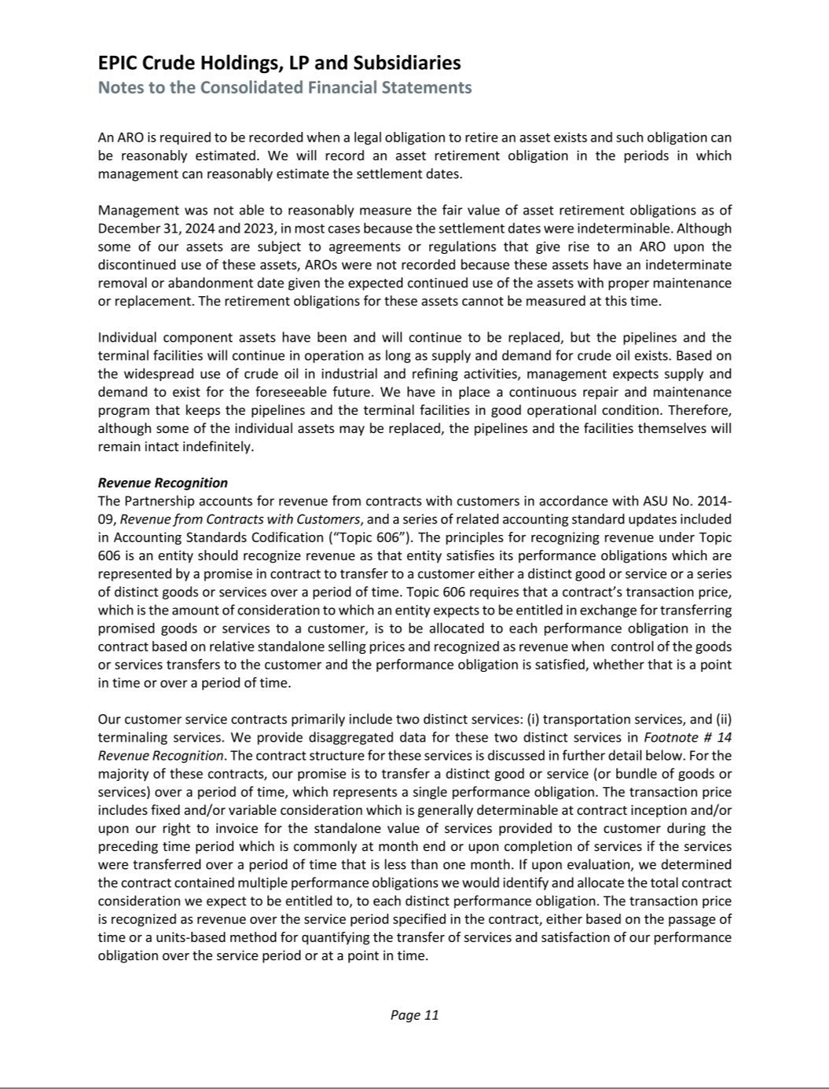

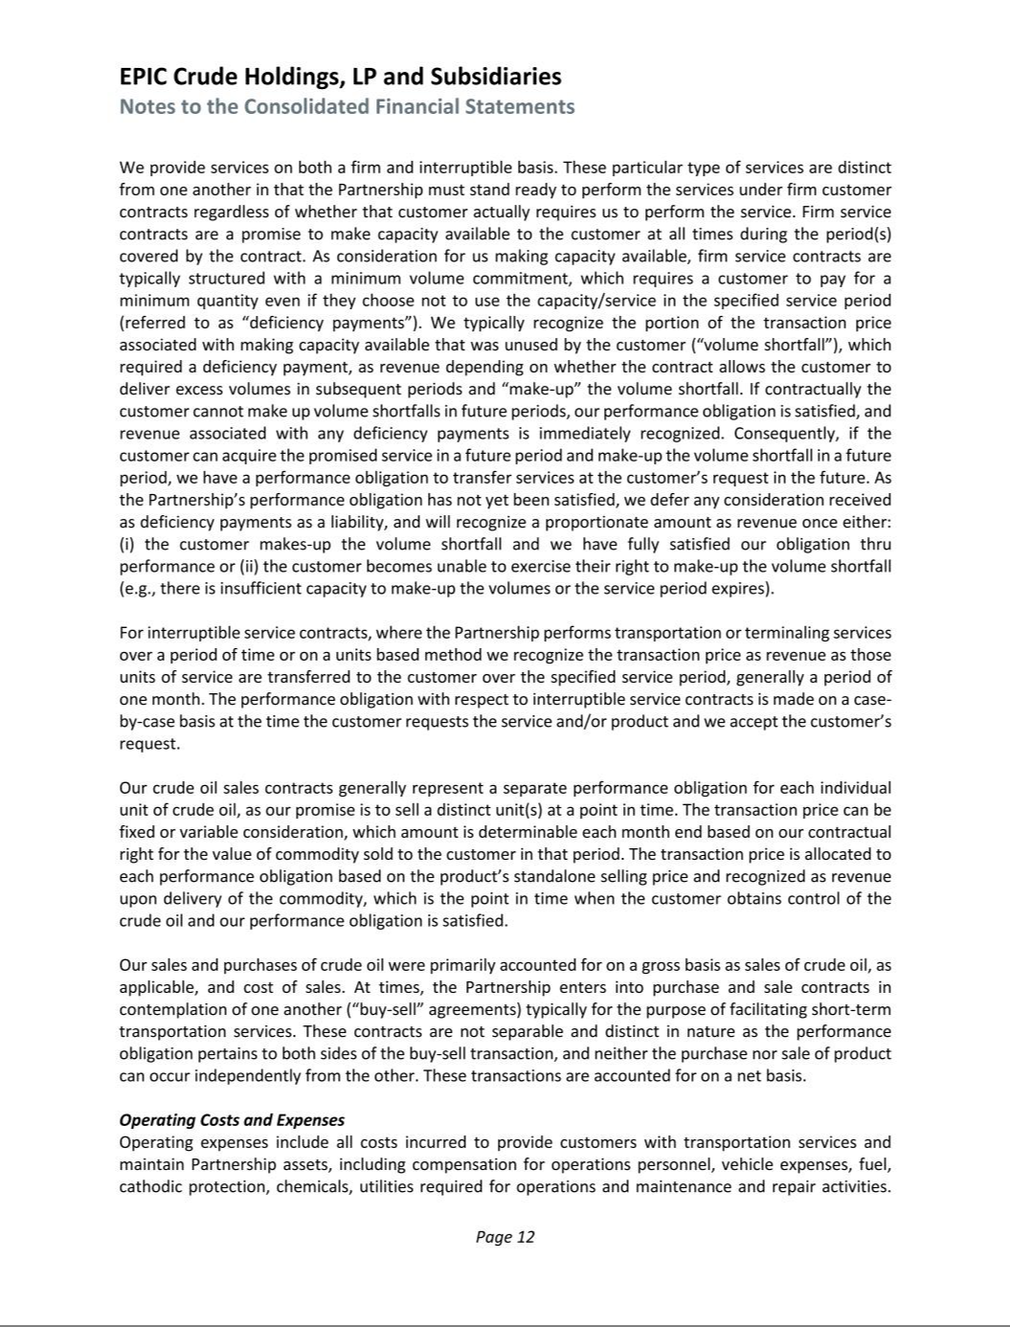

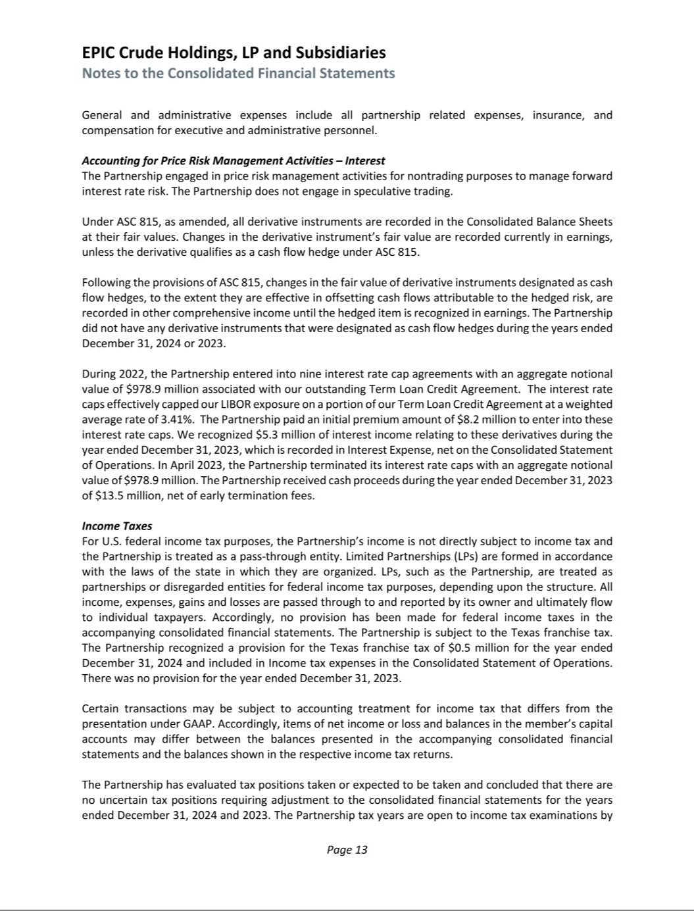

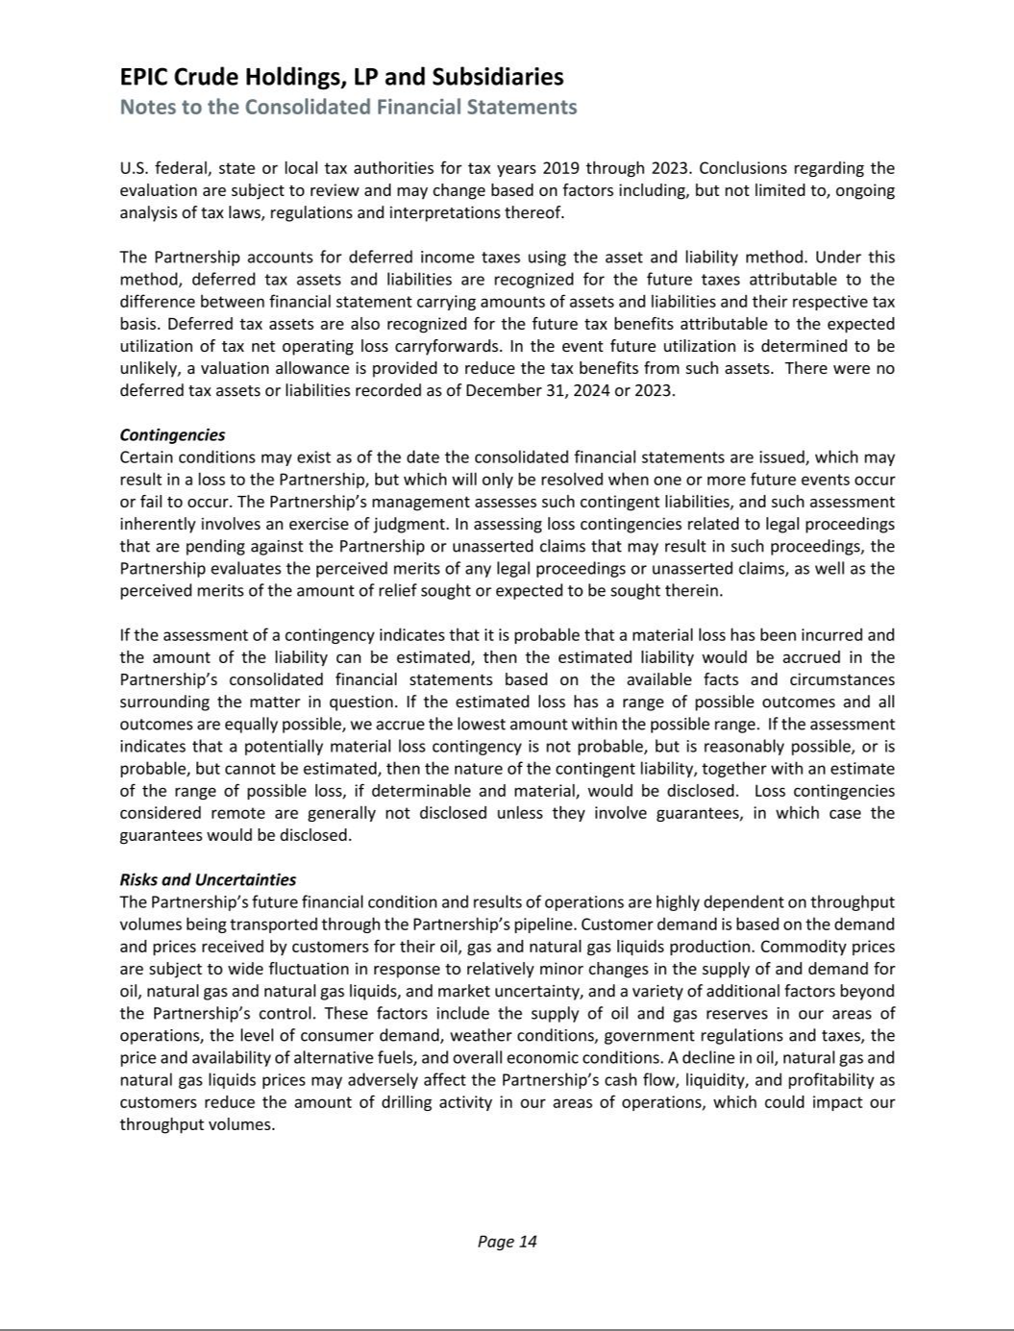

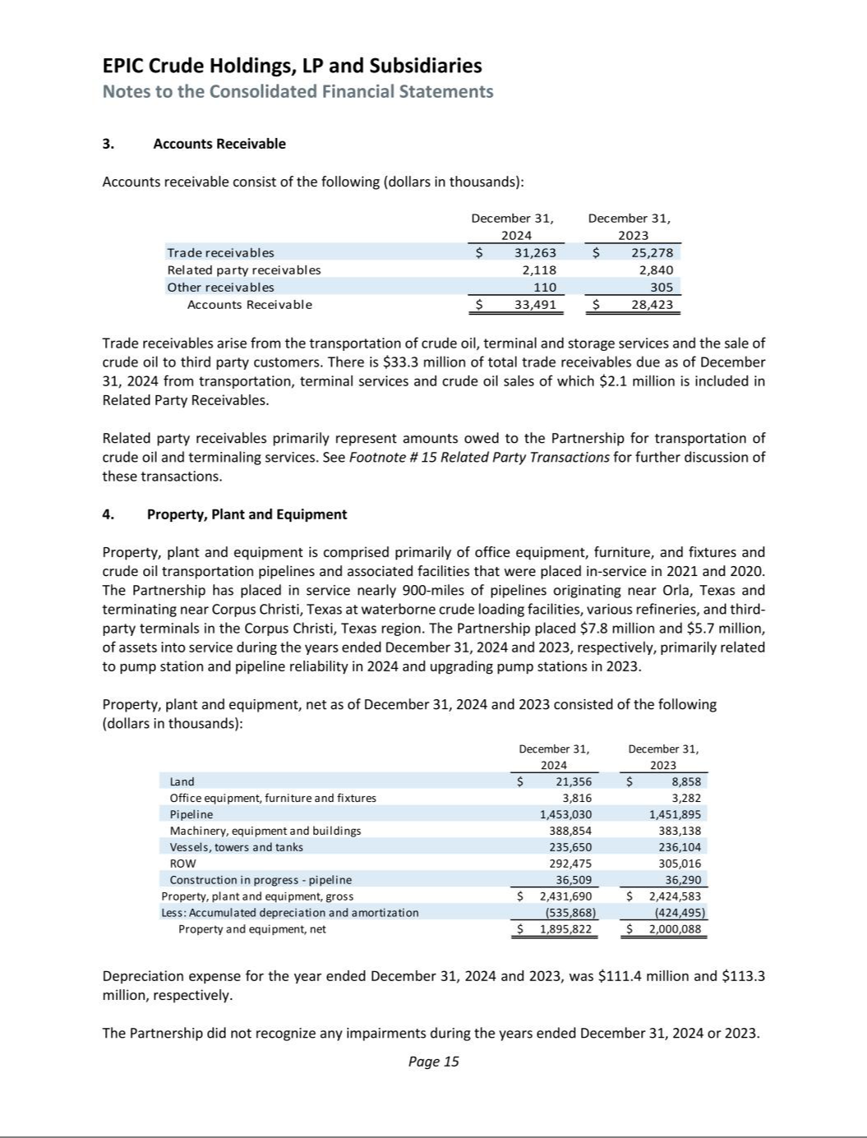

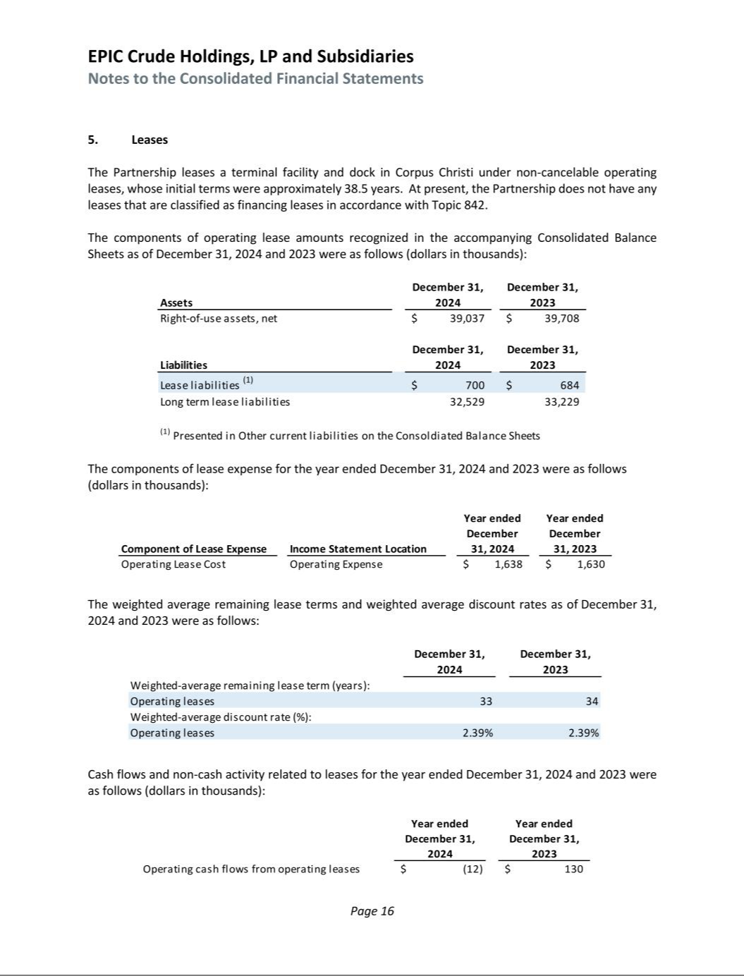

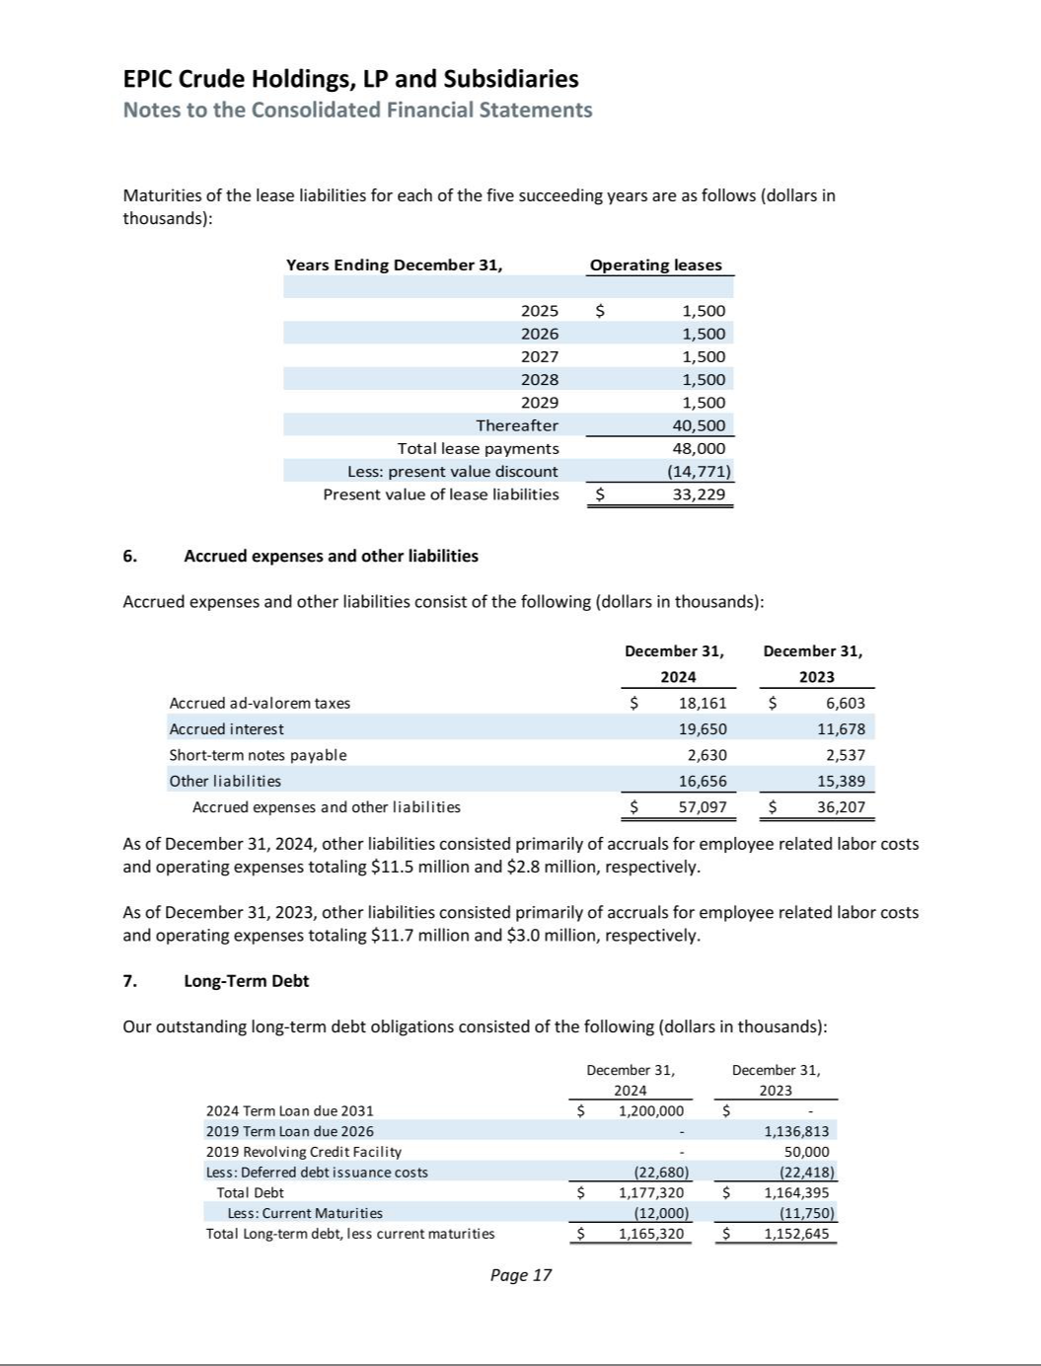

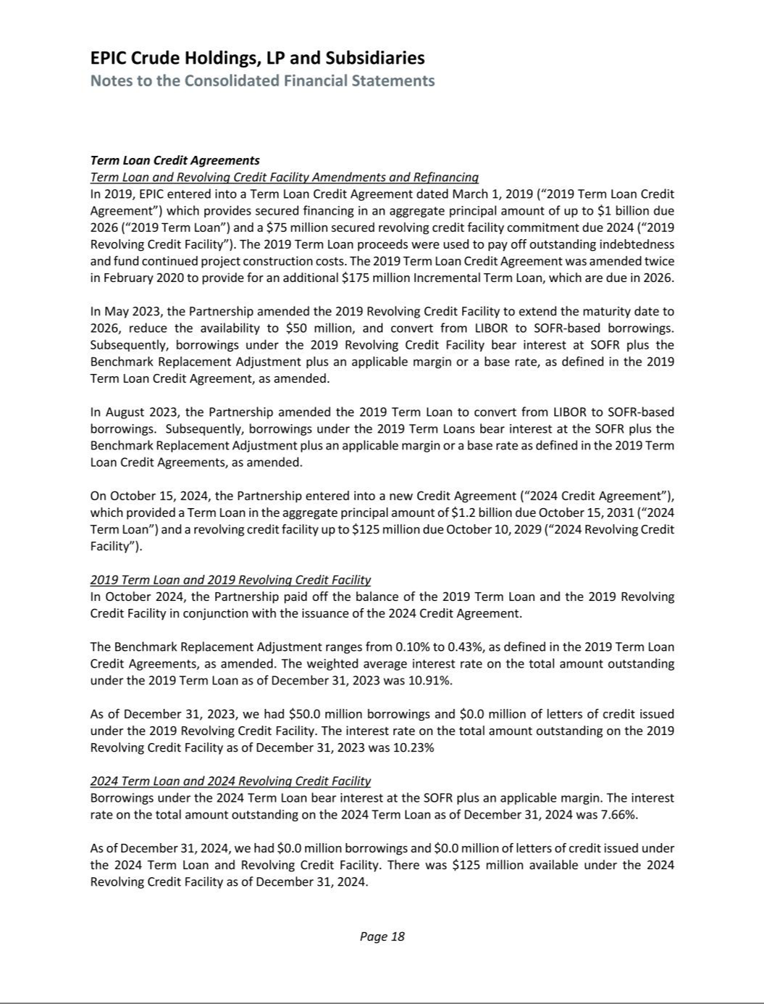

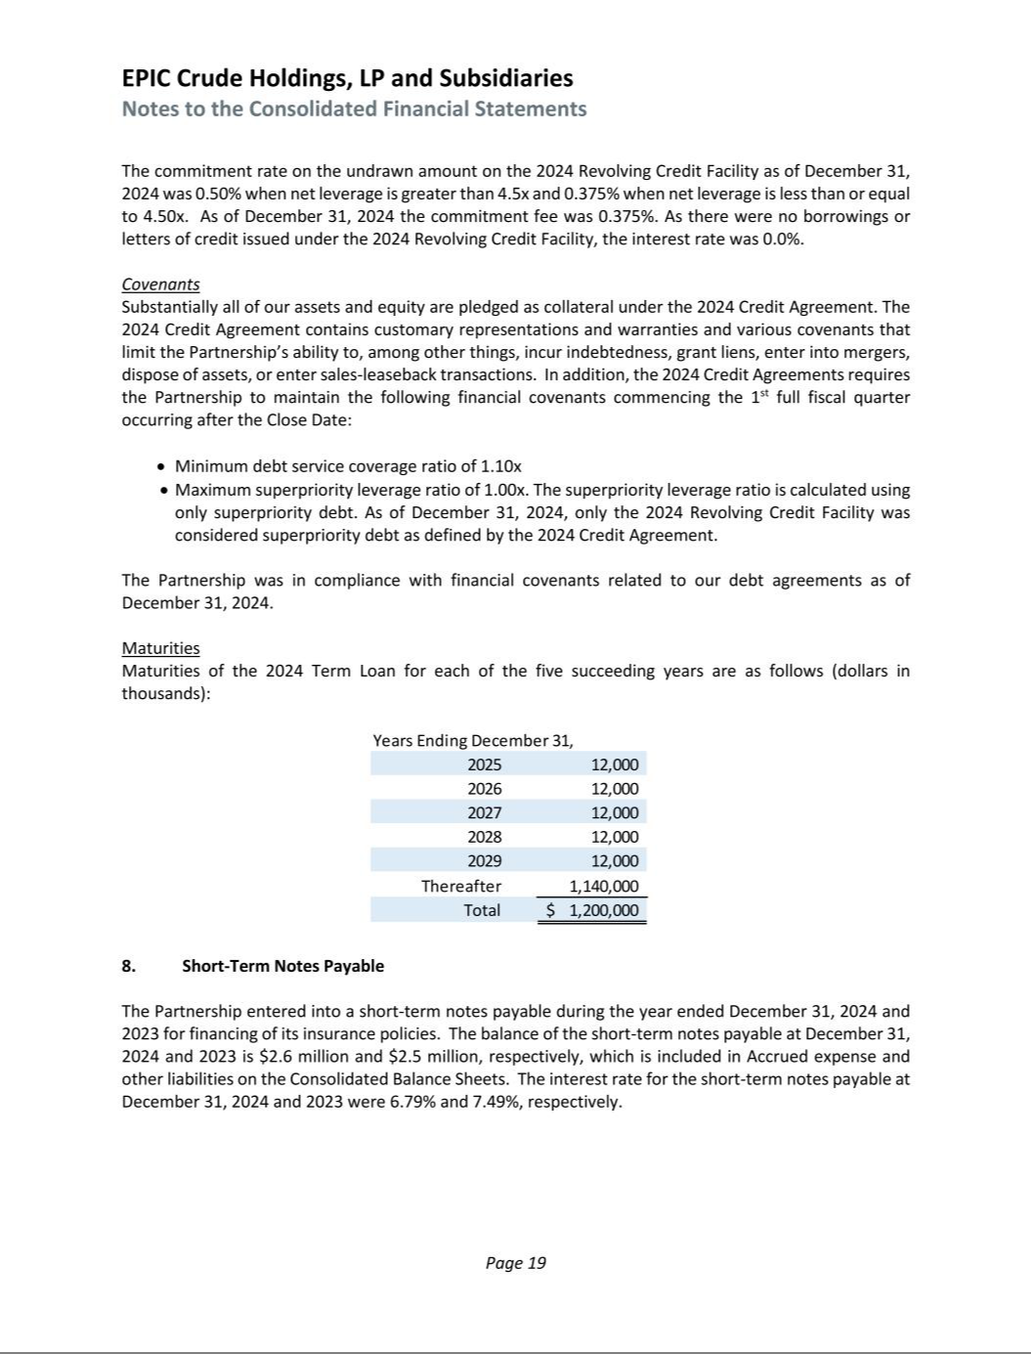

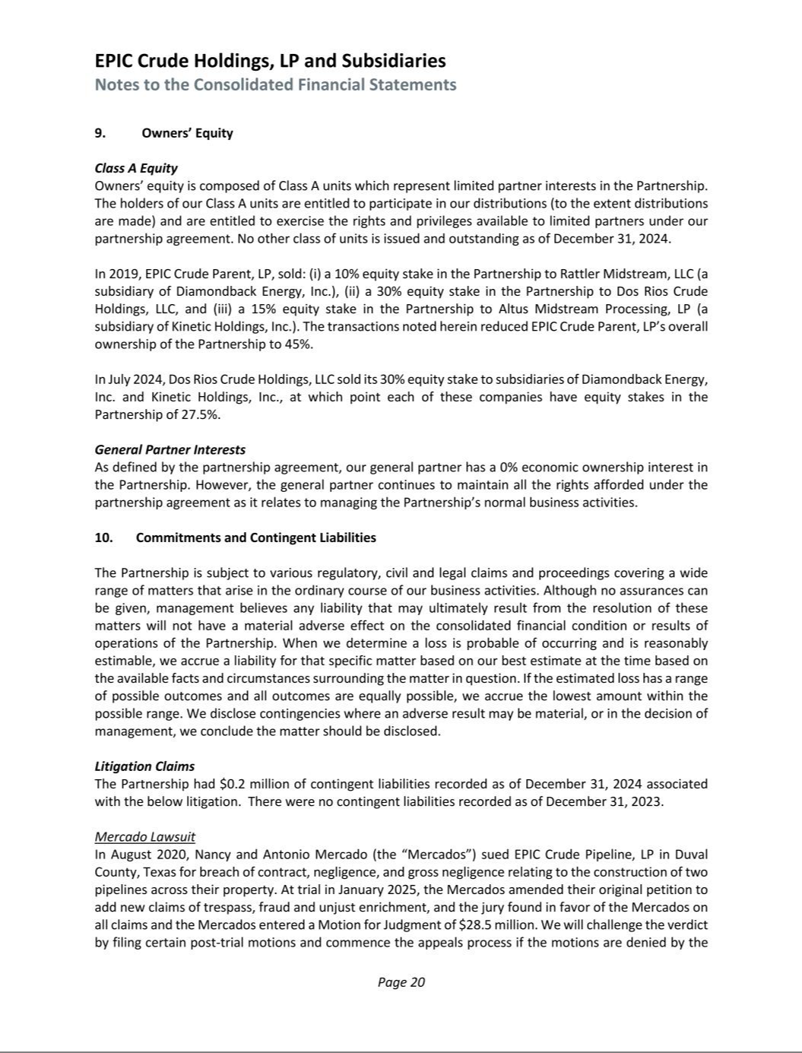

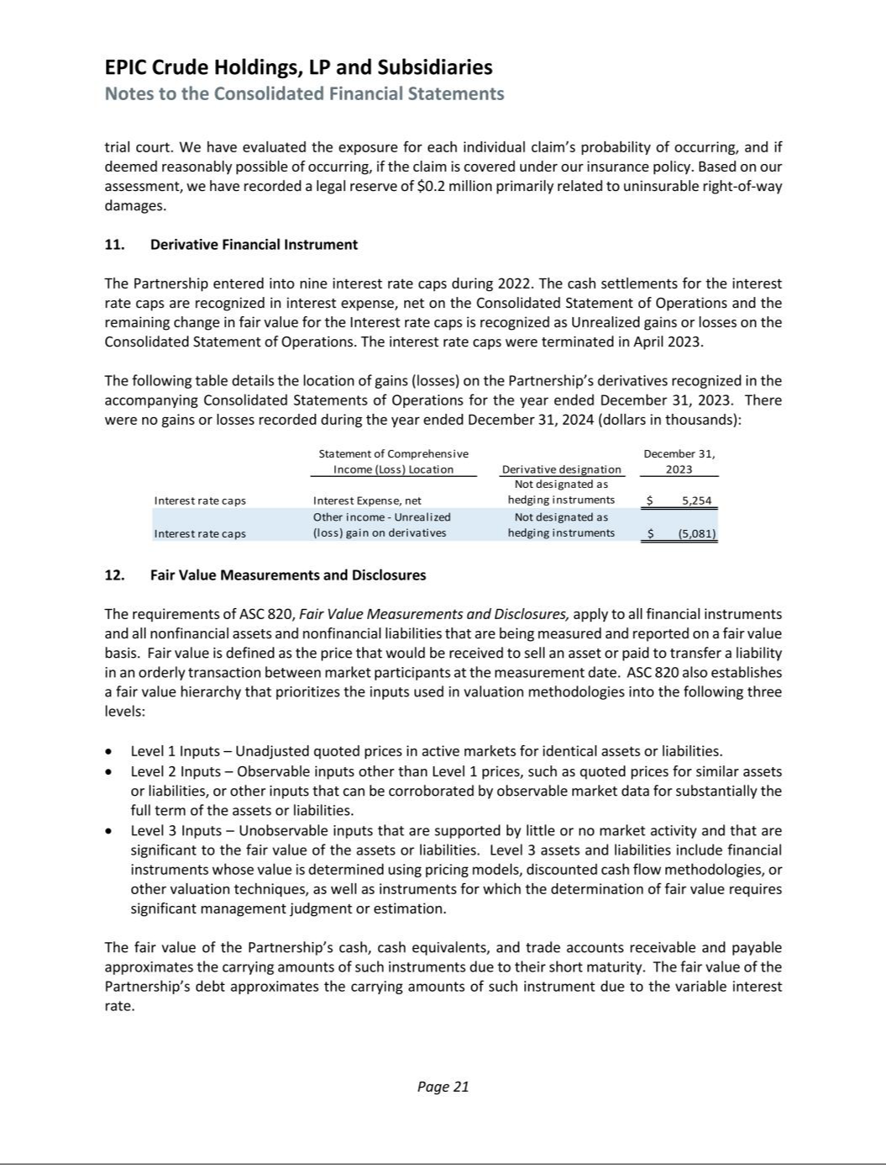

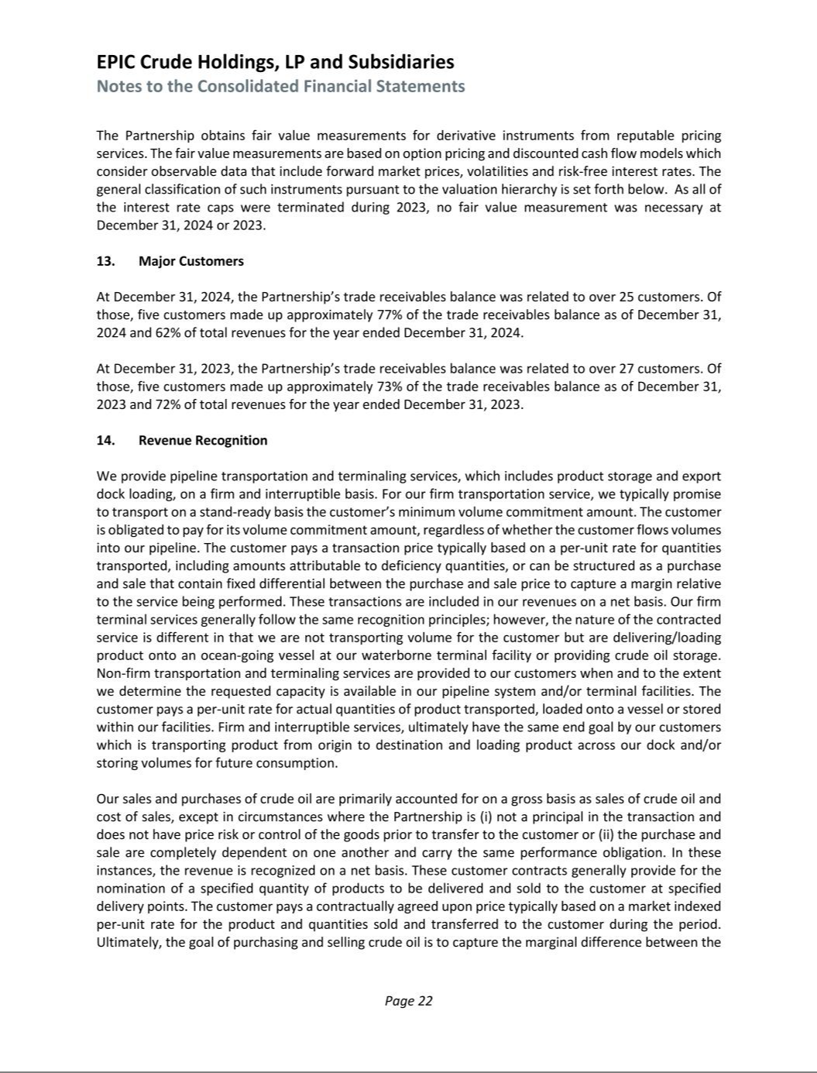

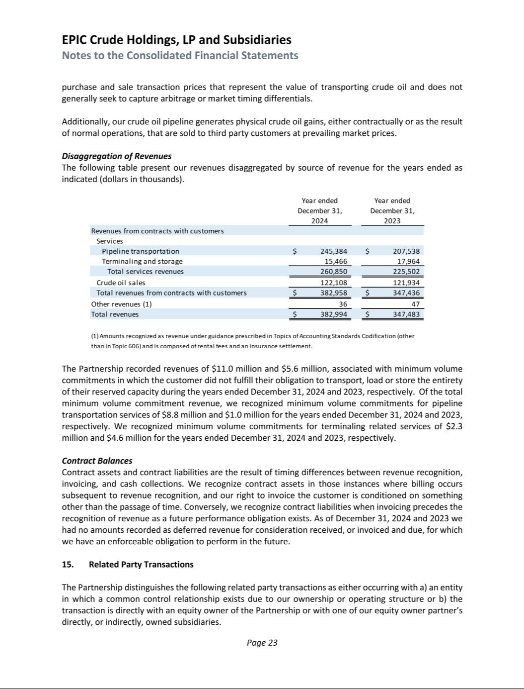

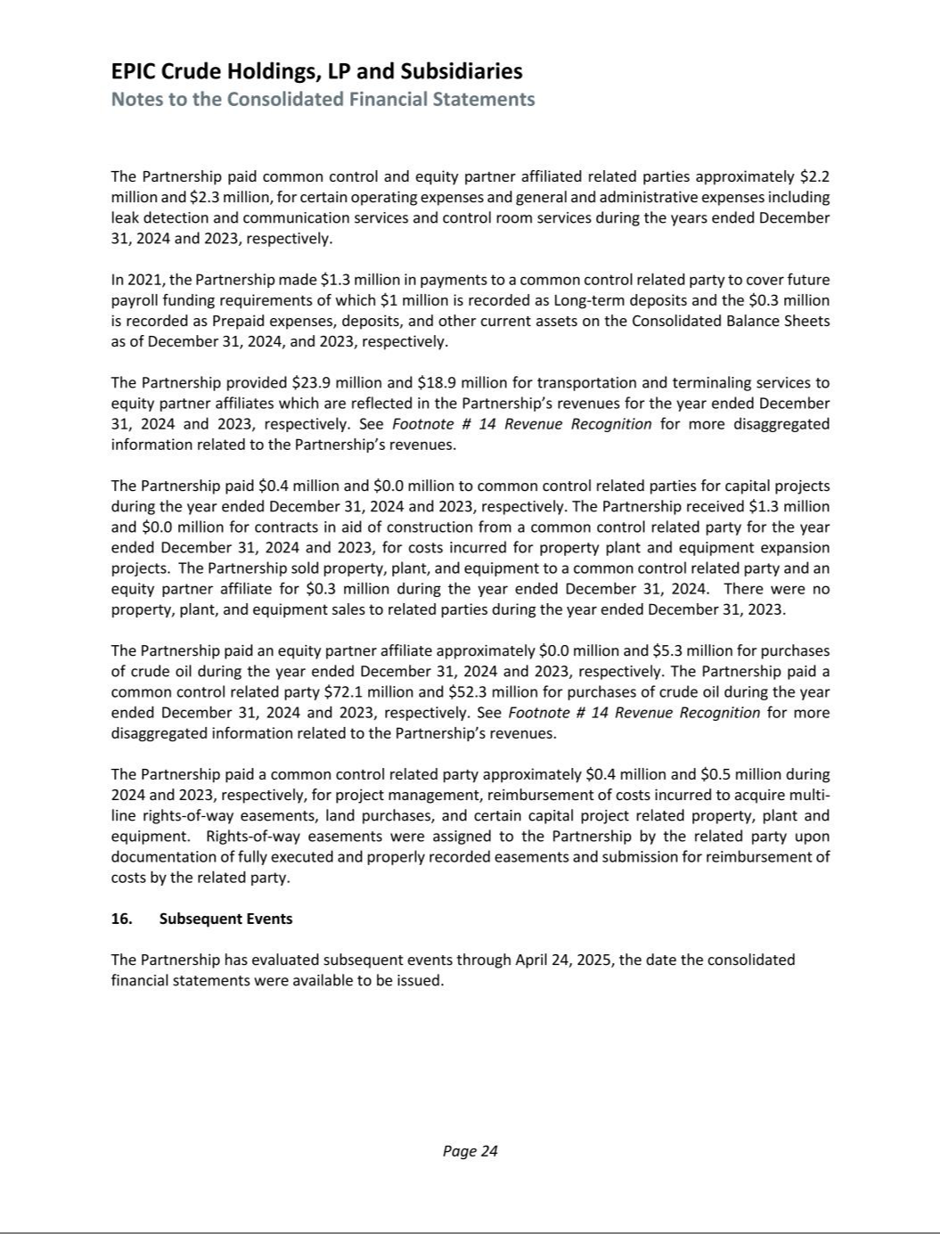

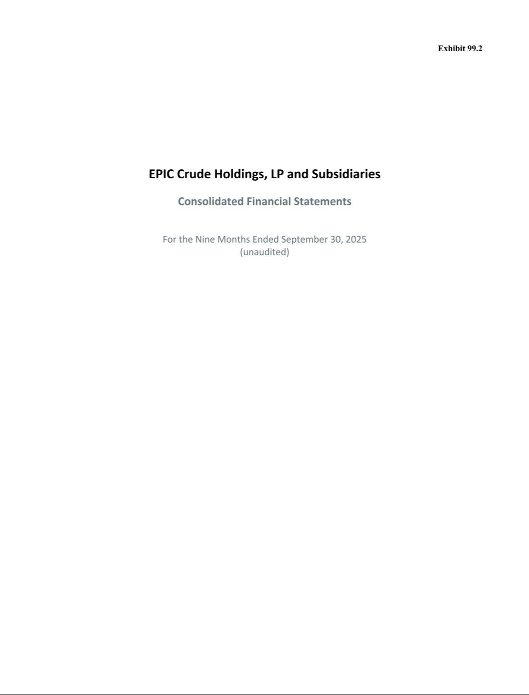

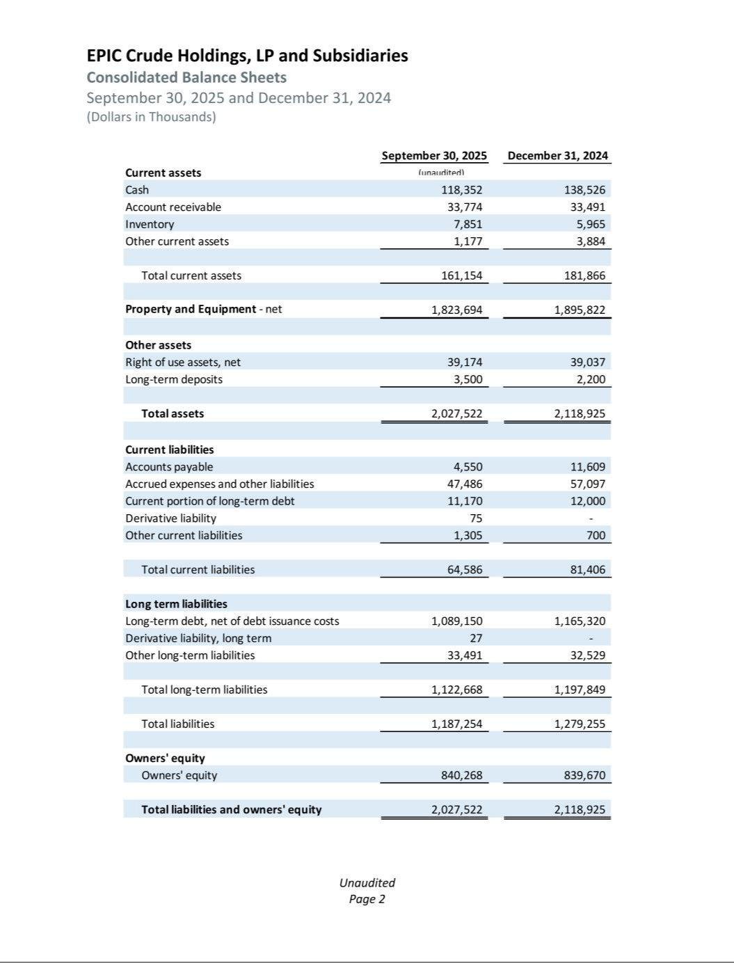

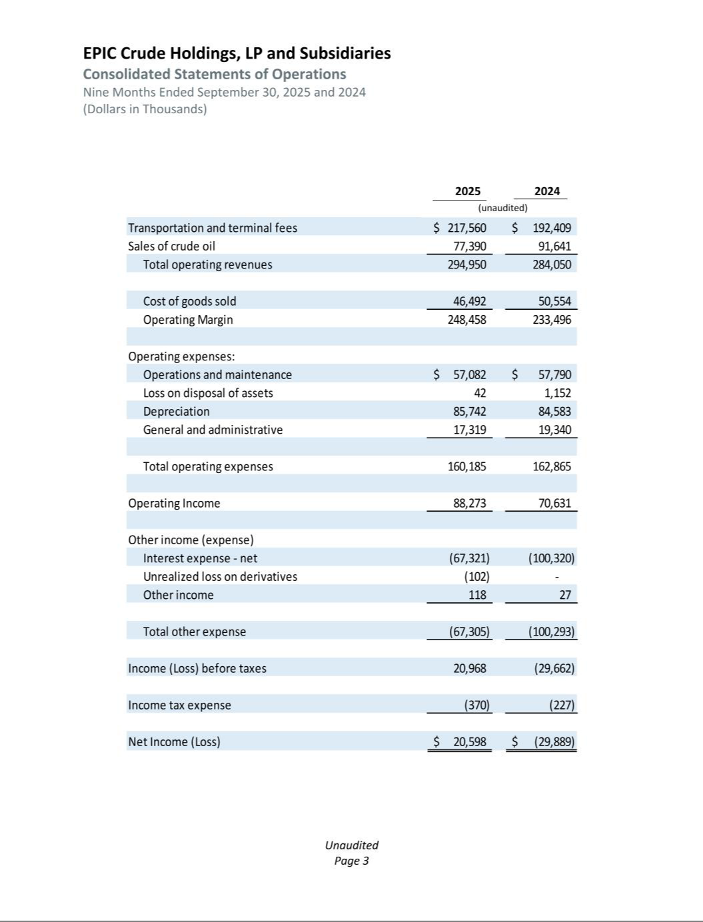

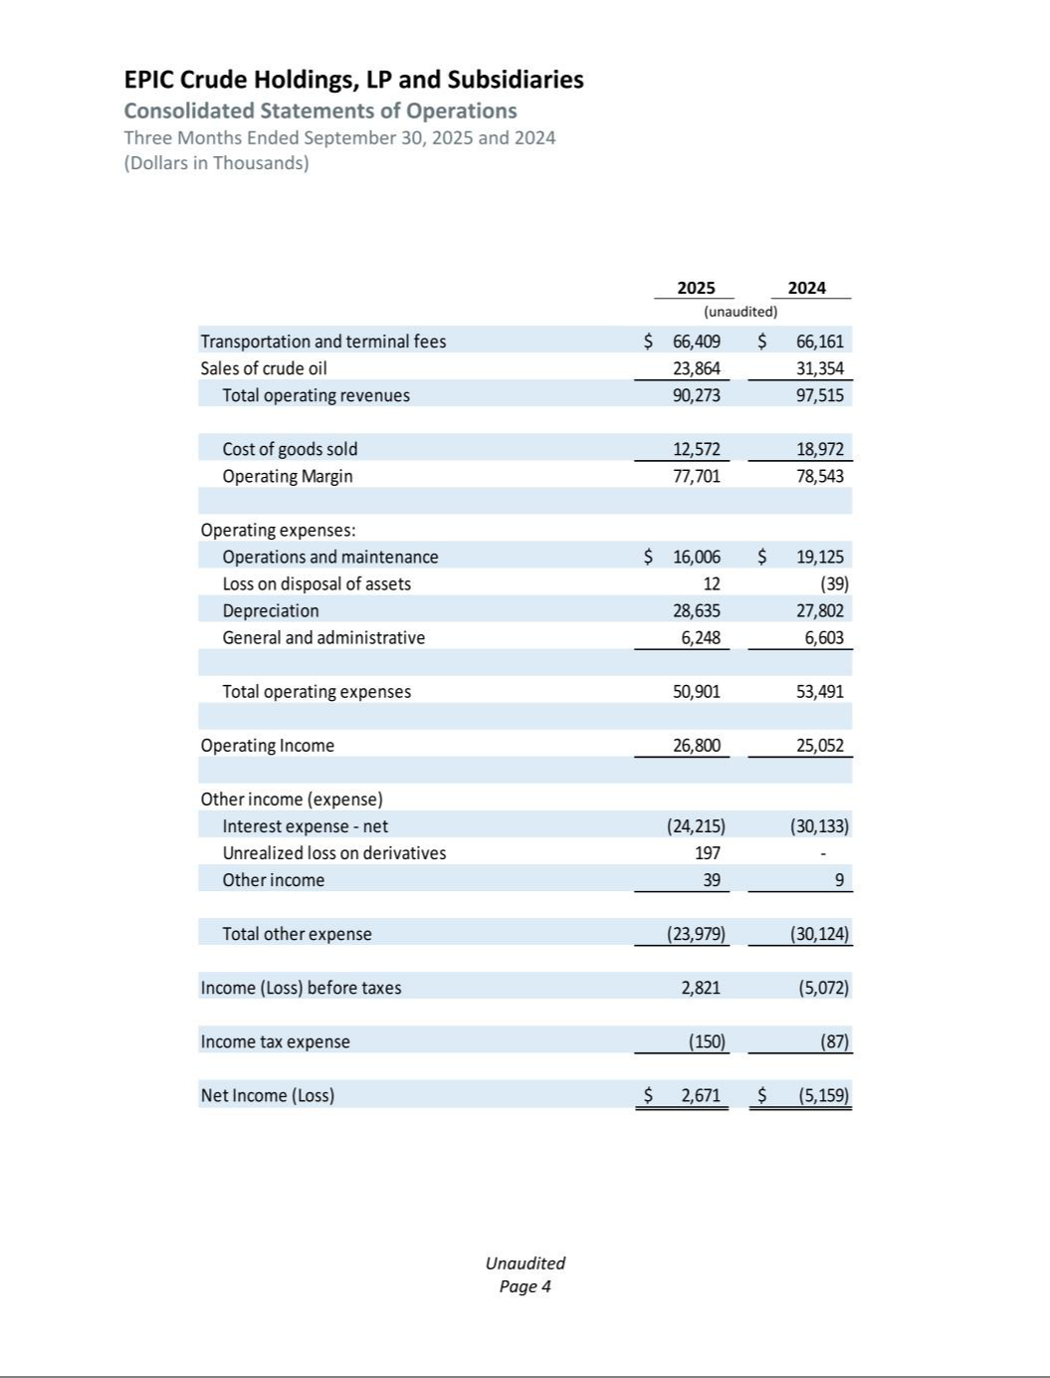

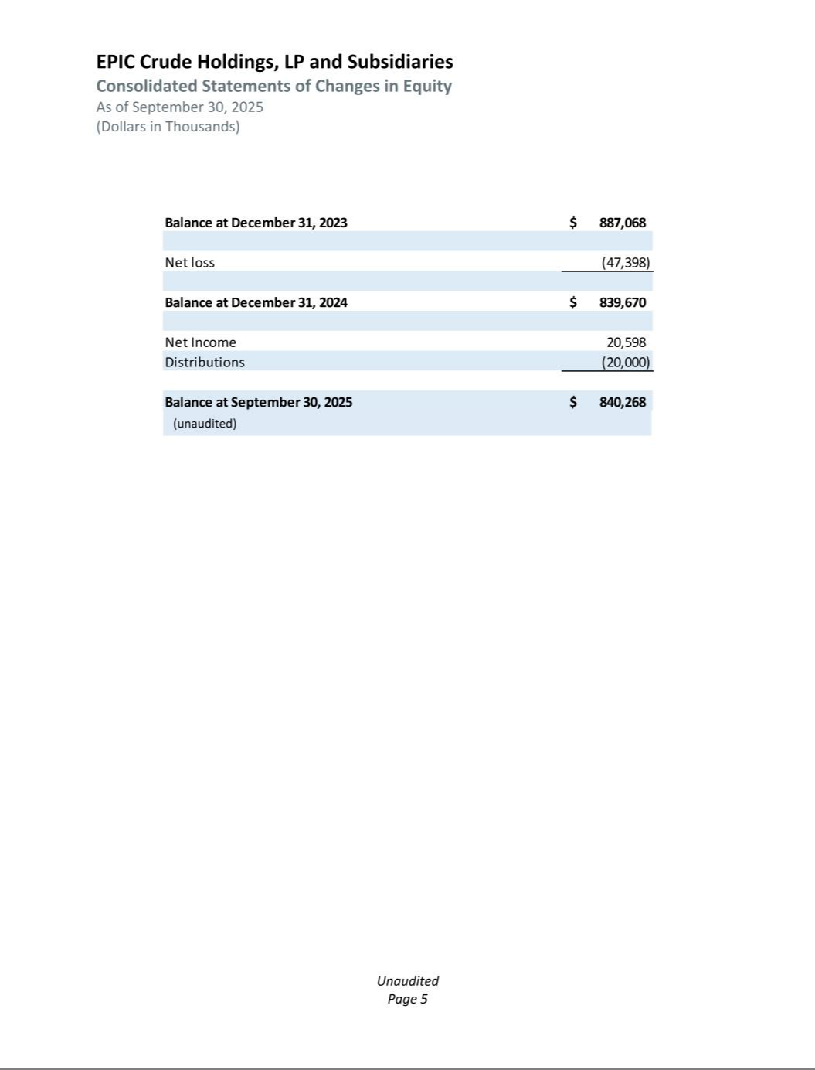

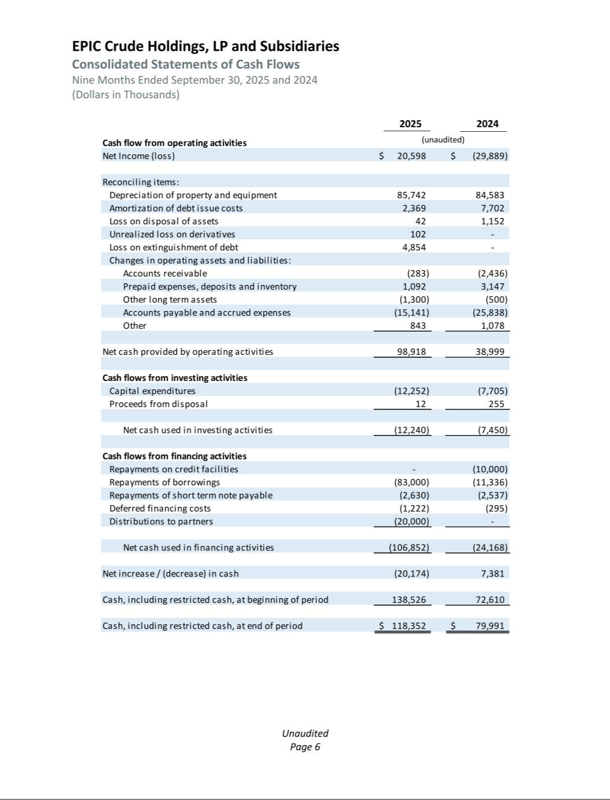

Exhibit 99.3

PLAINS ALL AMERICAN PIPELINE, L.P. AND SUBSIDIARIES

UNAUDITED PRO FORMA CONDENSED COMBINED FINANCIAL INFORMATION

On November 6, 2025, Plains All American Pipeline, L.P. (“PAA”, “we”, “us”, “our”, or the “Company”) filed a Current Report on Form 8-K (the “Original Filing”) to report that on October 31, 2025, pursuant to a Purchase and Sale Agreement (the “PSA”) entered into on August 30, 2025 by and among a wholly-owned subsidiary (the “Buyer”) of PAA, and subsidiaries of Diamondback Energy, Inc. and Kinetik Holdings Inc. (collectively, the “Sellers”), the Buyer completed the purchase from Sellers of an aggregate 55% non-operated equity interest in EPIC Crude Holdings, LP (“EPIC Crude Holdings”), the entity that owns and operates the EPIC Crude Oil Pipeline (the “EPIC Pipeline”), and an aggregate 55% of the membership interests in EPIC Crude Holdings GP, LLC (“EPIC GP”), the general partner of EPIC Crude Holdings (the “EPIC 55% Transaction”).

Effective November 1, 2025, in a separate transaction from the EPIC 55% Transaction, the Buyer also completed the purchase of the remaining 45% equity interest in EPIC Crude Holdings and the remaining 45% of the membership interests in EPIC GP from a subsidiary of Ares Management LLC (the “Ares Seller”) pursuant to that certain definitive Equity Purchase Agreement (the “EPA”) among the Buyer and the Ares Seller (the “EPIC 45% Transaction,” and, together with the EPIC 55% Transaction, the “Transactions”).
As a result of the Transactions, PAA now indirectly owns 100% of the equity interests in EPIC Crude Holdings and 100% of the membership interests in EPIC GP and will serve as operator of record of the EPIC Pipeline. PAA is reporting the Transactions in aggregate as a singular transaction (the “Transaction”) for purposes of the unaudited pro forma condensed combined financial information below due to EPIC Crude Holdings being managed by a common management team despite varying equity ownership.
The Transaction is accounted for as a business combination and thus the Transaction Accounting Adjustments presented in the unaudited pro forma condensed combined financial information have been prepared using the acquisition method of accounting in accordance with Financial Accounting Standards Board Accounting Standards Codification 805, Business Combinations (“ASC 805”). The unaudited pro forma condensed combined financial information is based on assumptions that we believe are reasonable under the circumstances and are intended for informational purposes only. They reflect management’s preliminary estimates of the values of the assets acquired and liabilities assumed, pending the completion of valuation procedures. A change in pro forma adjustments of the purchase price for the Transaction would primarily result in an adjustment to the determined fair values assigned to tangible and intangible assets. The income statement effect of any such changes will depend on the nature and amount of the adjustments.

The following unaudited pro forma condensed combined financial information has been prepared in accordance with Article 11 of SEC Regulation S-X and includes pro forma adjustments that are directly attributable to the Transaction and factually supportable. Certain adjustments have been reflected in the unaudited pro forma condensed statement of combined continuing operations for the year ended December 31, 2024 to give effect to the removal of the results of our natural gas liquids business in Canada (the “Canadian NGL Business”), which is presented as discontinued operations. Accordingly, these adjustments have been included to provide consistent presentation and enhance comparability between periods. See Note 4 for additional information. Additionally, certain reclassifications have been made to the historical presentation of EPIC Crude Holdings’ financial statements to conform to our presentation and to the presentation of the unaudited pro forma condensed combined financial information contained herein. See Note 6 for additional information.

The unaudited pro forma condensed combined financial information has been derived from and should be read in conjunction with the following historical financial statements and accompanying notes of PAA and EPIC Crude Holdings:

- audited consolidated financial statements and related notes of PAA included in PAA’s Annual Report on Form 10-K for the year ended December 31, 2024;

- unaudited condensed consolidated financial statements and related notes of PAA included in PAA’s Quarterly Report on Form 10-Q for the nine months ended September 30, 2025;

- audited consolidated financial statements and related notes of EPIC Crude Holdings, LP and Subsidiaries for the year ended December 31, 2024, included in Exhibit 99.1 to this Current Report on Form 8-K/A; and
- unaudited condensed consolidated financial statements of EPIC Crude Holdings, LP and Subsidiaries for the nine months ended September 30, 2025, included in Exhibit 99.2 to this Current Report on Form 8-K/A.

The unaudited pro forma condensed combined financial information should also be read together with the accompanying notes to the unaudited pro forma condensed combined financial information. The pro forma adjustments are preliminary and are based upon available information and certain assumptions, as described in the accompanying notes to the unaudited pro forma condensed combined financial information, which PAA believes are reasonable under the circumstances.

1

PLAINS ALL AMERICAN PIPELINE, L.P. AND SUBSIDIARIES

UNAUDITED PRO FORMA CONDENSED COMBINED FINANCIAL INFORMATION

The following unaudited pro forma condensed statements of combined continuing operations for the nine months ended September 30, 2025 and for the year ended December 31, 2024 have been prepared as if the Transaction described above had taken place on January 1, 2024. The unaudited pro forma condensed combined balance sheet as of September 30, 2025 assumes the Transaction was consummated on September 30, 2025.

The unaudited pro forma condensed combined financial information was prepared to reflect transaction accounting adjustments that PAA believes are necessary to present a fair statement of the combined company’s financial position and results of operations following the Transaction. They do not reflect any anticipated synergies, integration costs, cost savings, or other potential impacts of combining the businesses. The unaudited pro forma condensed combined financial information is presented for illustrative purposes only and are based on preliminary estimates and assumptions that are subject to change.

The unaudited pro forma condensed combined financial information is not necessarily indicative of the results of the actual or future operations or financial condition that would have been achieved had the Transaction occurred at the dates assumed (as noted above). The actual results in the periods following the Transaction may differ significantly from those reflected in the unaudited pro forma condensed combined financial information for a number of reasons including, but not limited to, differences between the assumptions used to prepare the unaudited pro forma condensed combined financial information and the actual amounts and the completion of a final valuation of the Transaction.

2

PLAINS ALL AMERICAN PIPELINE, L.P. AND SUBSIDIARIES

UNAUDITED PRO FORMA CONDENSED COMBINED FINANCIAL INFORMATION

PLAINS ALL AMERICAN PIPELINE, L.P. AND SUBSIDIARIES

UNAUDITED PRO FORMA CONDENSED COMBINED BALANCE SHEET

September 30, 2025

(in millions)

 |  | PAA |  |  | EPIC Historical |  |  | Pro Forma |  |  | PAA
 |  |  |  |  | As Adjusted |  |  | Adjustments |  |  | PAA
 |  | Historical |  |  | (Note 6) |  |  | (Note 3) |  |  | Pro Forma Combined
ASSETS
CURRENT ASSETS
Cash and cash equivalents | $ | 1,180 |  | $ | 118 |  | $ | — | $ |  | 1,298
Trade accounts receivable and other receivables, net |  | 3,623 |  |  | 34 |  |  | — |  |  | 3,657
Inventory |  | 184 |  |  | 8 |  |  | — |  |  | 192
Current assets of discontinued operations |  | 434 |  |  | — |  |  | — |  |  | 434
Other current assets |  | 162 |  |  | 1 |  |  | — |  |  | 163
Total current assets |  | 5,583 |  |  | 161 |  |  | — |  |  | 5,744
PROPERTY AND EQUIPMENT, NET |  | 14,143 |  |  | 1,824 |  |  | 913 | (a) |  | 16,880
OTHER ASSETS
Investments in unconsolidated entities |  | 2,873 |  |  | — |  |  | — |  |  | 2,873
Intangible assets, net |  | 1,570 |  |  | — |  |  | 278 | (a) |  | 1,848
Linefill |  | 933 |  |  | — |  |  | — |  |  | 933
Long term operating lease right of use asset, net |  | 184 |  |  | 39 |  |  | — |  |  | 223
Long-term inventory |  | 227 |  |  | — |  |  | — |  |  | 227
Long-term assets of discontinued operations |  | 2,479 |  |  | — |  |  | — |  |  | 2,479
Other long-term assets, net |  | 109 |  |  | 4 |  |  | (1) (a) |  |  | 112
Total assets | $ | 28,101 |  | $ | 2,028 |  | $ | 1,190 |  | $ | 31,319
LIABILITIES AND PARTNERS’ CAPITAL
CURRENT LIABILITIES
Trade accounts payable | $ | 3,584 |  | $ | 15 |  | $ | 7 | (b) $ |  | 3,606
Short-term debt |  | 1,010 |  |  | 11 |  |  | — |  |  | 1,021
Current liabilities of discontinued operations |  | 283 |  |  | — |  |  | — |  |  | 283
Other current liabilities |  | 488 |  |  | 38 |  |  | — |  |  | 526
Total current liabilities |  | 5,365 |  |  | 64 |  |  | 7 |  |  | 5,436
LONG-TERM LIABILITIES
Senior notes, net |  | 8,371 |  |  | — |  |  | — |  |  | 8,371
Other long-term debt, net |  | 68 |  |  | 1,089 |  |  | 1,901 | (c) |  | 3,072
 |  |  |  |  |  |  |  | 14 | (a)
Long-term operating lease liabilities |  | 188 |  |  | 34 |  |  | — |  |  | 222
Long-term liabilities of discontinued operations |  | 597 |  |  | — |  |  | — |  |  | 597
Other long-term liabilities and deferred credits |  | 523 |  |  | 1 |  |  | 115 | (d) |  | 639
Total long-term liabilities |  | 9,747 |  |  | 1,124 |  |  | 2,030 |  |  | 12,901
COMMITMENTS AND CONTINGENCIES
PARTNERS’ CAPITAL
Series A Preferred |  | 1,247 |  |  | — |  |  | — |  |  | 1,247
Series B Preferred |  | 787 |  |  | — |  |  | — |  |  | 787
Common unitholders |  | 7,729 |  |  | 840 |  |  | (840) (a) |  |  | 7,722
 |  |  |  |  |  |  |  | (7) (b)
Total partners’ capital excluding noncontrolling interests |  | 9,763 |  |  | 840 |  |  | (847) |  |  | 9,756
Noncontrolling interests |  | 3,226 |  |  | — |  |  | — |  |  | 3,226
Total partners’ capital |  | 12,989 |  |  | 840 |  |  | (847) |  |  | 12,982
Total liabilities and partners’ capital | $ | 28,101 |  | $ | 2,028 |  | $ | 1,190 | $ |  | 31,319

The accompanying notes are an integral part of this Unaudited Pro Forma Condensed Combined Financial Information.

3

PLAINS ALL AMERICAN PIPELINE, L.P. AND SUBSIDIARIES

UNAUDITED PRO FORMA CONDENSED COMBINED FINANCIAL INFORMATION

PLAINS ALL AMERICAN PIPELINE, L.P. AND SUBSIDIARIES

UNAUDITED PRO FORMA CONDENSED STATEMENT OF COMBINED CONTINUING OPERATIONS

For the Nine Months Ended September 30, 2025

(in millions, except per unit data)

 | PAA |  |  |  | EPIC Historical |  |  | Pro Forma |  |  | PAA
 | PAA |  |  |  | As Adjusted |  |  | Adjustments |  |  | PAA
 | Historical |  |  |  | (Note 6) |  |  | (Note 3) |  |  | Pro Forma Combined
REVENUES | $ | 33,698 | $ |  | 181 |  | $ | — | $ |  | 33,879
COSTS AND EXPENSES
Purchases and related costs |  | 30,862 |  |  | (68) |  |  | — |  |  | 30,794
Field operating costs |  | 873 |  |  | 57 |  |  | — |  |  | 930
General and administrative expenses |  | 251 |  |  | 17 |  |  | — |  |  | 268
Depreciation and amortization |  | 696 |  |  | 86 |  |  | (86) (f) |  |  | 777
 |  |  |  |  |  |  |  | 43 | (g)
 |  |  |  |  |  |  |  | 38 | (g)
Gain on asset sales, net |  | (64) |  |  | — |  |  | — |  |  | (64)
Total costs and expenses |  | 32,618 |  |  | 92 |  |  | (5) |  |  | 32,705
OPERATING INCOME |  | 1,080 |  |  | 89 |  |  | 5 |  |  | 1,174
OTHER INCOME/(EXPENSE)
Equity earnings in unconsolidated entities |  | 292 |  |  | — |  |  | — |  |  | 292
Gain on investments in unconsolidated entities, net |  | 31 |  |  | — |  |  | — |  |  | 31
Interest expense |  | (395) |  |  | (67) |  |  | (80) (h) |  |  | (542)
Other income, net |  | 70 |  |  | — |  |  | — |  |  | 70
INCOME FROM CONTINUING OPERATIONS BEFORE TAX |  | 1,078 |  |  | 22 |  |  | (75) |  |  | 1,025
Current income tax expense from continuing operations |  | (11) |  |  | — |  |  | — |  |  | (11)
Deferred income tax expense from continuing operations |  | (6) |  |  | — |  |  | — |  |  | (6)
INCOME FROM CONTINUING OPERATIONS, NET OF TAX |  | 1,061 |  |  | 22 |  |  | (75) |  |  | 1,008
Net income attributable to noncontrolling interests from continuing operations |  | (249) |  |  | — |  |  | — |  |  | (249)
NET INCOME ATTRIBUTABLE TO PAA FROM CONTINUING OPERATIONS | $ | 812 | $ |  | 22 |  | $ | (75) | $ |  | 759
NET INCOME PER COMMON UNIT:
Net income allocated to common unitholders - Basic and Diluted
Net income allocated to common unitholders from continuing operations - Basic and
Diluted | $ | 599 |  |  |  |  |  |  | $ |  | 546
Basic and diluted weighted average common units outstanding |  | 704 |  |  |  |  |  |  |  |  | 704
Basic and diluted net income per common unit
Basic and diluted net income per common unit from continuing operations | $ | 0.85 |  |  |  |  |  |  | $ |  | 0.78

The accompanying notes are an integral part of this Unaudited Pro Forma Condensed Combined Financial Information.

4

PLAINS ALL AMERICAN PIPELINE, L.P. AND SUBSIDIARIES

UNAUDITED PRO FORMA CONDENSED COMBINED FINANCIAL INFORMATION

PLAINS ALL AMERICAN PIPELINE, L.P. AND SUBSIDIARIES

UNAUDITED PRO FORMA CONDENSED STATEMENT OF COMBINED CONTINUING OPERATIONS

For the Year Ended December 31, 2024

(in millions, except per unit data)

 | PAA Historical |  |  |  | EPIC Historical |  |  | Pro Forma |  |  | PAA
 | As Adjusted for Continuing |  |  |  | As Adjusted |  |  | Adjustments |  |  | PAA
 | Operations (Note 4) |  |  |  | (Note 6) |  |  | (Note 3) |  |  | Pro Forma Combined
REVENUES | $ | 48,889 | $ |  | 235 |  | $ | — | $ |  | 49,124
COSTS AND EXPENSES
Purchases and related costs |  | 45,162 |  |  | (75) |  |  | — |  |  | 45,087
Field operating costs |  | 1,471 |  |  | 77 |  |  | 3 | (e) |  | 1,551
General and administrative expenses |  | 328 |  |  | 27 |  |  | 4 | (e) |  | 368
 |  |  |  |  |  |  |  | 9 | (b)
Depreciation and amortization |  | 901 |  |  | 111 |  |  | (111) (f) |  |  | 1,024
 |  |  |  |  |  |  |  | 57 | (g)
 |  |  |  |  |  |  |  | 66 | (g)
Loss on asset sales, net |  | 159 |  |  | 1 |  |  | — |  |  | 160
Total costs and expenses |  | 48,021 |  |  | 141 |  |  | 28 |  |  | 48,190
OPERATING INCOME |  | 868 |  |  | 94 |  |  | (28) |  |  | 934
OTHER INCOME/(EXPENSE)
Equity earnings in unconsolidated entities |  | 452 |  |  | — |  |  | — |  |  | 452
Gain on investments in unconsolidated entities, net |  | 15 |  |  | — |  |  | — |  |  | 15
Interest expense |  | (430) |  |  | (139) |  |  | (121) (h) |  |  | (690)
Other income, net |  | 64 |  |  | — |  |  | — |  |  | 64
INCOME (LOSS) FROM CONTINUING OPERATIONS BEFORE TAX |  | 969 |  |  | (45) |  |  | (149) |  |  | 775
Current income tax expense from continuing operations |  | (82) |  |  | — |  |  | — |  |  | (82)
Deferred income tax expense from continuing operations |  | (5) |  |  | — |  |  | — |  |  | (5)
INCOME (LOSS) FROM CONTINUING OPERATIONS, NET OF TAX |  | 882 |  |  | (45) |  |  | (149) |  |  | 688
Net income attributable to noncontrolling interests from continuing operations |  | (341) |  |  | — |  |  | — |  |  | (341)
NET INCOME (LOSS) ATTRIBUTABLE TO PAA FROM CONTINUING | $ | 541 |  | $ | (45) |  | $ | (149) |  | $ | 347
OPERATIONS
NET INCOME PER COMMON UNIT:
Net income allocated to common unitholders - Basic and Diluted
Net income allocated to common unitholders from continuing operations -
Basic and Diluted | $ | 283 |  |  |  |  |  |  | $ |  | 89
Basic and diluted weighted average common units outstanding |  | 702 |  |  |  |  |  |  |  |  | 702
Basic and diluted net income per common unit
Basic and diluted net income per common unit from continuing operations | $ | 0.40 |  |  |  |  |  |  | $ |  | 0.13

The accompanying notes are an integral part of this Unaudited Pro Forma Condensed Combined Financial Information.

5

PLAINS ALL AMERICAN PIPELINE, L.P. AND SUBSIDIARIES

NOTES TO UNAUDITED PRO FORMA CONDENSED COMBINED FINANCIAL INFORMATION

Note 1 - Basis of Presentation

The unaudited pro forma condensed combined financial information was prepared in accordance with Article 11 of SEC Regulation S-X (“Article 11”). The unaudited pro forma condensed combined financial information includes adjustments that depict the accounting for the Transaction using Transaction Accounting Adjustments (as defined in Article 11). Adjustments depicting synergies and dis-synergies of the Transaction (“Management Adjustments”) are not presented herein.

The unaudited pro forma condensed combined financial information and underlying pro forma adjustments are based upon currently available information and certain estimates and assumptions that management believes are factually supportable; therefore, actual results could differ materially from the unaudited pro forma condensed combined financial information. However, we believe the assumptions provide a reasonable basis for presenting the significant effects of the Transaction noted herein. We believe the pro forma adjustments give appropriate effect to those assumptions and are properly applied in the unaudited pro forma condensed combined financial information.

Note 2 - Purchase Price Allocation

We purchased an aggregate 55% equity interest in EPIC Crude Holdings for approximately $1,568 million, subject to certain adjustments and inclusive of approximately $600 million of debt assumed. We also agreed to a potential earnout payment of $193 million contingent upon the formal sanctioning before the end of 2027 of one or more expansions of EPIC Pipeline that in the aggregate will increase the capacity of the pipeline to at least 900,000 barrels per day. In a separate transaction, effective November 1, 2025, we acquired the remaining 45% equity interest in EPIC Crude Holdings for approximately $1,327 million, subject to certain adjustments and inclusive of approximately $500 million of debt assumed. We also agreed to a potential earnout payment to the seller of up to $157 million depending on the timing and amount of incremental expansion capacity up to 300,000 barrels per day in excess of 650,000 barrels per day that is formally sanctioned before the end of 2028. The aggregate cash consideration also includes closing cash and working capital of approximately $106 million. The estimated fair value of the aggregate earnout consideration recorded in connection with the Transaction was approximately $115 million. The fair value of the aggregate earnout consideration was determined based on weighted-average probabilities of certain capacity expansion scenarios and the related timing thereof.

The Transaction is accounted for as a business combination in accordance with ASC 805. As the majority owner and the controlling entity, PAA is considered the acquirer and as such the PAA predecessor business is accounted for at historical cost, while the EPIC Crude Holdings predecessor business is accounted for at fair value. In accordance with ASC 805, the following table presents the fair value of the consideration in the Transaction (in millions):

Consideration:
Cash consideration | $ | 1,901
Contingent consideration |  | 115
Total consideration | $ | 2,016

The Transaction has been accounted for using the acquisition method of accounting and the determination of the fair value of the assets acquired and liabilities assumed has been estimated in accordance with ASC 805. The following table shows our preliminary determination of the fair value of those assets and liabilities as of September 30, 2025 (in millions):

 |  |  |  |  |  | Average Depreciable
Description |  |  |  | Amount |  | Life (in years)
Working capital and other assets, net | $ |  |  | 139 |  | n/a
Land |  |  |  | 21 |  | n/a
Property and equipment, net |  |  |  | 2,716 | 47
Intangible assets (included within Intangible assets, net) |  |  |  | 278 | 10
Other long-term debt, net |  |  |  | (1,103) |  | n/a
Long-term operating lease liability |  |  |  | (34) |  | n/a
Other long-term liabilities and deferred credits |  |  |  | (1) |  | n/a
Total |  |  | $ | 2,016
 | 6

PLAINS ALL AMERICAN PIPELINE, L.P. AND SUBSIDIARIES

NOTES TO UNAUDITED PRO FORMA CONDENSED COMBINED FINANCIAL INFORMATION

This preliminary purchase price allocation has been used to prepare the Transaction Accounting Adjustments in the unaudited pro forma condensed combined financial information. The analysis was performed based on estimates that are reflective of market participant assumptions. The determination of the fair value of the assets acquired and liabilities assumed is preliminary pending the completion of valuation procedures and other potential adjustments. The final allocation is expected to be completed as soon as practicable and could differ materially from the preliminary allocation used in the Transaction Accounting Adjustments.

Intangible Assets are comprised of favorable contracts with useful lives from 5 to 10 years. Amortization of these intangible assets is through the declining balance amortization method and is estimated to be approximately $13 million for the remaining three months of 2025 and approximately $32 million, $27 million, $19 million, $12 million and $10 million, respectively, for each of the five years thereafter.

Note 3 - Pro Forma Adjustments

- Reflects adjustments to fair value of the assets acquired and liabilities assumed in the Transaction based on the acquisition method of accounting. Reflects the elimination of EPIC Crude Holdings’ historical Partners’ capital balance.

- Reflects transaction costs that are directly attributable to the Transaction of $9 million. As of September 30, 2025, $2 million of such costs had been accrued and were reflected in the Company’s historical balance sheet. The remaining $7 million of transaction costs are reflected as an adjustment to Trade accounts payable on the unaudited pro forma condensed combined balance sheet, with the offset to Partners’ capital. The total of $9 million of transaction costs has been recorded as an adjustment to General and administrative expense in the unaudited pro forma condensed statement of combined continuing operations for the year ended December 31, 2024.

- Reflects the adjustment of $1,901 million as of September 30, 2025 in connection with the borrowings to finance the Transaction.

- Reflects the estimated fair value of earnout payments of $115 million pursuant to the PSA and EPA. See Note 2 for additional information regarding the earnout payments.

- Reflects transition service agreement costs directly attributable to the Transaction of $7 million. As these costs are expected to be incurred after the acquisition date, they are not reflected on the unaudited pro forma condensed combined balance sheet. These amounts have been recorded as adjustments to Field operating costs and General and administrative expense in the unaudited pro forma condensed statement of combined continuing operations for the year ended December 31, 2024.

- Reflects the elimination of EPIC Crude Holdings’ historical depreciation and amortization of $86 million and $111 million for the nine months ended September 30, 2025 and the year ended December 31, 2024, respectively.

- Reflects the depreciation on the acquired property and equipment under the straight-line method of depreciation over a blended average useful life of 47 years resulting in depreciation expense of $43 million and $57 million for the nine months ended September 30, 2025 and the year ended December 31, 2024, respectively. Also reflects the amortization of the intangible assets under the declining balance method resulting in amortization expense of $38 million and $66 million for the nine months ended September 30, 2025 and the year ended December 31, 2024, respectively.

- Represents the interest expense on the $1,901 million of financing as if such financing was obtained on or prior to January 1, 2024, and was outstanding for the entire year ended December 31, 2024 and nine months ended September 30, 2025. The interest rate assumed for purposes of preparing this unaudited pro forma condensed combined financial information was based off the one-month SOFR plus 1.125% as of the Closing Date. The amortization of debt issuance costs is not considered material to the unaudited pro forma condensed combined financial information.

7

PLAINS ALL AMERICAN PIPELINE, L.P. AND SUBSIDIARIES

NOTES TO UNAUDITED PRO FORMA CONDENSED COMBINED FINANCIAL INFORMATION

Note 4 - Canadian NGL Business Adjustments

On June 17, 2025, we entered into a definitive Share Purchase Agreement (“SPA”) with Keyera Corp. (“Keyera”), an Alberta corporation, pursuant to which Keyera agreed to acquire all of the issued and outstanding shares of Plains Midstream Canada ULC, our wholly-owned subsidiary that owns substantially all of the Canadian NGL Business, for cash consideration of approximately CAD$5.15 billion (approximately $3.75 billion), subject to certain post-closing adjustments, as defined in the SPA. As of the date of filing of this Current Report on Form 8-K/A, the sale of the Canadian NGL Business has not yet closed. Beginning with the Company’s Quarterly Report on Form 10-Q for the quarterly period ended June 30, 2025 the Canadian NGL business was presented as discontinued operations for all periods presented in accordance with Financial Accounting Standards Board Accounting Standard Codification (“ASC”) 205, Presentation of Financial Statements.

The Company’s historical results of operations for the year ended December 31, 2024 do not reflect the Canadian NGL Business as discontinued operations, whereas the statements of operations for the nine months ended September 30, 2025 already reflects the Canadian NGL Business as discontinued operations. Certain adjustments have been reflected in the unaudited pro forma condensed statement of combined continuing operations for the year ended December 31, 2024 to give effect to the removal of the results of the Canadian NGL Business, which is presented as discontinued operations. Accordingly, these adjustments have been included to provide consistent presentation and enhance comparability between periods.

The table below presents the Company’s historical results of operations for the year ended December 31, 2024, the adjustments to remove the results of the Canadian NGL Business as discontinued operations, and the resulting amounts as adjusted.

8

PLAINS ALL AMERICAN PIPELINE, L.P. AND SUBSIDIARIES

NOTES TO UNAUDITED PRO FORMA CONDENSED COMBINED FINANCIAL INFORMATION

PLAINS ALL AMERICAN PIPELINE, L.P. AND SUBSIDIARIES

UNAUDITED CONDENSED CONSOLIDATED STATEMENT OF CONTINUING OPERATIONS

For the Year Ended December 31, 2024

(in millions, except per unit data)

 |  |  |  |  |  |  |  | PAA Historical
 |  | PAA Historical |  | Canadian NGL Business |  |  |  | As Adjusted for
 |  | PAA Historical |  |  |  |  | Continuing Operations
REVENUES | $ | 50,073 | $ |  | (1,184) |  | $ | 48,889
COSTS AND EXPENSES
Purchases and related costs |  | 45,560 |  |  | (398) |  |  | 45,162
Field operating costs |  | 1,768 |  |  | (297) |  |  | 1,471
General and administrative expenses |  | 381 |  |  | (53) |  |  | 328
Depreciation and amortization |  | 1,026 |  |  | (125) |  |  | 901
Loss on asset sales, net |  | 160 |  |  | (1) |  |  | 159
Total costs and expenses |  | 48,895 |  |  | (874) |  |  | 48,021
OPERATING INCOME |  | 1,178 |  |  | (310) |  |  | 868
OTHER INCOME/(EXPENSE)
Equity earnings in unconsolidated entities |  | 452 |  |  | — |  |  | 452
Gain on investments in unconsolidated entities, net |  | 15 |  |  | — |  |  | 15
Interest expense |  | (430) |  |  | — |  |  | (430)
Other income, net |  | 65 |  |  | (1) |  |  | 64
INCOME FROM CONTINUING OPERATIONS BEFORE TAX |  | 1,280 |  |  | (311) |  |  | 969
Current income tax expense from continuing operations |  | (195) |  |  | 113 |  |  | (82)
Deferred income tax (expense)/benefit from continuing operations |  | 28 |  |  | (33) |  |  | (5)
INCOME FROM CONTINUING OPERATIONS, NET OF TAX |  | 1,113 |  |  | (231) |  |  | 882
Net income attributable to noncontrolling interests from continuing operations |  | (341) |  |  | — |  |  | (341)
NET INCOME ATTRIBUTABLE TO PAA FROM CONTINUING OPERATIONS | $ | 772 | $ |  | (231) |  | $ | 541
NET INCOME PER COMMON UNIT:
Net income allocated to common unitholders - Basic and diluted
Net income allocated to common unitholders from continuing operations - Basic and diluted | $ | 514 |  |  |  |  | $ | 283
Basic and diluted weighted average common units outstanding |  | 702 |  |  |  |  |  | 702
Basic and diluted net income per common unit
Basic and diluted net income per common unit from continuing operations | $ | 0.73 |  |  |  |  | $ | 0.40

The accompanying notes are an integral part of these Unaudited Pro Forma Condensed Combined Financial Information.

9

PLAINS ALL AMERICAN PIPELINE, L.P. AND SUBSIDIARIES

NOTES TO UNAUDITED PRO FORMA CONDENSED COMBINED FINANCIAL INFORMATION

Note 5 - Pro Forma Net Income Per Common Unit

Pro forma basic and diluted net income per common unit is determined by dividing the pro forma net income attributable to PAA (after deducting amounts allocated to preferred unitholders and participating securities) by the basic and diluted weighted average number of common units outstanding during the applicable periods. The Transaction did not involve the issuance or redemption of securities. For purposes of this calculation, we assumed that distributions were equal to historical PAA distributions for the respective periods; all remaining excess earnings were assumed to be allocated to our common unitholders and participating securities in accordance with the contractual terms of our partnership agreement. Because our partnership agreement requires us to distribute available cash rather than earnings reflected in our statement of operations and the pro forma net income per unit calculation has been prepared on an annual basis in lieu of a quarterly basis, actual cash distributions declared and paid by us may vary significantly from reported pro forma net income per common unit.

Note 6 - Reclassification of EPIC Crude Holdings’ Historical Financial Statements

Reclassification adjustments were made to EPIC Crude Holdings’ historical balance sheet as of September 30, 2025, and the statements of operations for the nine months ended September 30, 2025 and the year ended December 31, 2024. Certain balance sheet and income statement line items presented by EPIC Crude Holdings under GAAP have been reclassified to align with the presentation used by PAA under GAAP. In addition, EPIC Crude Holdings’ historical presentation of margin related to inventory exchanges has been conformed to PAA’s accounting policy, which results in a reclassification from Revenue to Purchases and related costs. The amount of reclassification was $114 million for the nine months ended September 30, 2025 and $148 million for the year ended December 31, 2024. These reclassification adjustments are shown in the tables below:

10

PLAINS ALL AMERICAN PIPELINE, L.P. AND SUBSIDIARIES

NOTES TO UNAUDITED PRO FORMA CONDENSED COMBINED FINANCIAL INFORMATION

EPIC CRUDE HOLDINGS, LP AND SUBSIDIARIES

CONDENSED CONSOLIDATED BALANCE SHEET

September 30, 2025

(in millions)

 |  | EPIC |  |  | Reclassification |  |  | EPIC Historical
 |  | Historical |  |  | Adjustments |  |  | As Adjusted
 |  | (unaudited)
CURRENT ASSETS
Cash | $ | 118 |  | $ | (118) |  | $ | —
Accounts receivable |  | 34 |  |  | (34) |  |  | —
Inventory |  | 8 |  |  | — |  |  | 8
Other current assets |  | 1 |  |  | — |  |  | 1
Cash and cash equivalents |  | — |  |  | 118 |  |  | 118
Trade accounts receivable and other receivables, net |  | — |  |  | 34 |  |  | 34
 |  | 161 |  |  | — |  |  | 161
Property and equipment - net |  | 1,824 |  |  | — |  |  | 1,824
Right of use assets |  | 39 |  |  | (39) |  |  | —
Long-term deposits |  | 4 |  |  | (4) |  |  | —
Long term operating lease right of use asset, net |  | — |  |  | 39 |  |  | 39
Other long-term assets, net |  | — |  |  | 4 |  |  | 4
TOTAL ASSETS | $ | 2,028 |  | $ | — |  | $ | 2,028
CURRENT LIABILITIES
Accounts payable | $ | 5 |  | $ | (5) |  | $ | —
Accrued expenses and other liabilities |  | 47 |  |  | (47) |  |  | —
Right of use liabilities |  | 1 |  |  | (1) |  |  | —
Short-term debt |  | 11 |  |  | — |  |  | 11
Other current liabilities |  | — |  |  | 38 |  |  | 38
Trade accounts payable |  | — |  |  | 15 |  |  | 15
Other current liabilities |  | 64 |  |  | — |  |  | 64
LONG-TERM LIABILITIES
Long-term debt, net of debt issuance cost |  | 1,089 |  |  | (1,089) |  |  | —
Right of use liabilities |  | 34 |  |  | (34) |  |  | —
Long-term derivative liability |  | 1 |  |  | (1) |  |  | —
Other long-term debt, net |  | — |  |  | 1,089 |  |  | 1,089
Long-term operating lease liabilities |  | — |  |  | 34 |  |  | 34
Other long-term liabilities and deferred credits |  | — |  |  | 1 |  |  | 1
TOTAL LIABILITIES |  | 1,188 |  |  | — |  |  | 1,188
MEMBER’S EQUITY |  | 840 |  |  | — |  |  | 840
TOTAL LIABILITIES AND MEMBER’S EQUITY | $ | 2,028 |  | $ | — |  | $ | 2,028

11

PLAINS ALL AMERICAN PIPELINE, L.P. AND SUBSIDIARIES

NOTES TO UNAUDITED PRO FORMA CONDENSED COMBINED FINANCIAL INFORMATION

EPIC CRUDE HOLDINGS, LP AND SUBSIDIARIES

CONDENSED CONSOLIDATED STATEMENT OF OPERATIONS

For the Nine Months Ended September 30, 2025

(in millions)

 |  | EPIC |  |  | Reclassification |  |  | EPIC Historical
 |  | Historical |  |  | Adjustments |  |  | As Adjusted
 |  | (unaudited)
REVENUE | $ | 295 |  | $ | (114) |  | $ | 181
EXPENSES
Cost of goods sold |  | 46 |  |  | (46) |  |  | —
Operations and maintenance |  | 57 |  |  | (57) |  |  | —
Depreciation and amortization |  | 86 |  |  | — |  |  | 86
General and administrative |  | 17 |  |  | (17) |  |  | —
Purchases and related costs |  | — |  |  | (68) |  |  | (68)
Field operating costs |  | — |  |  | 57 |  |  | 57
General and administrative expenses |  | — |  |  | 17 |  |  | 17
 |  | 206 |  |  | (114) |  |  | 92
INCOME FROM OPERATIONS |  | 89 |  |  | — |  |  | 89
OTHER INCOME (EXPENSE)
Interest expense |  | (67) |  |  | — |  |  | (67)
INCOME BEFORE TAXES |  | 22 |  |  | — |  |  | 22
NET INCOME | $ | 22 |  | $ | — |  | $ | 22

12

PLAINS ALL AMERICAN PIPELINE, L.P. AND SUBSIDIARIES

NOTES TO UNAUDITED PRO FORMA CONDENSED COMBINED FINANCIAL INFORMATION

EPIC CRUDE HOLDINGS, LP AND SUBSIDIARIES

CONDENSED CONSOLIDATED STATEMENT OF OPERATIONS

For the Year Ended December 31, 2024

(in millions)

 |  | EPIC |  |  | Reclassification |  |  |  | EPIC Historical
 |  | Historical |  |  | Adjustments |  |  |  | As Adjusted
 |  | (unaudited)
REVENUE | $ |  | 383 |  | $ | (148) |  | $ | 235
EXPENSES
Cost of goods sold |  |  | 73 |  |  | (73) |  |  | —
Operations and maintenance |  |  | 77 |  |  | (77) |  |  | —
Loss on disposal of assets |  |  | 1 |  |  | (1) |  |  | —
Depreciation |  |  | 111 |  |  | (111) |  |  | —
General and administrative |  |  | 27 |  |  | (27) |  |  | —
Purchases and related costs |  |  | — |  |  | (75) |  |  | (75)
Field operating costs |  |  | — |  |  | 77 |  |  | 77
Loss on asset sales, net |  |  | — |  |  | 1 |  |  | 1
Depreciation and amortization |  |  | — |  |  | 111 |  |  | 111
General and administrative expenses |  |  | — |  |  | 27 |  |  | 27
Total Operating expenses |  |  | 289 |  |  | (148) |  |  | 141
INCOME FROM OPERATIONS |  |  | 94 |  |  | — |  |  | 94
OTHER INCOME (EXPENSE)
Interest expense |  |  | (139) |  |  | — |  |  | (139)
NET LOSS BEFORE TAXES |  |  | (45) |  |  | — |  |  | (45)
NET LOSS | $ |  | (45) |  | $ | — |  | $ | (45)
 | 13

