UNITED STATES

SECURITIES AND EXCHANGE COMMISSION

Washington, D.C. 20549

SCHEDULE 14A

Proxy Statement Pursuant to Section 14(a) of

the Securities Exchange Act of 1934 (Amendment No. )

Filed by the Registrant x

Filed by a Party other than the Registrant o

Check the appropriate box:

- Preliminary Proxy Statement

- Confidential, for Use of the Commission Only (as permitted by Rule 14a-6(e)(2))

- Definitive Proxy Statement

- Definitive Additional Materials

- Soliciting Material under §240.14a-12

Plains All American Pipeline, L.P.

(Name of Registrant as Specified In Its Charter)

(Name of Person(s) Filing Proxy Statement, if other than the Registrant)

Payment of Filing Fee (Check the appropriate box):

- No fee required.

- Fee computed on table below per Exchange Act Rules 14a-6(i)(1) and 0-11.

  - Title of each class of securities to which transaction applies:

  - Aggregate number of securities to which transaction applies:

  - Per unit price or other underlying value of transaction computed pursuant to Exchange Act Rule 0-11 (set forth the amount on which the filing fee is calculated and state how it was determined):

  - Proposed maximum aggregate value of transaction:

  - Total fee paid:

- Fee paid previously with preliminary materials.

- Check box if any part of the fee is offset as provided by Exchange Act Rule 0-11(a)(2) and identify the filing for which the offsetting fee was paid previously. Identify the previous filing by registration statement number, or the Form or Schedule and the date of its filing.
  - Amount Previously Paid:

  - Form, Schedule or Registration Statement No.:

  - Filing Party:

  - Date Filed:

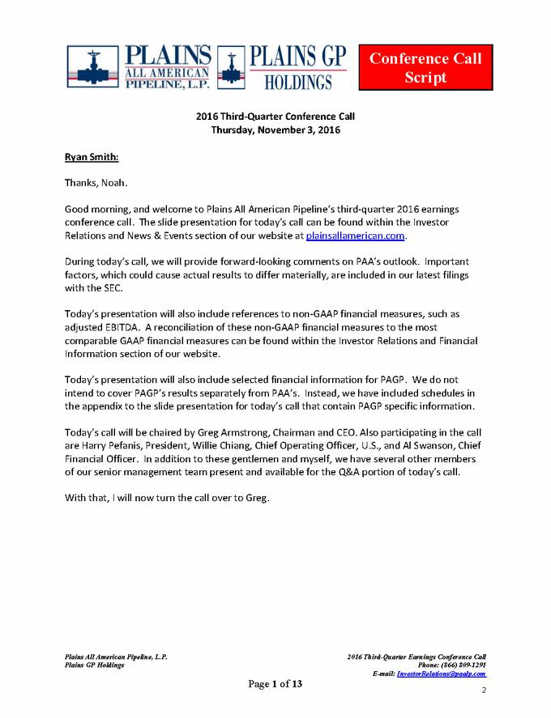

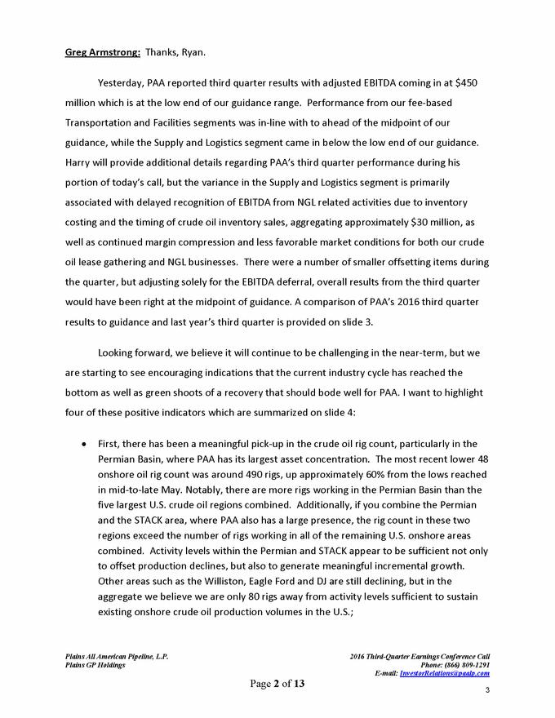

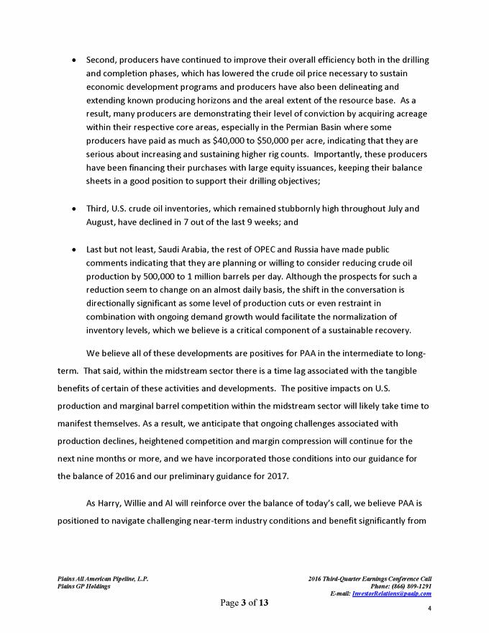

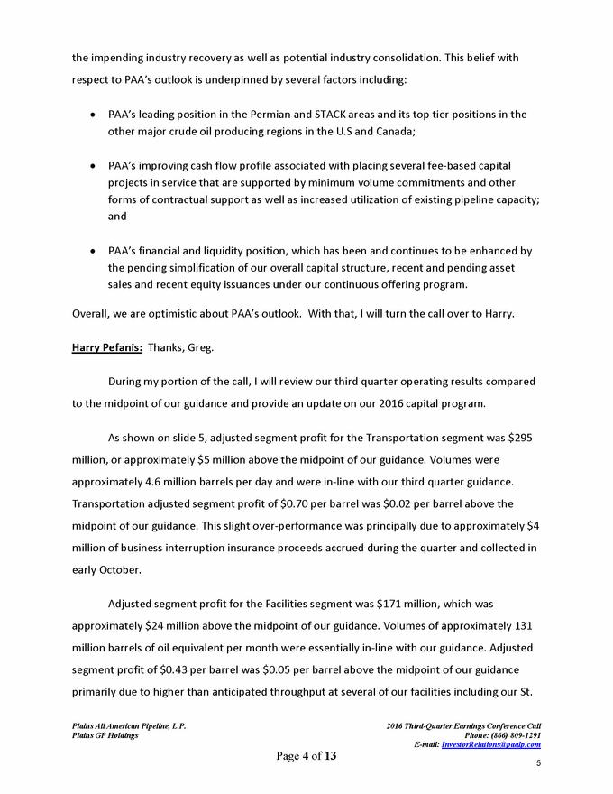

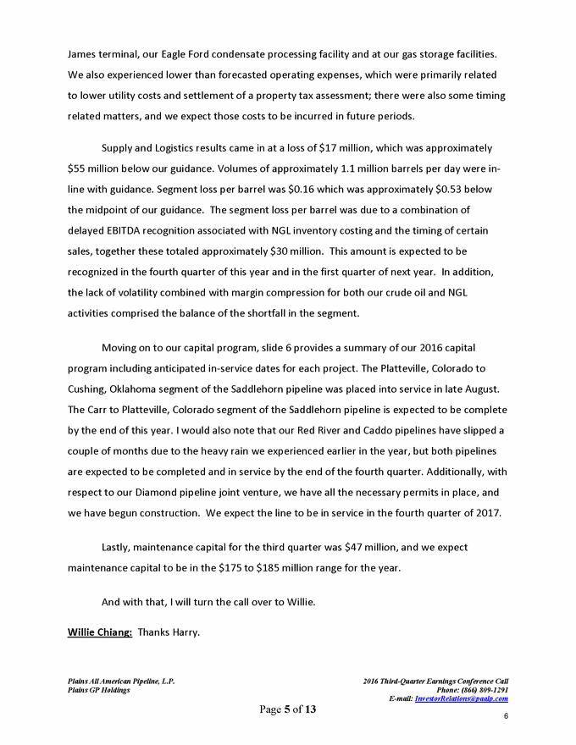

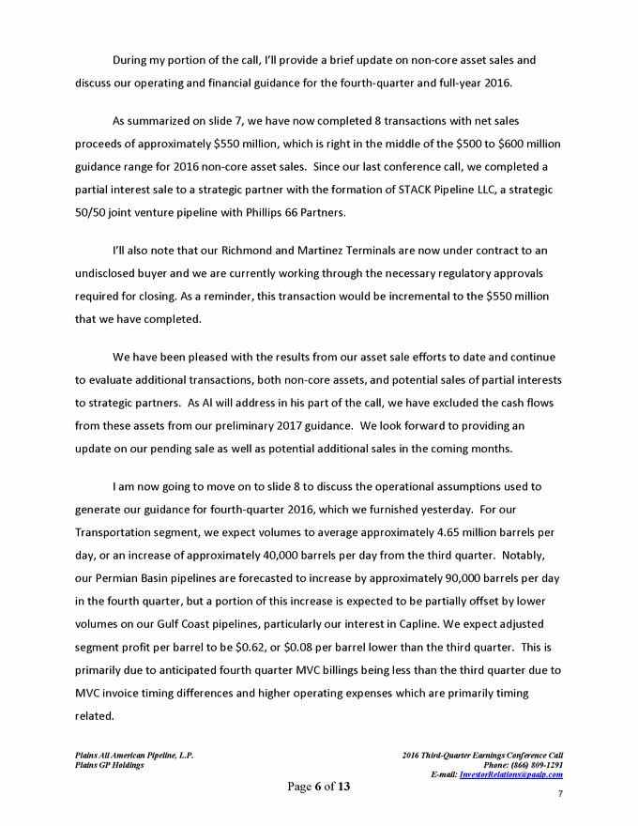

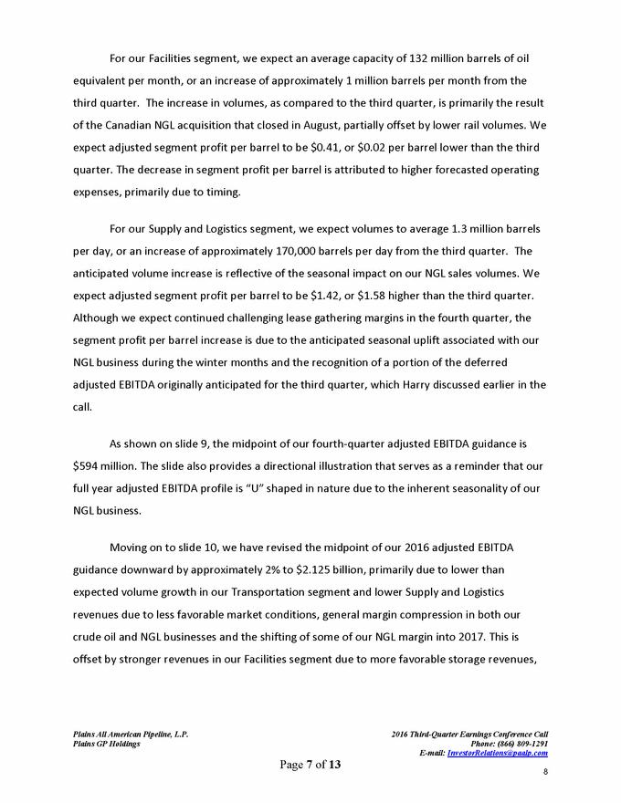

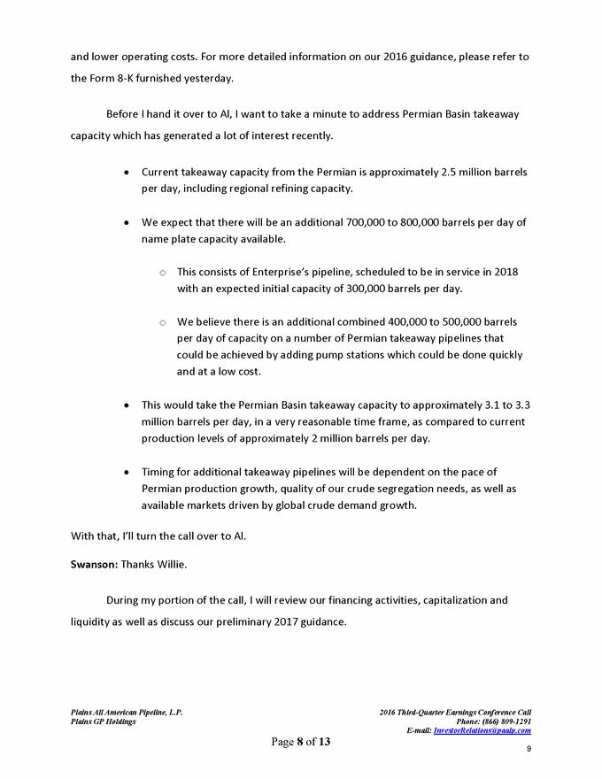

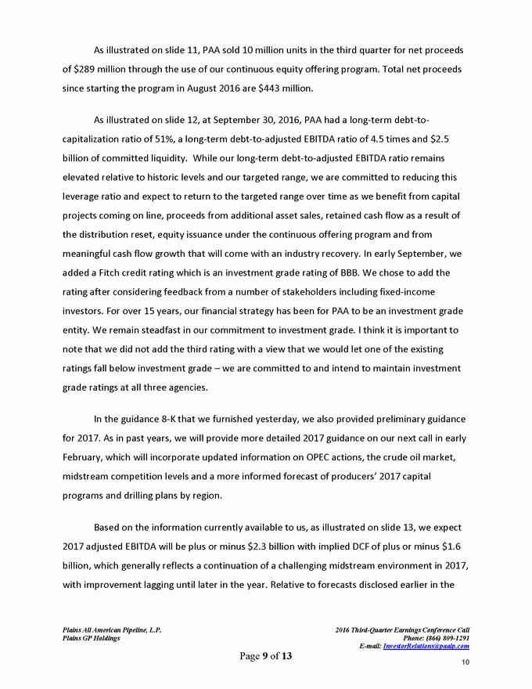

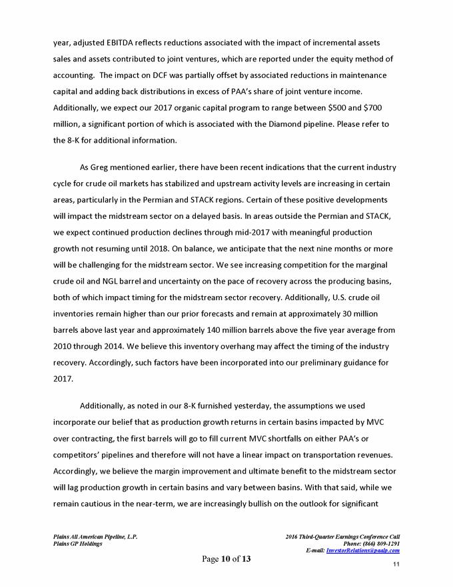

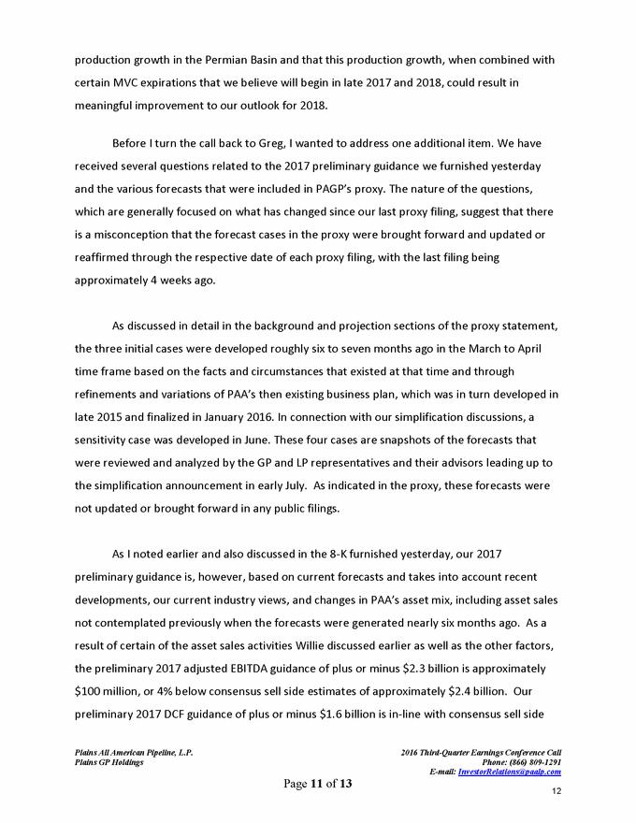

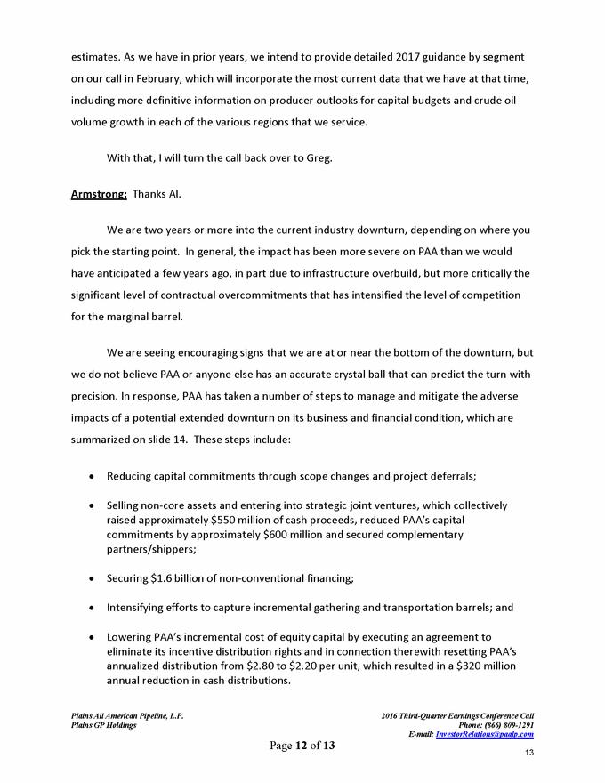

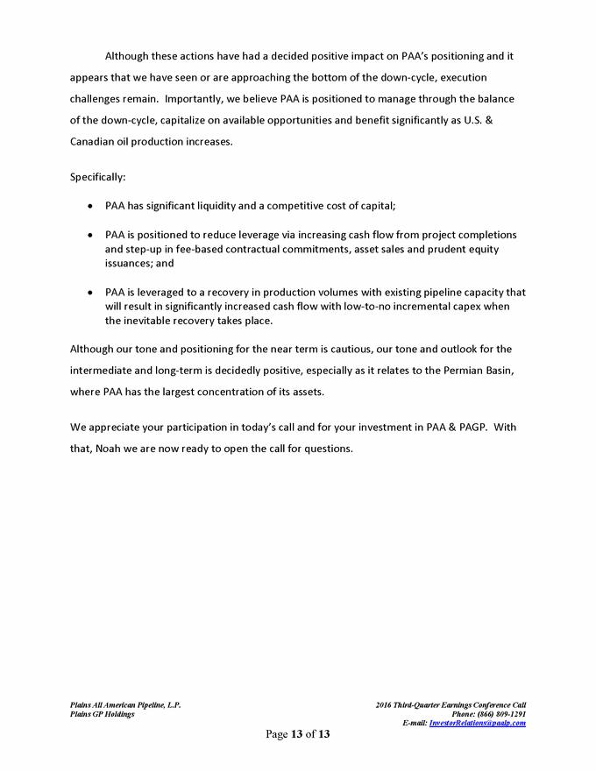

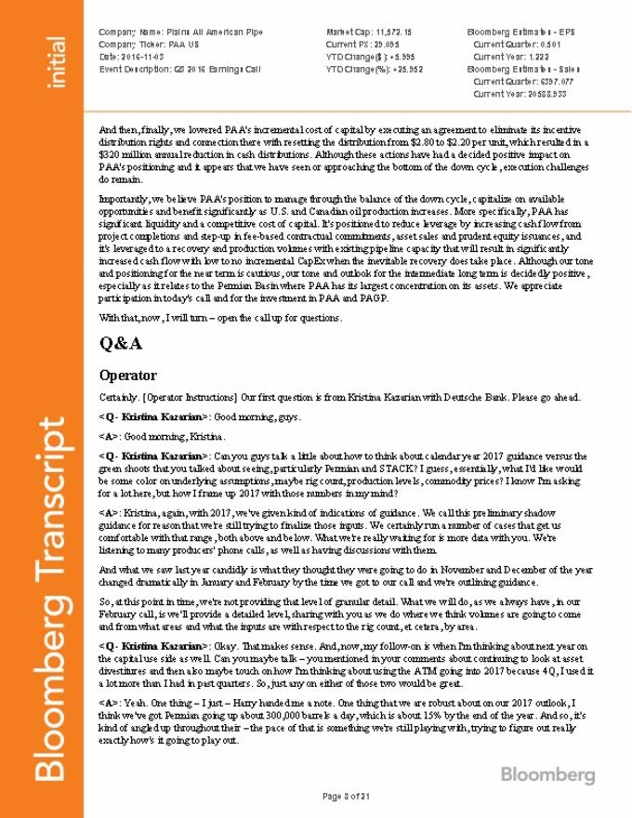

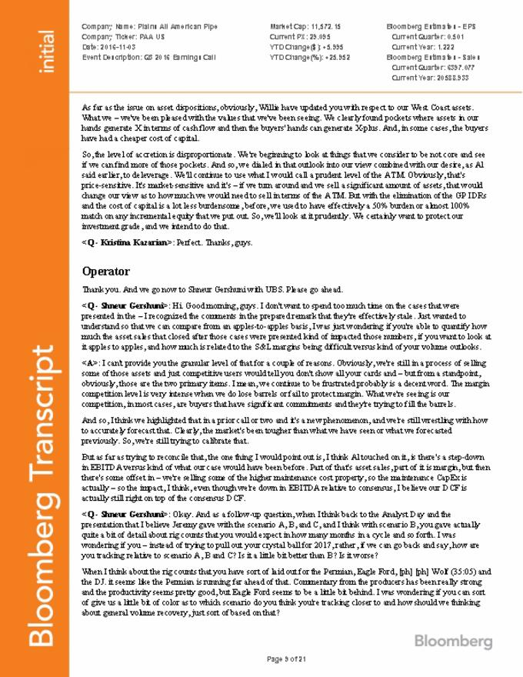

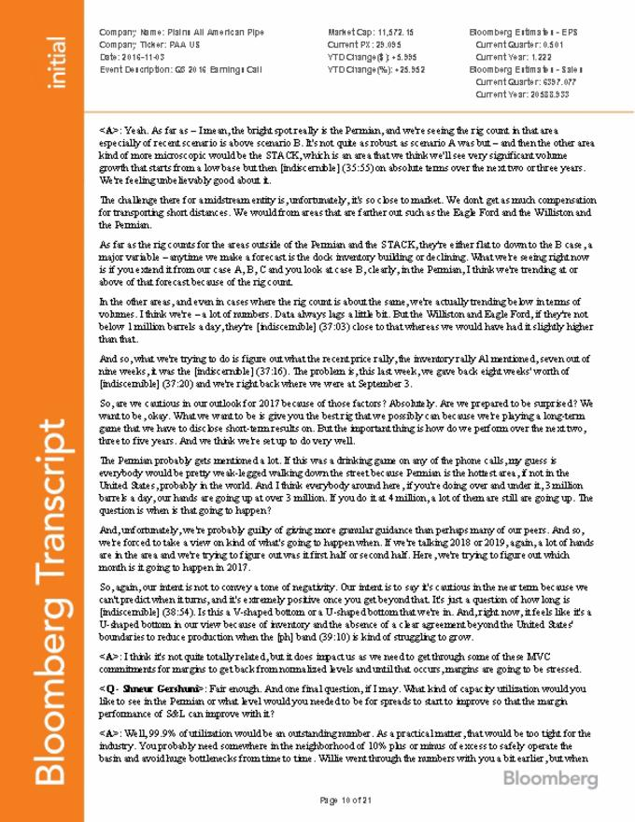

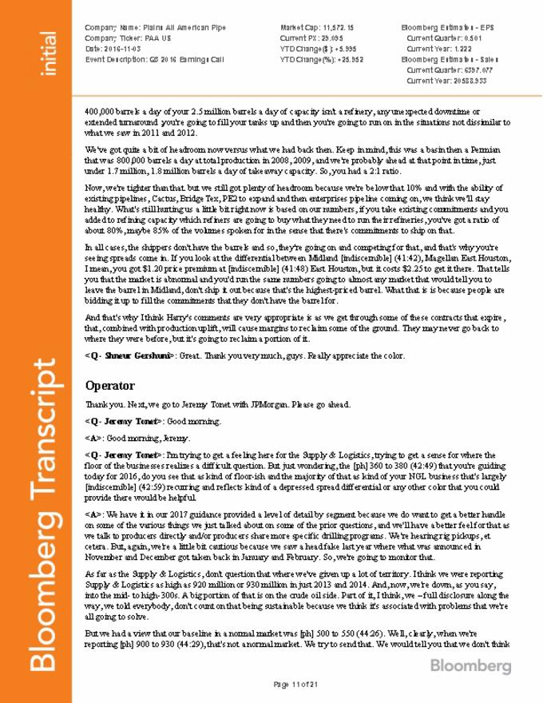

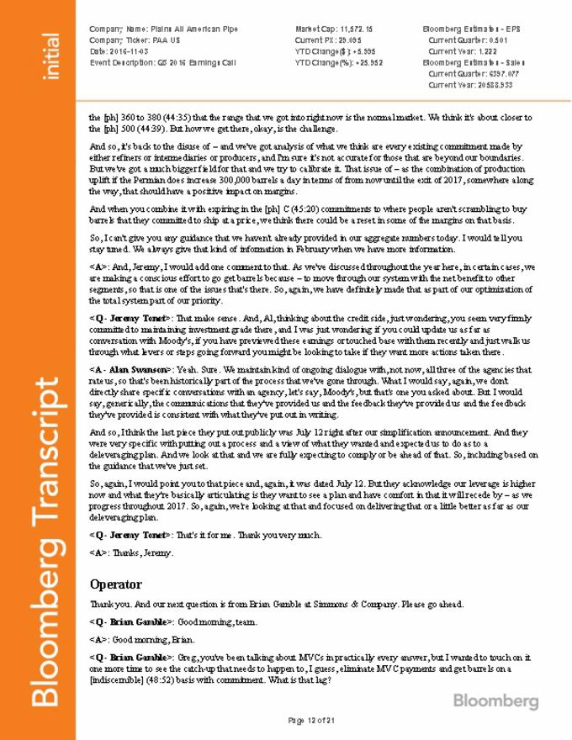

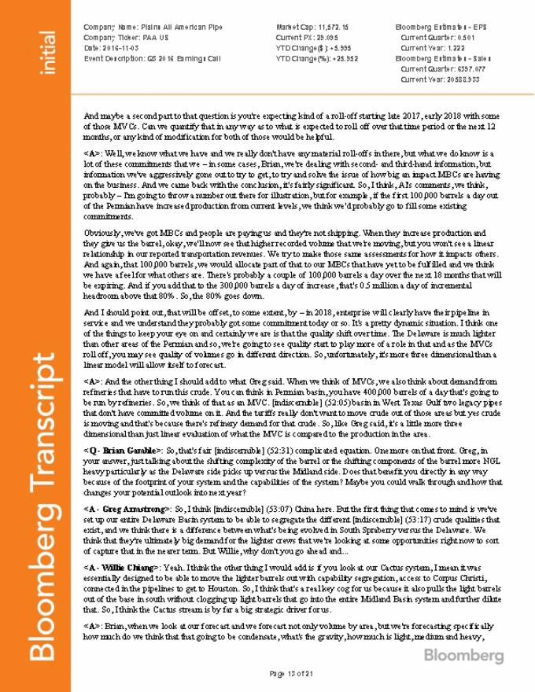

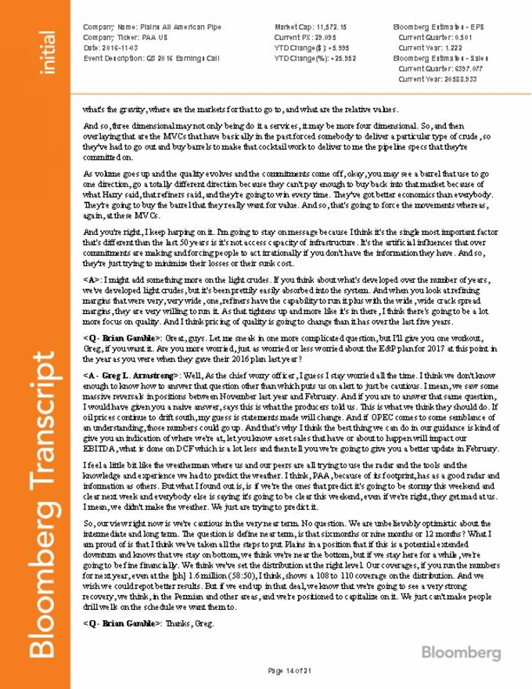

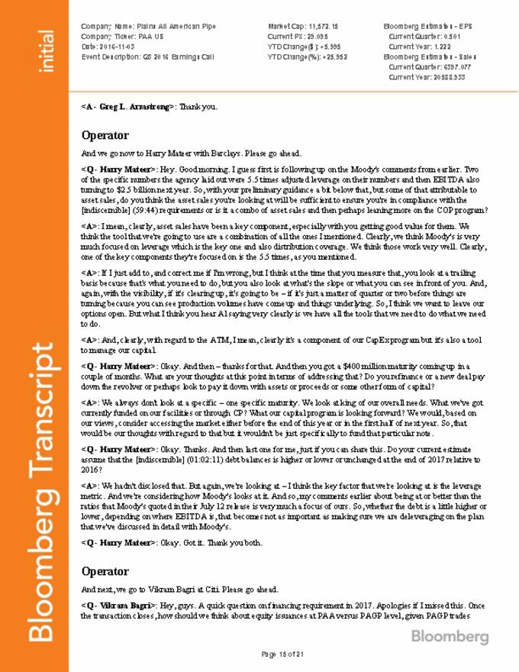

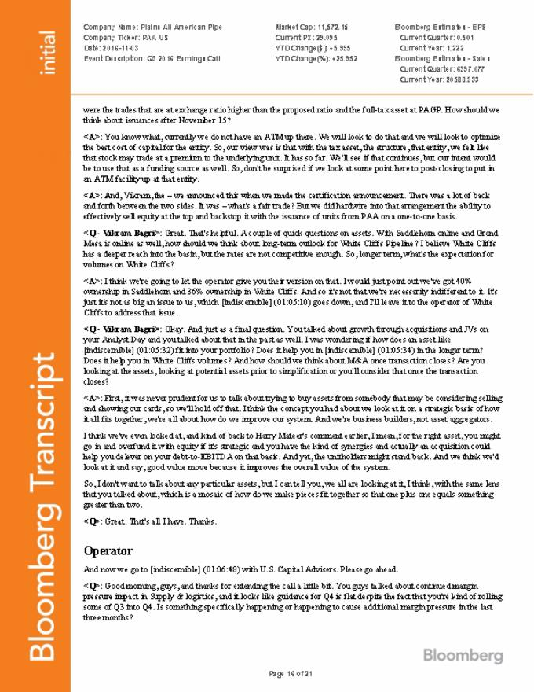

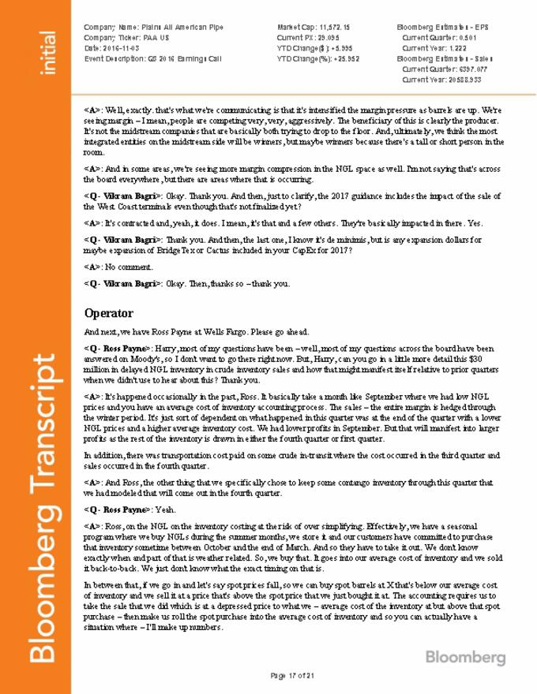

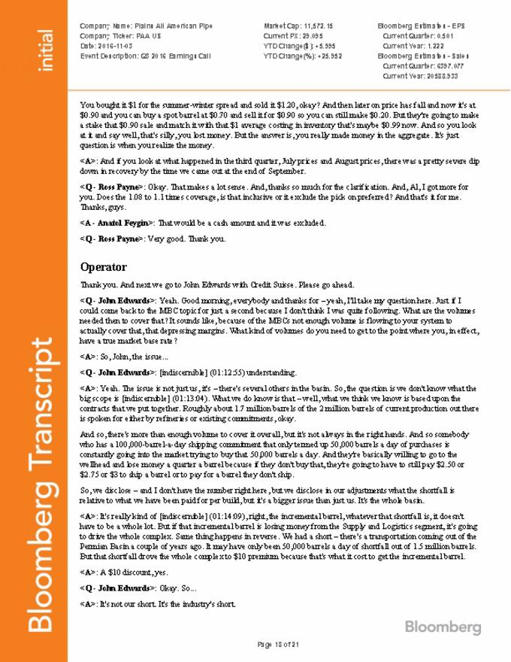

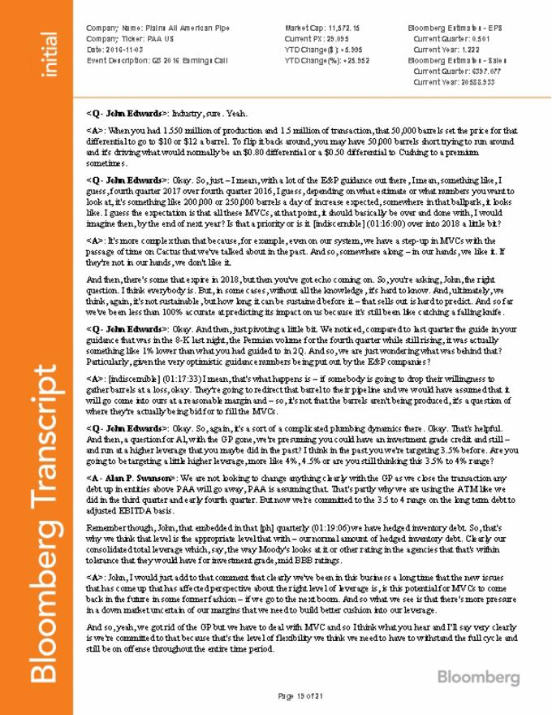

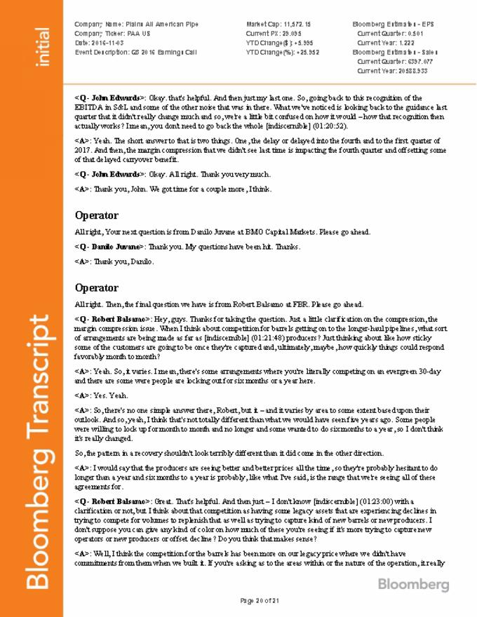

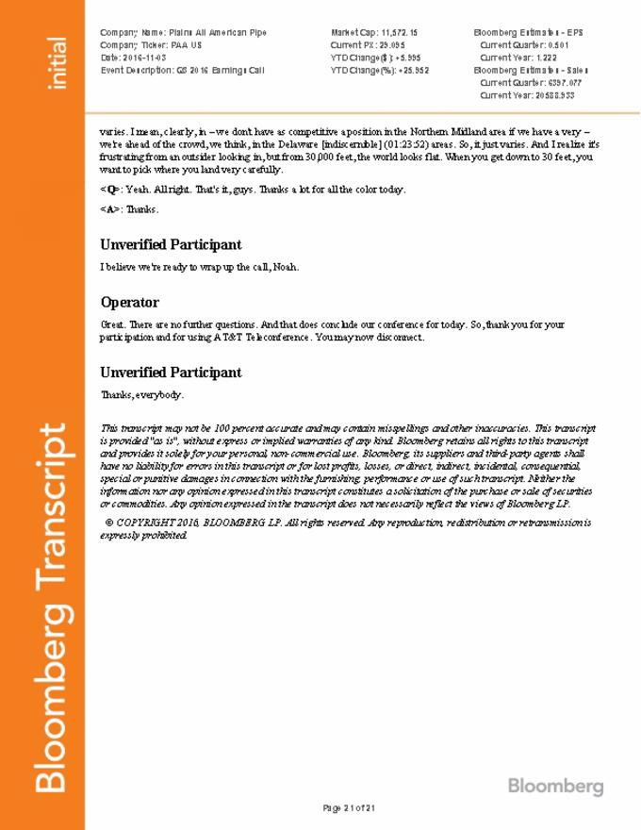

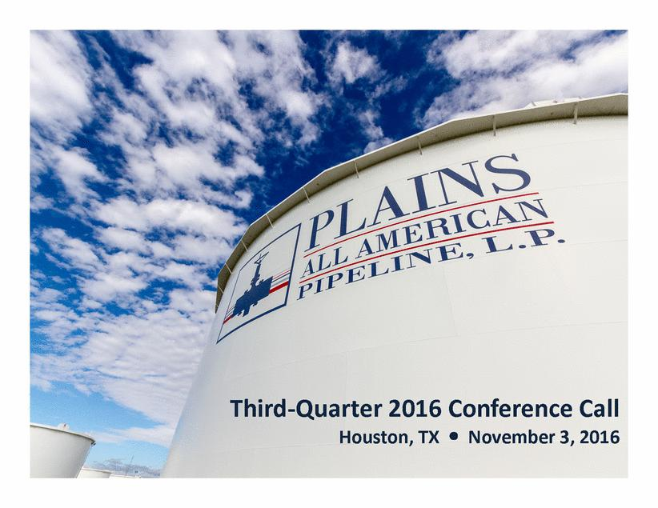

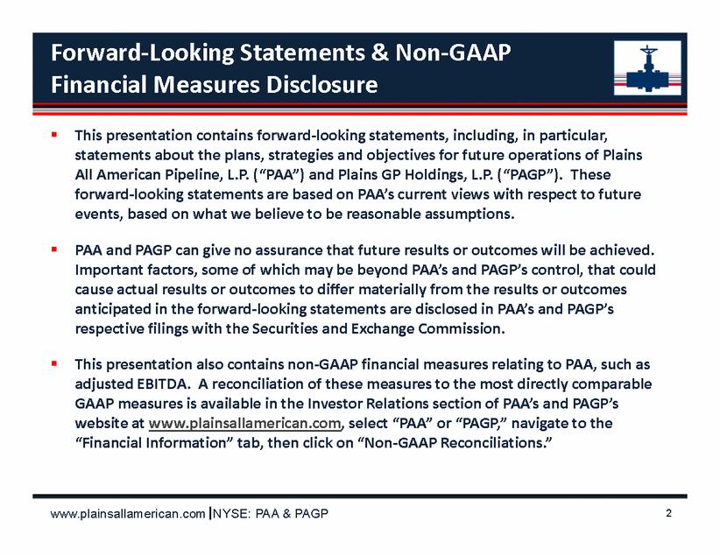

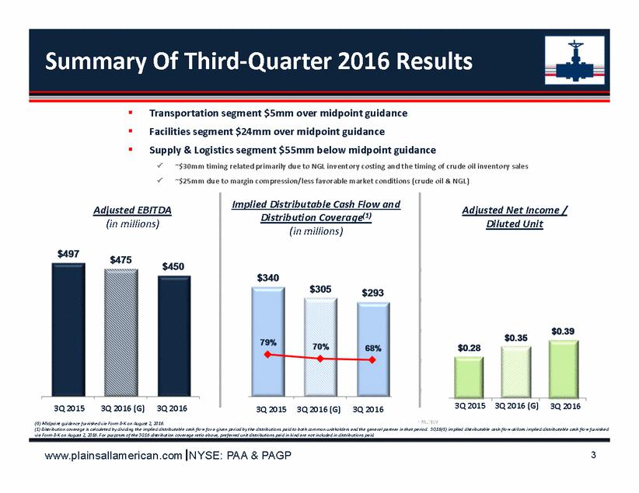

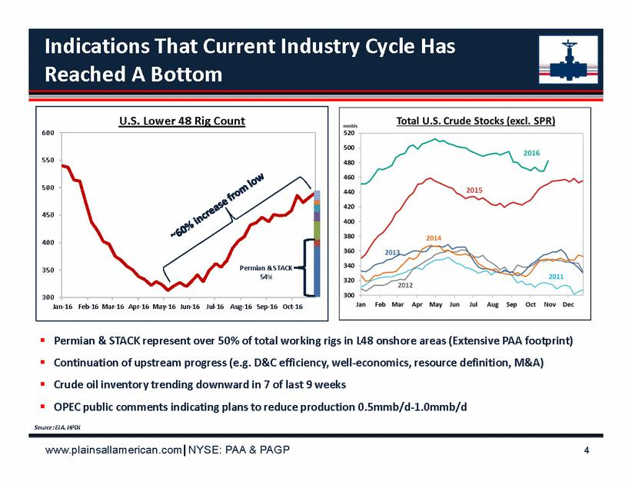

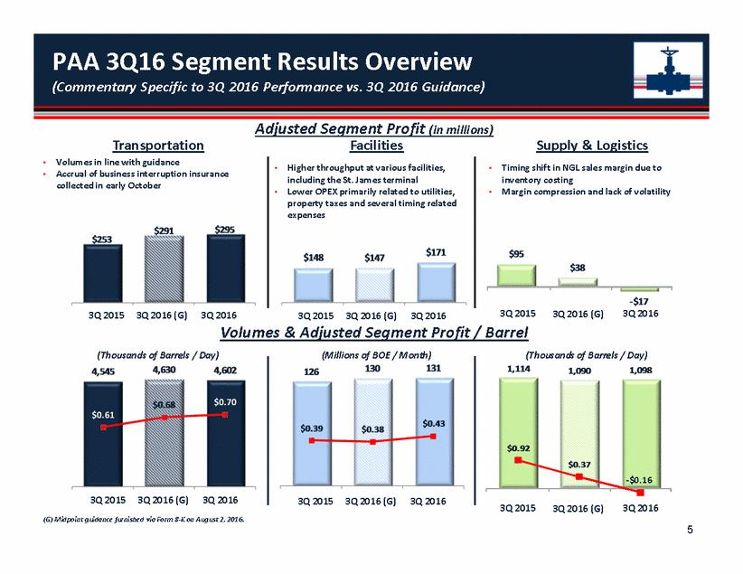

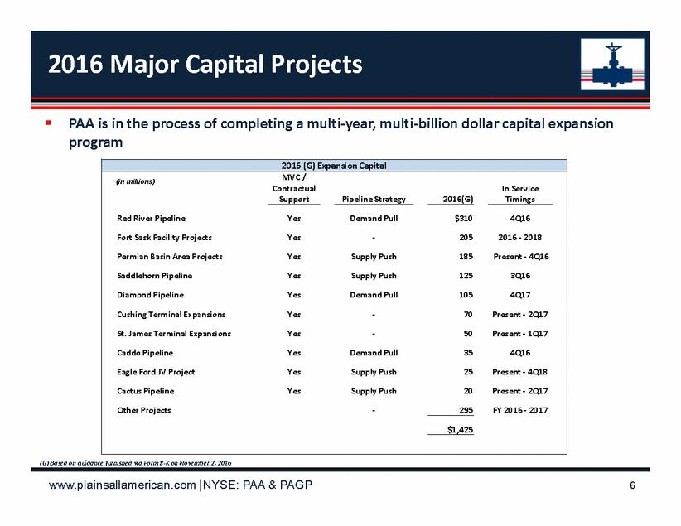

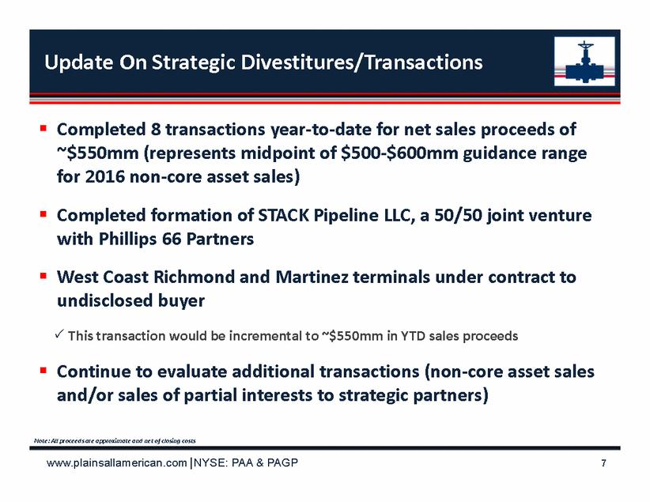

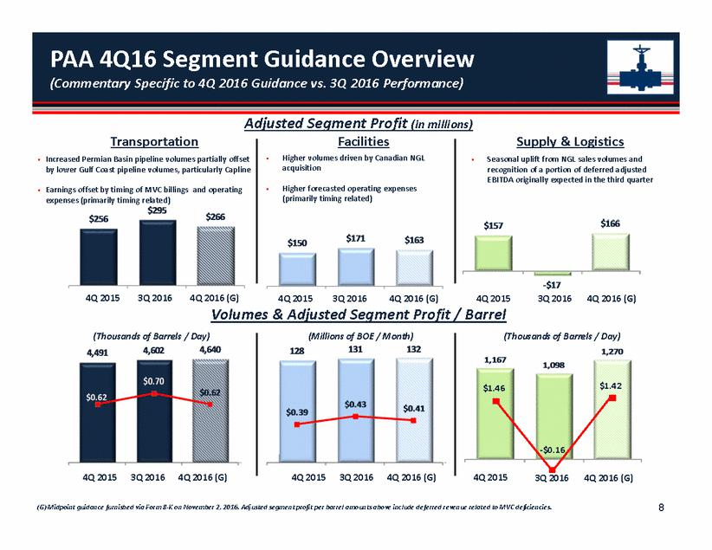

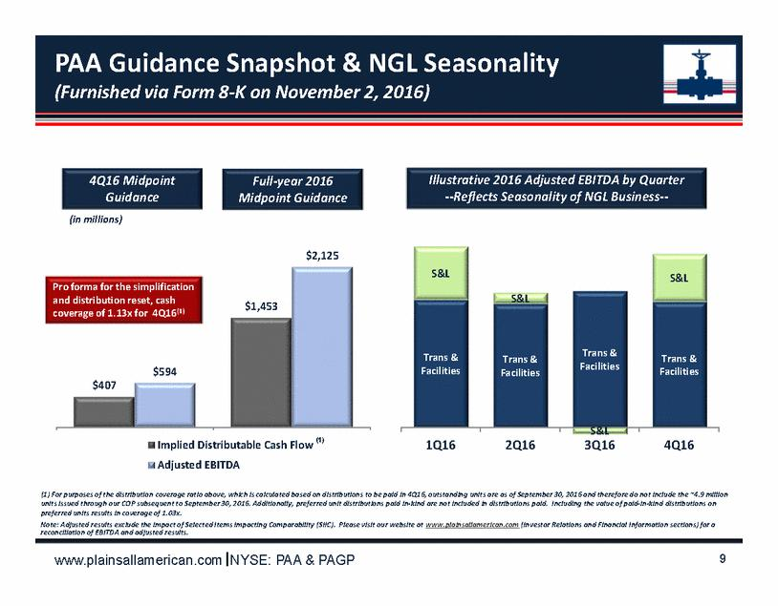

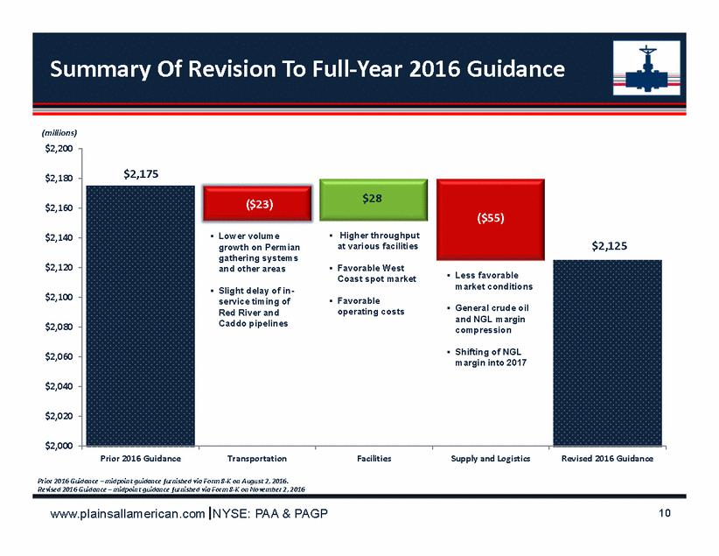

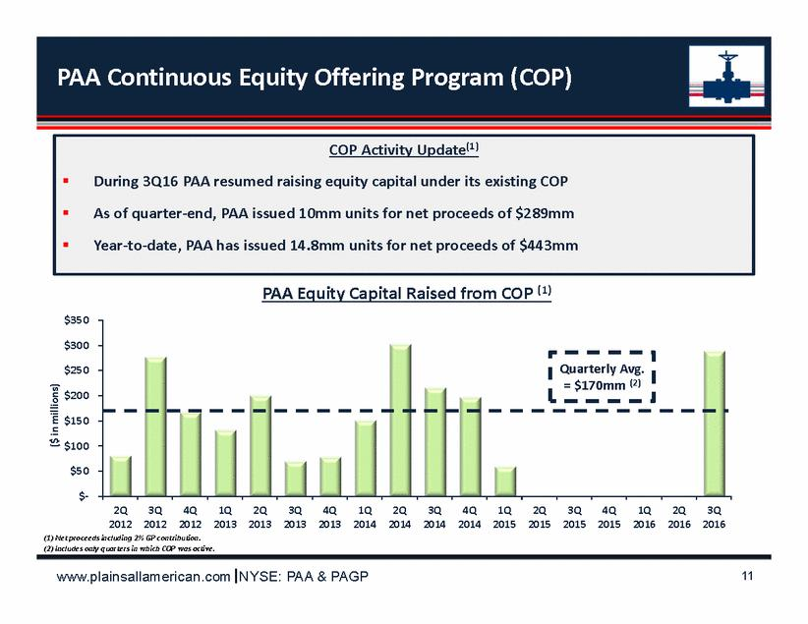

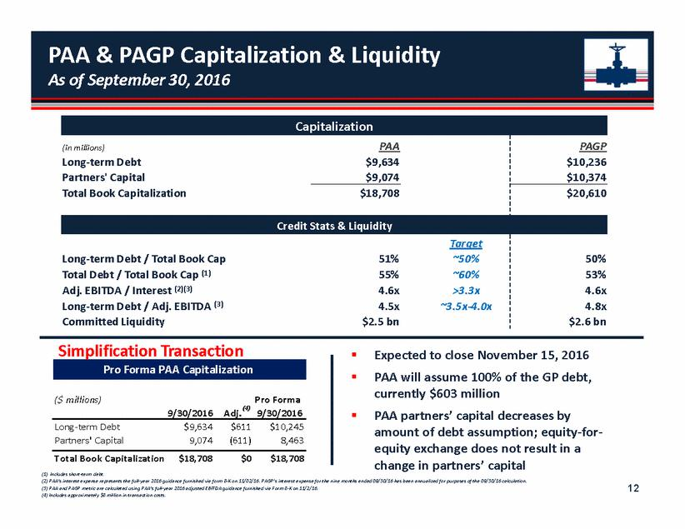

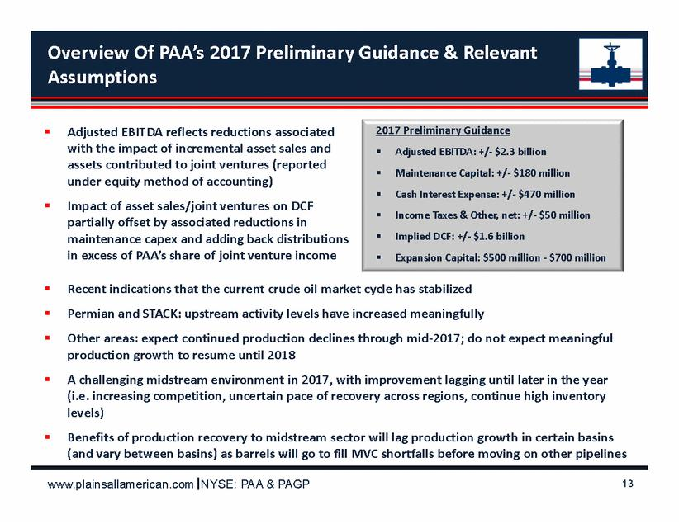

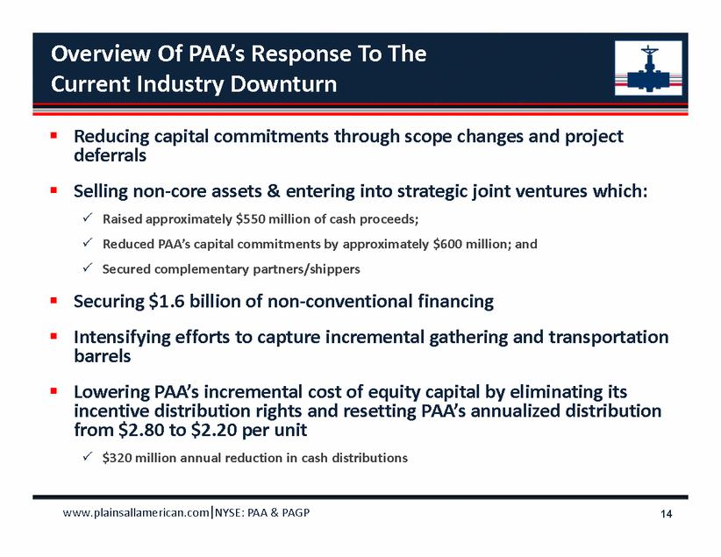

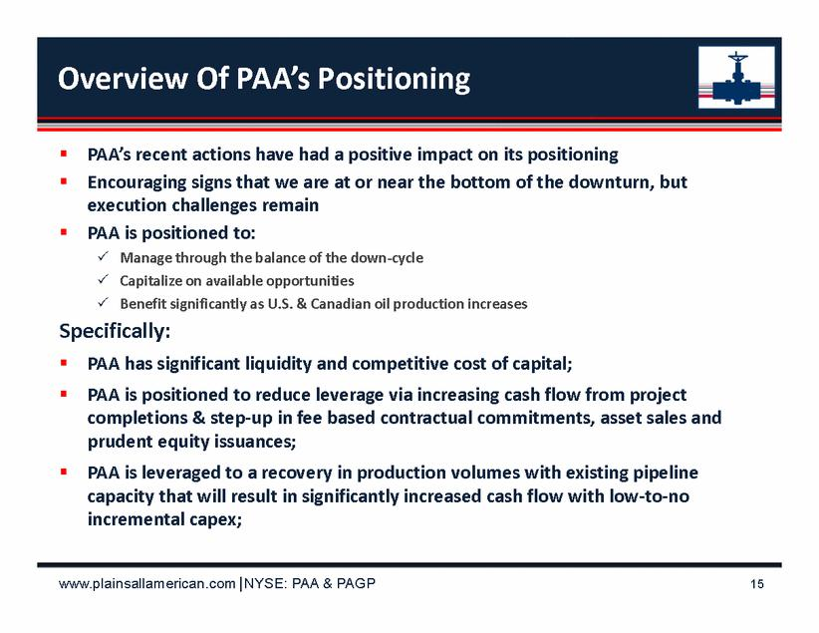

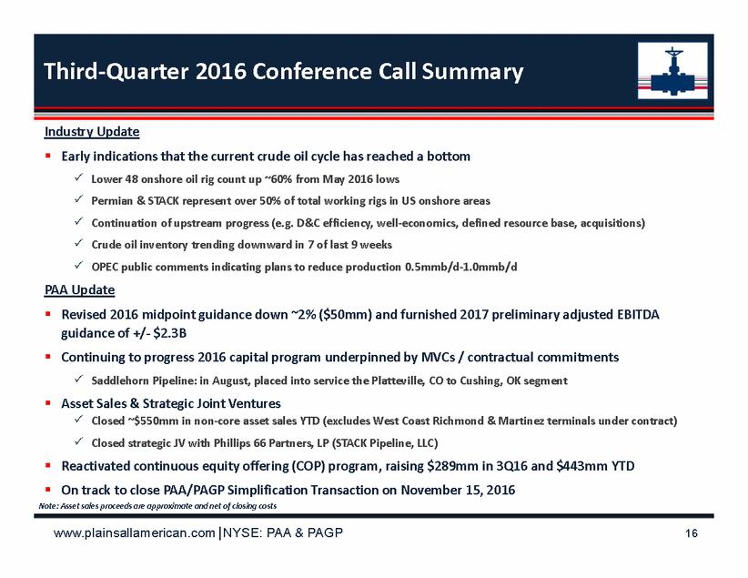

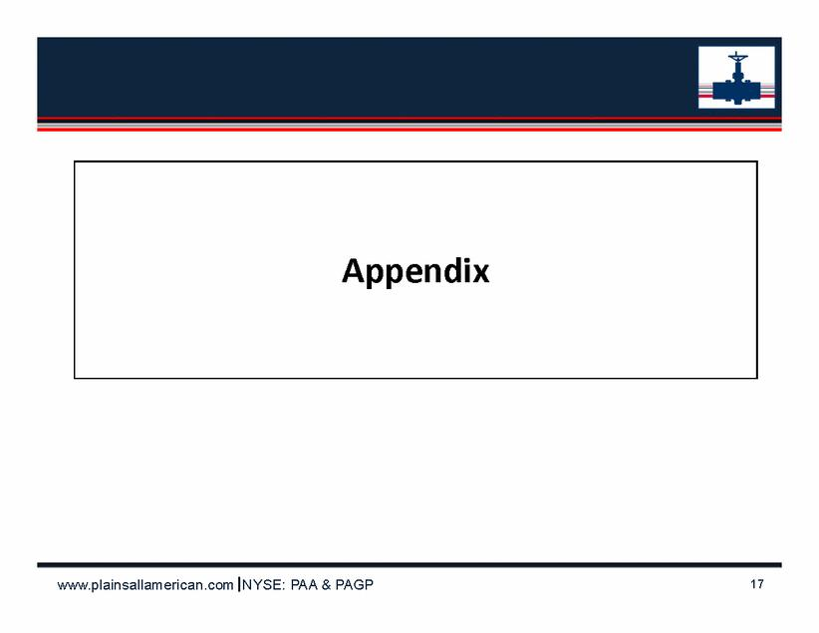

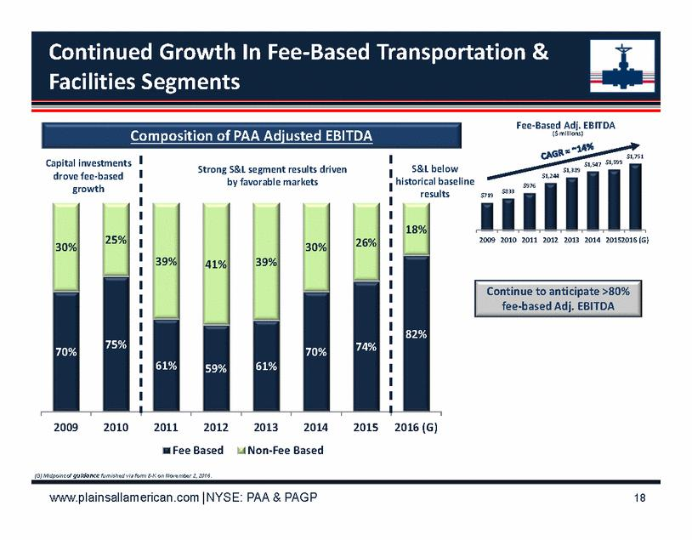

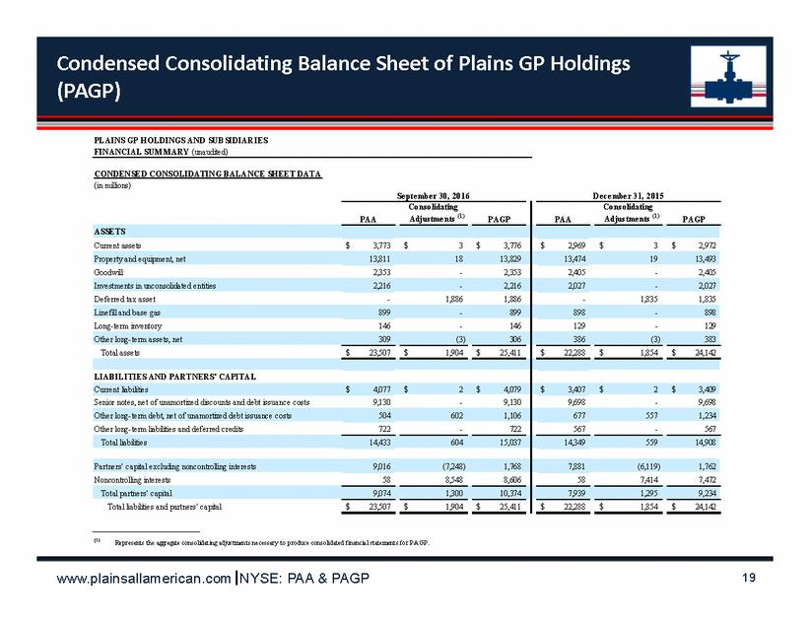

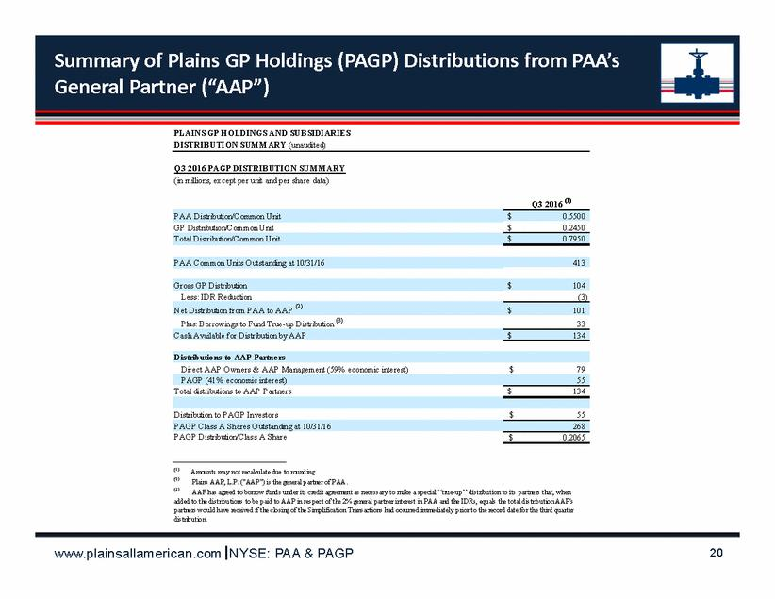

Additional Information and Where to Find It

This communication may be deemed to be solicitation material in respect of the special meeting of PAGP’s shareholders to vote on the approval of the previously-announced Simplification Agreement and the transactions contemplated thereby (the “Simplification Proposal”). PAGP filed a definitive proxy statement with the SEC on October 7, 2016, and has mailed the definitive proxy statement to its shareholders on or about October 7, 2016. The proxy statement contains important information about PAGP and the Simplification Proposal. INVESTORS AND SECURITY HOLDERS OF PAGP ARE URGED TO READ THE PROXY STATEMENT, THE ACCOMPANYING PROXY CARD AND ANY OTHER DOCUMENTS THAT HAVE BEEN FILED OR WILL BE FILED WITH THE SEC IN CONNECTION WITH THE SIMPLIFICATION PROPOSAL OR INCORPORATED BY REFERENCE INTO THE PROXY STATEMENT. Security holders may obtain free copies of the proxy statement and other documents containing important information about PAGP, once such documents are filed with the SEC, through the website maintained by the SEC at http://www.sec.gov. Copies of the documents filed with the SEC by PAGP will be available free of charge on PAGP’s website at ir.pagp.com or by contacting PAGP’s Investor Relations Department at (866) 809-1291.

